About Comics

# Story Construction – Part 5: More Moore

This week, I cover the approach to creating comics authored by Alan Moore. An earlier column touched upon Moore’s approach as viewed through the lens of Neil Gaiman, who claims to have learned his technique directly from Moore.

For those who don’t know, Alan Moore is credited with a fresh approach to comics in the mid-eighties with his tenure on Swamp Thing, Watchmen, and various other titles. Shortly after his success, Moore authored the book entitled *Alan Moore’s Writing for Comics*. The edition that I reviewed was a reprint of the original work with an added Afterword section that was published by Avatar Press in 2006.

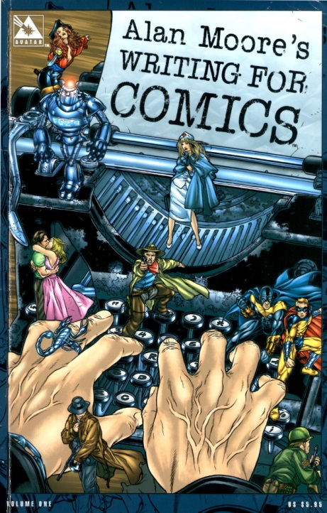

As a writer, Alan Moore’s approach to story construction is obviously text-based. That said, it was remarkable how little he dwells on the imagery of the comic in his text. He chooses to confine the majority of his discussion to the thinking process associated with the creating comics. He explicitly avoids saying how he does it

“…I don’t want to produce anything that smacks even remotely of “How to Write Comics the Alan Moore Way.” Teaching a generation of emergent artists or writers how to copy the generation that came before was a stupid idea when Marvel introduced their “How to Draw…” book and it would be equally irresponsible of me to instruct up-and-coming writers on how to write sickly extravagant captions like “Dawn transformed the sky into an abattoir or whatever.””

Rather he discusses how to think about the craft of comics writing. The main point here is that a story should be useful in some way – it should be relevant to the reader. He feels that changing printing techniques, adding new characters or new computer graphics won’t make a difference unless the fundamental assumptions of the artform are challenged. And he identifies comics writing as the greater area of focus because it is the very start of the process; the bones on which the flesh of the story is hung.

## Story Structure

Moore urges the reader to understand the structure of the work that he is creating; even if the creator is deviating from it, it is important to know that he is. He identifies four types of story structure, most of which he used in his run on the Swamp Thing (note some of the terminology is mine):

* Elliptical structure – the elements of the beginning of the story mirror those at the end
* Middle-Outwards – the story starts in the middle and the background is filled in a way that interleaves the pieces with the current story line
* POV – the same narrative of the story is told by more than one character and only by sifting through the various pieces can the reader determine the facts
* Gimmick – a central piece, like a poem, is used around which the rest of the structure is placed

Once the basic notion of the structure is chosen, Moore then identifies areas of story composition. In this category he includes

* Transitions – movement between one scene and another
* Pacing – the intellectual speed at which that the reader moves through the story
* Rhythm – the balance between active and passive panels*
* Smoothness of flow – overall package of the above*

* Note that these definitions are my own based on my reading of Moore’s intent.

### Transitions

Moore labels transitions as one of the trickiest and intriguing elements of the whole story process. The aim of the transition is to move the reader’s attention from one element to another without disturbing his immersion in the story. Moore’s idea is that the reader voluntarily subjects himself to a kind of hypnosis when reading the comic and the last thing that the creator wants to do is to disturb this with an awkward change in focus. Several concepts are proffered as ‘tricks’ to make the transitions better. These include:

* the use of overlapping or coincidental dialog,
* writing in basic units of a page,
* and a repeat of images or concepts (e.g., an idea or a color) between scenes.

Moore does emphasize that the transition need not be smooth if what the creator is aiming for is a jarring change of attention. But again, this is one of these ‘it’s okay to break the rule if you know you are doing it moments’.

### Pacing

The idea here is to meter out the duration that it will take a reader to complete their passage through an entire page. Moore doesn’t have a lot to say on this front. He does cite a standard of 35 words per panel, a figure that I had never encountered prior to reading this piece. According to him, an average reader spends 7 to 8 seconds on such a panel. Moore believes that by dwelling on these sorts of concepts, the creator can exercise some control over the duration that the reader spends on each page. To quote Moore

“If you read a few comics with the pacing in mind you soon get a workable intuition for how long the reader will spend on each picture. While this doesn’t give you anything like the rigid control of the time frame enjoyed by the film industry … it does grant you some broad measure of control over how long it will take the reader’s eyes to be guided through the whole page.”

This assertion seems highly questionable based on earlier comments made about the differences between literary works (e.g. novels, short stories, etc.) and film. Moore makes a particular point about the strengths afforded the written work – particularly that the individual reader can set his own pace; moving forward and even backward as he see fit.

What I believe that Moore actually means is that the creator can set the minimum time that the reader must spend on each page by tailoring the amount of written versus rendered information.

### Rhythm & Smoothness of Flow

If Moore says precious little about pacing then he says even less about rhythm and smoothness of flow. Specifically, he never mentions them by name again. Getting beyond that point, one can infer possible meanings for him listing them in the first place. The starting point for guessing what he had in mind comes from his insistence that the story is a kind of hypnosis that the reader voluntarily enters. The immediate interpretation is that rhythm is the balance and metering of active versus passive panels. An active panel is one predominantly communicating movement whereas a passive panel communicates location, or thought, or dialog. As far as I know, this terminology is peculiar to me.

This inference is bolstered by Moore’s discussion about the elegance of the fight sequences of Frank Miller, where the active panels are completely devoid of dialog. The action is allowed to happen as in real life without being cluttered by a lot of words.

The smoothness of flow is then judged as the complete package where active and passive panels are knitted together with the pacing and transitions working seamlessly to keep the reader engaged.

Next week, I finish up my summary of the theoretical study of Alan Moore’s Writing for Comics, where I will cover world building and plot and script.

# Story Construction – Part 6: Even More Moore

Last week’s column reviewed the first half of the book *Alan Moore’s Writing for Comics* covering the general thought process of the writer, the type of structures the creator might think about using, and the pacing of the events in the structure. This week will finish the review by discussing world building and plot and dialog.

As discussed earlier, since Moore’s work deals with the planning and writing components, he doesn’t dwell at all on specific visuals (perspective, color, etc.). The book, which is 47 pages in length, has 22 panels, each isolated from the others in both location and in content. Clearly this is not a tome on drawing, nor does it concern itself with the visual composition. Its focus is on story-telling plain and simple.

## World Building – Locale and Character

Under the broad heading of world building, Moore lumps both the development of the characters and the construction of the inanimate locales in which they live. For him, the back stories of the environment in which the characters live are on the same ground as the back story for each character. The locales history is important to building a believable and consistent world, even if the bulk of it is invisible to the reader. To quote

“Before writing *V* [for Vendetta], for example, I came up with a mass of information about the world and the people in it, much of which will never be revealed within the strip for the simple reason that it isn’t stuff that’s essential for the readers to know and there probably won’t be space to fit it all in.”

This approach, which I rather like, shows roots in the gothic literature that has come before wherein the location of the events narrated is often a character in its own right. Consider that the first ‘entity’ that the reader encounters in Poe’s The Fall of the House of Usher is the melancholy house of the same name and that much of the text is devoted to discussing the bleak and depressing nature of the setting and the feelings that it provokes. The house and the ‘gray tarn’ that surrounds it are just as important (or perhaps more) as the human characters of the story – the narrator and the two Usher siblings.

Moore also advocates for a complete understanding, on the part of the writer, or the rules of the world that is being constructed. This is the concept of verisimilitude, where the fabric of the world being discussed is complete and self-consistent. Characters react in a well understood way to the rules of the particular environment in which they find themselves, just as we would react consistent (although not necessarily rationally) to the rules of ours. Moore states

“What is important is that the writer should have a clear picture of the imagined world in all its detail.”

But he also cautions the creator in being too explicit in the exposition of this world. If the verisimilitude is the skeleton, Moore would advocate that none of the hard bones be obvious. All of them should be wrapped in soft flesh that hides the structure underneath. He cites the work of Howard Chaykin in American Flagg, where the reader is exposed to the political realities and popular attitudes though bits of advertising and media coverage of the events in that world.

Once the locales are built, the next piece is characterization. Moore calls this piece highly problematical.

He analyzes the evolution of character in the comics medium from its inception until the time of his writing. The earliest approach involved portraying a character in a ‘one-dimensional’ fashion – the character is good or bad; a hero or a villain. Although Moore doesn’t mention it, this type of portrayal means that the vast number of characters in the world, which were neither good nor bad, per se, were actually part of the scenery. They were the organic piece of the locale that the creator provided – the good natured cop on the beat who offered a piece of advice at the right time.

As time progressed, Moore claims that characterization became more developed and he cites Stan Lee as the person most responsible. He says

Thus Stan Lee invented two-dimensional characterization: “This person is good but has bad luck with girlfriends,” and “This person is bad but might just reform and join the Avengers if enough readers write in asking for it.”

Despite this evolution, Moore believes progress since that point has been minimal. He blames this lack of progress on the industry reliance on the 15-word skeleton. If a character can’t be summarized in 15 words then it is no good. He throws out the example of Captain Ahab from *Moby Dick* as an ‘insane amputee with a grudge against a whale’ but notes that Melville spent more than 15 words delving into Ahab’s psychology.

Moore advocates that the writer should start by looking at real world people. Perhaps this was good advice back in the nineties when this piece was first written but in the intervening years real life has rapidly accelerated its imitation of art and I am not quite sure that people today allow themselves to be complex.

He also recommends a ‘method-acting’ approach to writing characters. He claims that he imagines himself as the character and then tries to understand how he would react in a given situation. The particular example he includes involves his use of the character Etrigan the Demon in Swamp Thing. As a denizen of hell (or what passes for it), Moore imagines Etrigan as having a densely built body, needed to survive the rigors of such a place, and so he frames the pacing of the demon’s movement appropriately.

He finishes with a personal conclusion that almost everybody has a practically infinite number of facets to their personality but that each of us chooses to focus only one a few at a time. He urges creators to tap into the well spring and to become adventurous in their characterizations.

## Plot and Dialog

The final ingredient is the plot and the accompanying dialog. Despite Moore claiming that

“I suppose we might as well think about coming up with a plot although… if you’ve read much of my work I very often can’t be bothered with this formality”

his chapter on plot and script is by far the largest in his book. He begins by criticizing the ‘disproportionate amount of effort … expended on coming up with madly elaborate plots involving dozens of characters’ he does end up conceding that there are some stories where the plot is the central idea. He cites murder mysteries as the primary genre where this idea holds.

Only after this long introduction does he actually define what he means by plot. Roughly speaking, if the world is the ‘who’, ‘what’, and ‘where’ then the plot is the ‘when’ – the time sequence of events that get the world from its initial state to its final state; along the way telling the story that needs to be told. (Note that the ‘why’ and the ‘how’ seem to be a complex interplay between the world and the time).

For Moore, the creator has an idea he wishes to communicate and the plot underlines and reveals this idea in an interesting way.

Since the plot must fit within a given page length constraint, the plotting mechanism is inextricably linked with the discussions of pacing, rhythm, and flow that he covered earlier. He also emphasizes that the plot can always be done in an ‘interesting way’ simply by the style in which the plot follows. He asserts that a good writer can make even a mundane topic interesting with the correctly constructed sentences. This is, of course, a habit that the British school of thought believes and practices on a regular basis even outside the domain of comics. Consider Douglas Adams opening sentence in The Long Dark Tea Time of the Soul

“It can hardly be a coincidence that no language on Earth has ever produced the expression as pretty as an airport.”

Concerning dialog, Moore’s fundamental advice is to speak the dialog out loud. This litmus test will determine if the dialog is natural enough to be digested by the reader. In his assessment, the majority of comics dialog fails this test.

Finally Moore discusses the visual look-and-feel. For him, the visual narrative is simply what goes into the pictures but that it is vital that the writer think visually and try to take advantage of all the possible ways to convey the point. He further urges that the writer try to create rough thumb nail sketches of the pages before writing the story.

Next week will be the final installment on Alan Moore in which various stories from his successful run on *Swamp Thing* are presented and a comparison between his practice and his theoretical structure, as presented over these last two columns, is made.

# Story Construction – Part 7: Just a Bit Moore

In this final installment of the exploration of Alan Moore’s work, I’m going to show examples from his early run on the *Swamp Thing*. Although Moore has done a great deal of work that is critically acclaimed (*V for Vendetta*, *Watchmen*, *League of Extraordinary Gentlemen*, etc.) he really made his mark with Swamp Thing, which remains his best work.

It is also the work most germane at the time he wrote his treatise on comic book creation that was covered in the last two posts and most of his techniques are visible in his tenure on that book.

The material below is from his first two years on Swamp Thing which spans issues #20 – #43. My sources are the collected trade paperback reprints, some of which are almost as old as the run itself. I find that Moore’s stories are best enjoyed without the interruption of advertisements and other various distractions (letter pages, inside covers, etc.) since his stories are predominantly about mood and atmosphere.

Moore’s central ideas from his *Alan Moore’s Writing for Comics* were: to focus on a story concept; build a structure that matched; worry about transitions; worry about pacing and flow; and put plot and dialog in last. These five main points will be covered in turn below.

## Story Concept

The first point that Moore raised was the idea of having a relevant story to tell. By relevant, he means one that has some meaning to the reader – a fascinating idea, a socially important tale, and so on.

For *Swamp Thing*, Moore chooses as his basic idea the concept that the Swamp Thing is actually a hybrid between man and plant, having the physical and essential properties of a plant but with the memory, consciousness, and intelligence of a man. With this basic idea as its core, the subsequent tales all fall into the perspective of man’s interaction with the plant world.

To flesh out this idea, Moore has to connect the scientist, Alec Holland, whose coincident death with the Swamp Thing’s creation leads all to think the two are the same entity, with the plant-thing-that-thinks-itself-a-man that he was creating. Here Moore drew on the existing ‘science’ of cannibal planarian worms (as explained in issue #21 by the [Floronic Man](https://en.wikipedia.org/wiki/Floronic_Man))

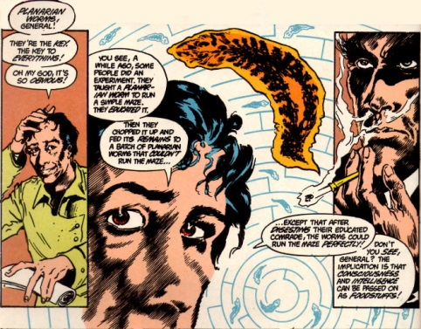

to establish how even the Swamp Thing could believe that it was the Alec Holland. Published in the early 1960s, this science was largely discredited even though the sensation it created lingers to today. Whether Moore was impressed by this story and reworked Swamp Thing around it or whether he wanted a plant-human and found the science convenient is unknown to probably all but him.

What is clear is that this simple idea forms the core of almost everything that he writes afterward. By making the Swamp Thing truly a plant, Moore can draw a huge number of new ideas all from a single premise. The Swamp Thing is now a plant elemental who speaks for the entire plant kingdom and, in some sense, for the earth itself.

One of the more fruitful lines of concepts is the reoccurring notion of eating a vegetable substance produced by the Swamp Thing

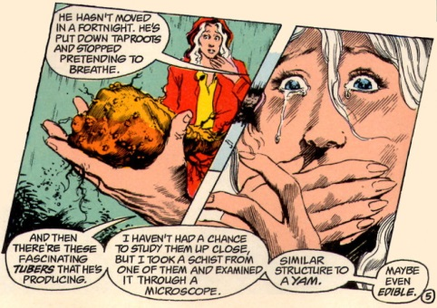

and the Floronic Man’s consumption of these tubers allows him to have some access in the awareness that the Swamp Thing possesses as an avatar of that portion of nature known as ‘The Green’.

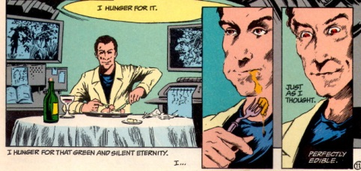

This in turn drives the Floronic Man mad so that he orchestrates the subsequent, horrific events that fill the plots of issues #22-24.

Later on the idea of consuming a portion of the Swamp Thing plays out in many different ways. Two of them are particularly notable as they comprise reoccurring ideas.

In issue #34 the Swamp Thing wishes to have a ‘sexual communion’ with his love interest Abigail Cable but being composed of plant matter, he lacks the necessary anatomy. As an alternative, he produces a fruit that when consumed takes Abigail on a psychedelic trip through his awareness. The lovers join on a spiritual level and their version of marriage and union is established.

In issue #37, the Swamp Thing begins to learn that his consciousness exist independently of the plant matter that forms his physical shape. As a result, if his body is consumed by fire or damaged by toxins, he can abandon it and regrow a new one. This then leads to his ability to transport himself, almost instantaneously, anywhere in the world. This handy trait not only allows him to respond to emergencies world-wide, but it also opens the door for subsequent explorations of consciousness and soul.

## Story Structure

Moore spoke of several story structures, but the one that he seems to favor is the idea he calls elliptical, where the events at the beginning of the tale match, in some fashion, those at the end.

The image below is a reproduction of the first page of Issue #21, which starts with “It’s raining in Washington tonight.” and shows the Floronic Man reflecting on the events of the day through a finely paned window.

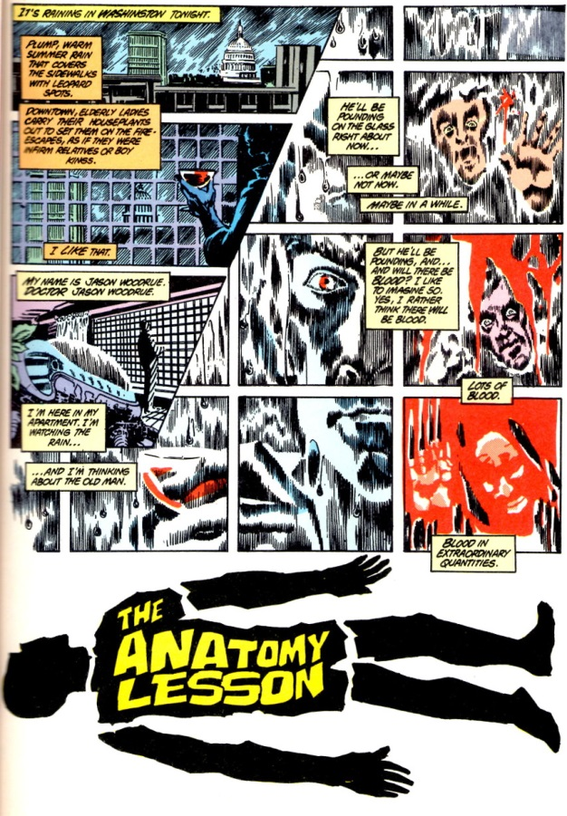

The image below is the last page of the same issue showing the same structure verbally and visually as the opening page. Note the subtle changes in the appearance of the Floronic Man’s reflection in the panes and the bookend placement of the “It’s raining in Washington tonight.” to close the issue.

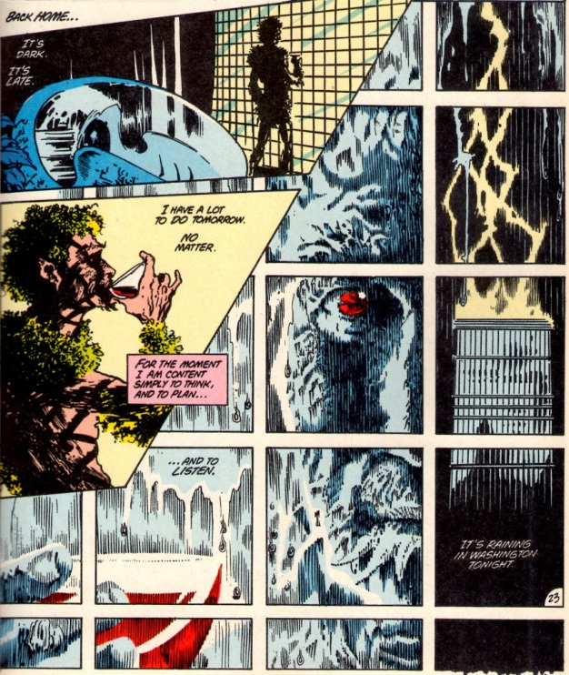

Another structure Moore suggested is the gimmick where a central piece is used to build the rest of the story around it. In Issue #35, the reoccurring motif of the newspaper articles form the backbone in both the visual imagery and the background information needed to convey the impact toxic waste has on the environment.

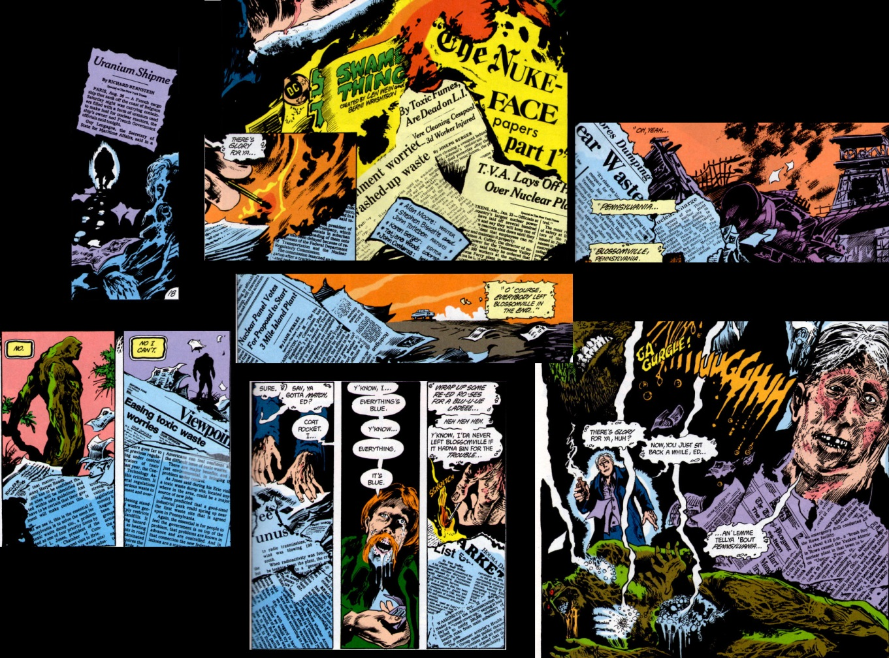

## Transitions

Moore spends a lot of time discussing transitions. His concern, seemingly above all else, is that a bad transition will break the spell under which he has placed the reader. As a result, much of his work shows an attention to this point.

His approach is to think about storytelling in units of a whole page with the transitions linking the pages together. The most common linkage is verbal, where the same word is repeated between the last panel on one page and the first panel on the subsequent page. Often the word is used in different context or with a different shade of meaning, thus mimicking the way the brain connects disparate notions of a word together to create humor or double entendre.

The following image is a transition between pages 21 and 22 in #Issue 25.

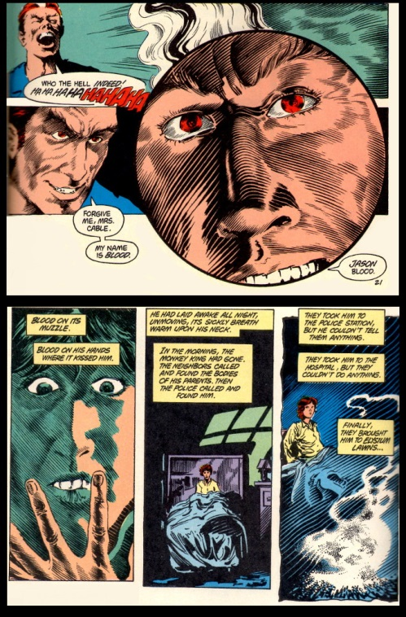

Note the use of the word “blood”, first as a last name, second as the substance, to link to different threads together.

Verbal transitions also provide larger linkages. The following example comes from pages 11 and 12 of Issue #26. The first two panels come from page 11 and are in the relative orientation on the page; the first one being on the top left, the second being on the bottom right. The word “believe” links the change in mental state of Abigail as she ponders what a young man has told her. The word “believe” also links her realization to her subsequent discussion with her husband Matt (note Matt is soon after done away with to make room for the Abigail-Swamp Thing romance).

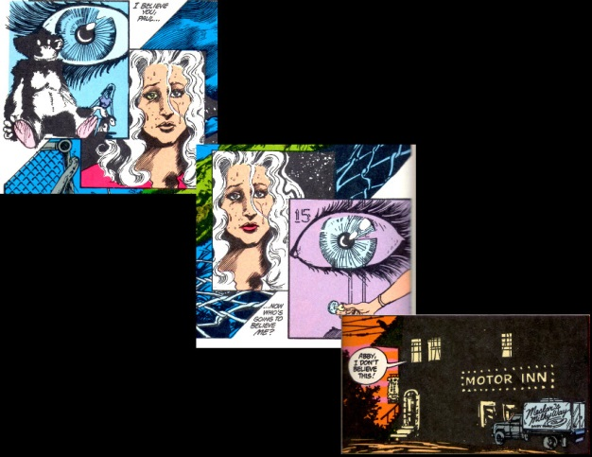

Transitions can also be used to provide linkage between larger entities. This is the well-known ‘cliff-hanger’ end to comics where a scene at the end of one issue is essentially the same as opens the subsequent one. That said, the transition between issues #30 and #31 with the Swamp Thing holding Abigail’s body is particularly well done.

Structure and transition meet in Issue #30, where the gimmick is also the transition. In this issue, a denizen of hell has escaped and returned to plague the living. Whenever this “returned man” smiles or chuckles or whatever and somewhere in the world someone commits evil and madness. The clause “the returned man smiles…” and the following “… and…” provide transitions and structure for the majority of that issue.

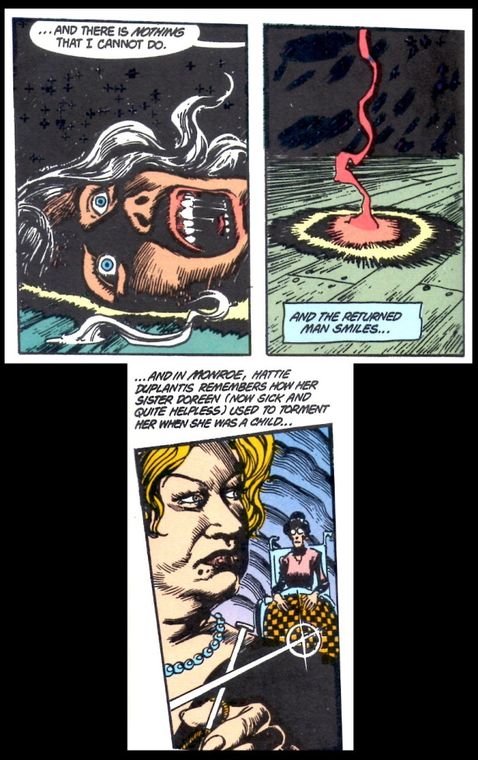

Finally, one of my personal favorites is the almost humorous juxtapositioning of the word “lines” in the transition between pages 16 and 17 of Issue #41

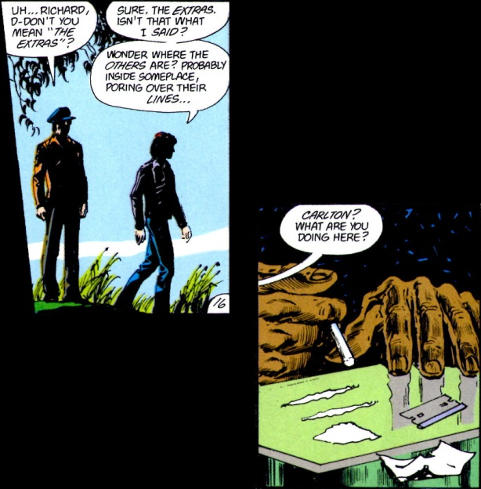

## Pacing and Flow

Since Moore is writing a horror/suspense story in Swamp Thing, setting atmosphere and mood is essential. This is done predominantly by slowing the pace of the stories down and focusing on the sensations or psychological implications of the events. Often, a deliberate pacing is achieved by interleaving stories about ‘the inside’ and ‘the outside’. The inside shows the internal mental state of the character, often in confusion or madness, and its inclusion allows for a slow build-up in tension without ‘filler’.

It also allows for more bizarre scenes with a dark humor that adds to the creepiness rather than detracts from it the way conventional comedy would. As an example from Issue #22 is the internal madness the Swamp Thing endures after he discovers that he has been living a lie by thinking he was a human transformed into a monster.

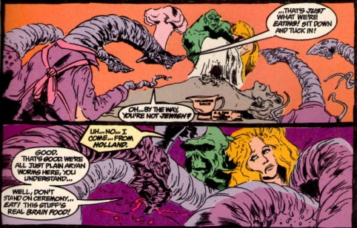

Note the word play of “planarian” and “plain Aryan” and the reoccurring theme of eating.

Sometimes, Moore and company do need some filler to round out the page count. Even in these cases, they manage to use it to good effect as in the very bizarre and horrific accident that ends the life of an insurance salesman when he is impaled by a sword fish. This sub-story fills 3-4 pages of Issue #25 and offers again some black comedy that serves to heighten the horror. It also provides a very nice transition (pages 14 & 15)

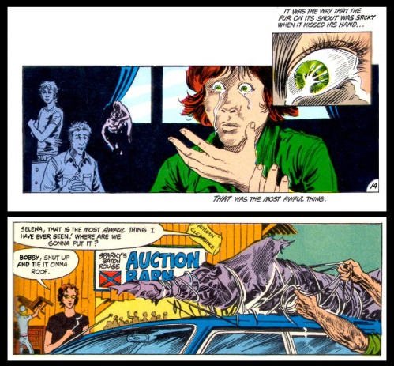

## Plot

As discussed last week, Moore claims that the plot is often the least important piece. But is that claim really true in practice rather than just in theory. I believe the answer to be yes. As a horror/suspense writer Moore’s predominant interest is in setting mood. As a result, what happens is not nearly as important to him as how the characters feel about it.

As a very clear example, consider the content of Issue #28, entitled “The Burial!”. The whole issue is devoted to the Swamp Thing coming to peace with the fact that he is not Alec Holland. The plot of the entire issue can be summarized in one sentence: Swamp Thing digs a grave for Alec Holland, finds Holland’s remains, puts them to rest in the ground, and come to peace with his existence.

Moore chooses the elliptical story structure here, starting with an empty grave

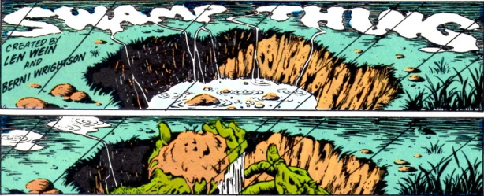

and ending with burial mound and the resulting peace.

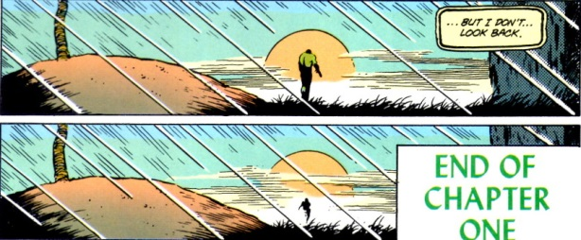

The above 4 panels constitute a small fraction of the 135 panels found in the issue. The remainder of the space is spent on finding Hollands remains both physical and psychological and how the Swamp Thing reacts to this.

Many of the other issues fare similarly and it is reasonable to regard Moore and being more in line with Poe or Lovecraft in his approach to storytelling. His focus is almost always on the character and not on the events surrounding them.

## Conclusion

So having toured Alan Moore’s work for the past 3 weeks, what to make of it? I think there is no denying that Moore is talented and that he is a consummate professional in his craft.

He clearly has mastered some basic, compelling approaches to sequential art and uses them to great effect. However, I can’t escape the feeling that there is a sort of glamour, in the traditional fairy sense, about his work. That style exceeds substance and that impressions and feelings dominate events. In real life, events matter, results are important, and talk is cheap. While I admire his work I judge that much of his storytelling is more like a dream. Once the sleeper awakens the particulars fade but the feelings remain.

# Story Construction 7 – The New Marvel Way?

After the rather heavy analysis of Alan Moore over the last three weeks, I thought I would take a look at a lighter presentation to the approach to comic book creation found in the back of the 2005 Free Comic Book Day offering from Marvel Comics.

Tucked in the back of the issue, after a story involving Spider-Man, the Fantastic Four, and the Chameleon, is a short 8-page crash-course in the mechanics of creating comic books by John Barber.

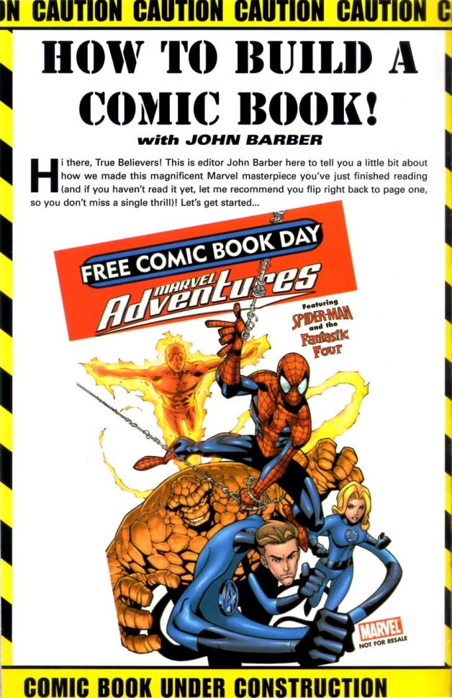

Using the short story that preceded it as a guide, Barber’s treatment focuses essentially on one page, discussing how the page is transformed from script to finished product through a number of steps. In a nutshell, these are:

* Creation of a plot/script
* Generation of rough thumbnail sketches showing panel configuration and action layout
* Detailed penciling based on the thumbnails
* Inking of the penciled page
* Coloring of the inked page
* Lettering and captioning

For the most part, the creation of the plot/script is not covered. No details are given about how the creator gets started, what points should be covered in the writing, how to pace the panels, or any other details.

Barber simply provides the bare-bones description of what a plot/script is and, despite its brevity, this description is actually quite revealing of his point-of-view on the creative process and the writer’s role. Specifically, he says that the script is the writer’s way of describing each and every panel via the panel description, which provides a verbal summary of the image the reader will see, and the dialog, which contains what each character will say (and I suppose what captions, if any, will be used to provide exposition).

As way of an example, the following page of script is offered to describe a particularly action-packed page in the story.

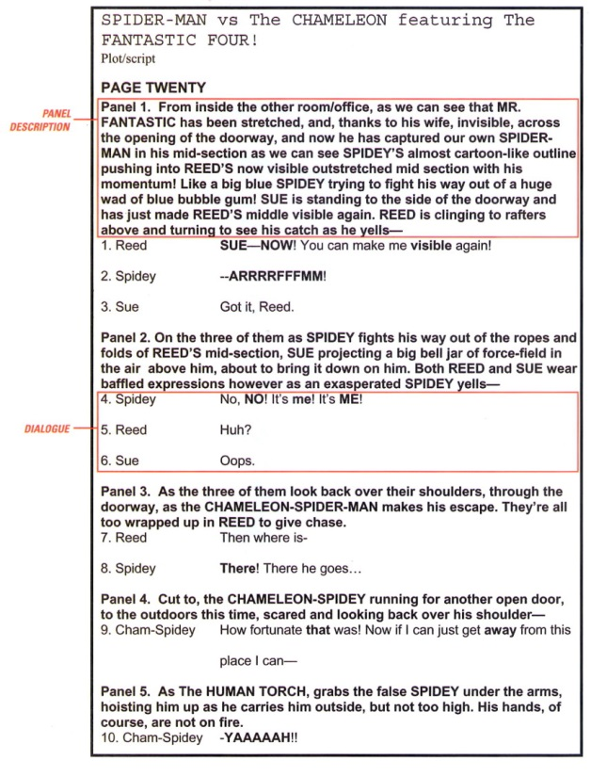

Barber characterizes the panel description as the writer’s method for telling the artist “who’s doing what (and sometimes why!).” This terse and seemingly innocent sentence suggests that Barber is endorsing a method that is very much like what [Gaiman presented in his ‘behind the scenes’ look at the creation of Sandman](http://aboutcomics.blogwyrm.com/?p=404). The emphasis is on the writer calling the shots in the story-telling and it is from his mind that the visuals come. The artist’s job is to render the scene for the writer, according to the writer’s conception, with small visual changes either due to aesthetic or to technical details, but with little input on the overall storytelling structure.

Admittedly, this is a lot to read into a few sentences, but given that this ‘how-to’ was part of the Marvel Free Comic Book Day offering in 2005, a showcase for Marvel creativity, and that the refined tastes of the modern young reader are more visual now than ever before, I think that it speaks volumes.

Further evidence of a writer-centric approach can be found in narrative that accompanies the four figures presented in the later pages showing how the writer’s description transitioned from thumbnail sketches (a), to pencils (b), to an inked page (c), and finally to colors and letters (d).

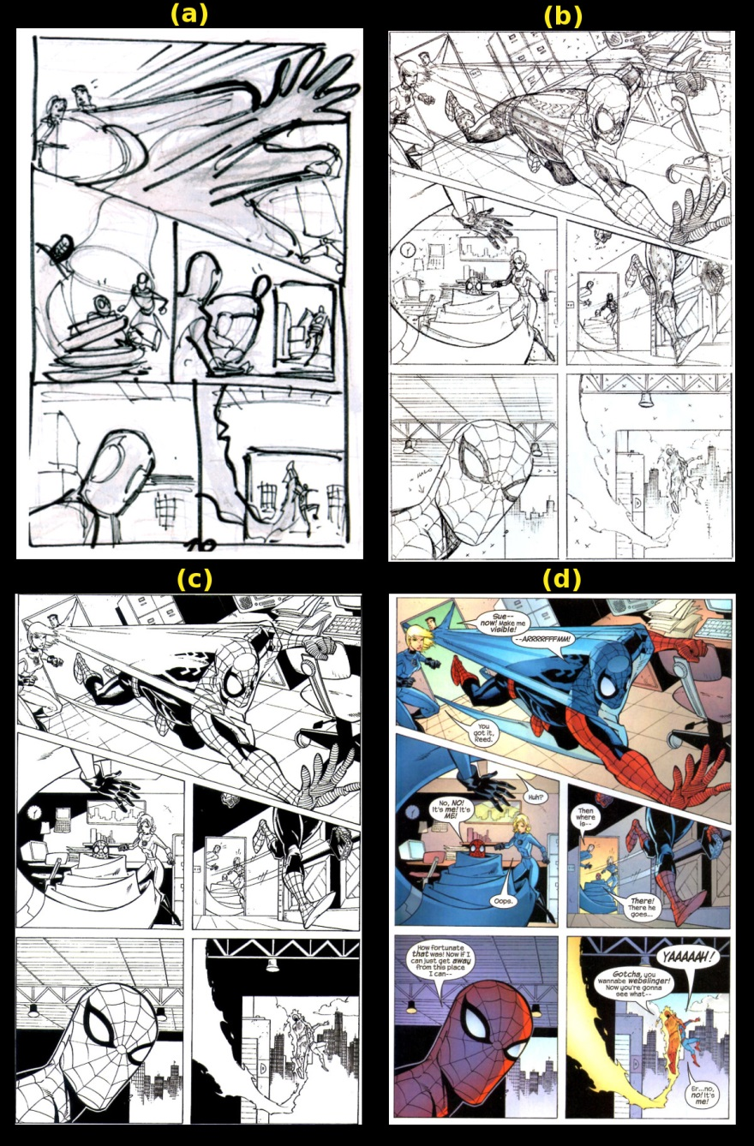

According to the text, the thumbnails are produced by the artist and then sent to the editor (in this particular case, Barber) for confirmation that the rendering is following the writer’s plan and leaves ample space for dialog and captions. After the editor gives his approval, the artist produces pencils that mostly match the thumbnails, although a side-by-side comparison of panels 1 and 3, show that the artist has changed the composition from the original conception. However, the artist doesn’t deviate, even in this case, from the panel description originally proposed by the writer.

Consider panel 1 that has changed most from the original thumbnail. In both compositions, the basic idea is preserved as can be seen by comparing the final panel version directly with the panel description provided by the writer.

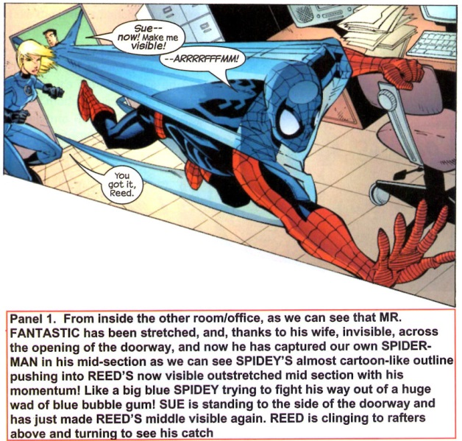

Barber does touch upon a more collaborative component to this work when he discusses panel 1 during the inking step. He says that the action is pretty complex and that to make it clear “we put our heads together to figure out how to make the panel work.” The result of this collaborative group-think was to omit certain details of Spider-Man’s costume as being obscured by the mid-section of Mr. Fantastic as he begins to turn visible. Again, this input on the story-telling is confined to technical details of the visuals but doesn’t touch the story or plot itself.

What’s most remarkable about this presentation is the implication that the artist’s job is to render the writer’s concept – not to embellish or change it. I am sure that embellishment does happen but when and under what circumstances it occurs is not touched upon. I must admit that I found this ‘21st-century’ Marvel way surprising after many of the traveler’s tales I have heard at various conventions and Marvel’s own press about the central role of the artist in the storytelling. Perhaps the most well-known example that Marvel has presented about the impact of the artist on the story is famous page 12 from X-Men #57 where Neal Adams as the Beast falling from the roof of a skyscraper.

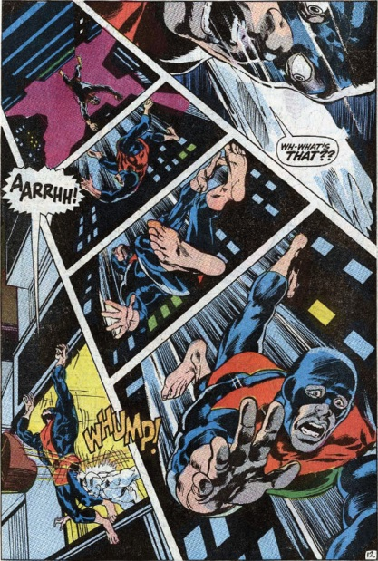

They had sold this as a basic component of the Marvel Way in the 1970s through the 1990s and the pinnacle of this approach was reached by the style-over-substance, artist-centric nonsense of the mid to late 90s that resulted in the mass exodus of ‘talent’ from Marvel to Image.

I suppose that if Barber’s brief exposition is to be held up as the Marvel standard then the pendulum has swung the other way and maybe that’s all for the best. After all, as the early Image comics proved, there’s only some much eye candy a reader wants before they crave a more filling helping of solid stories.

# Story Construction 8 – The DC Way: Single Issue

This week’s column turns its attention to ‘The DC Comics Guide to Writing Comics’ by Dennis O’Neil.

Denny O’Neil is perhaps best known for his Green Lantern/Green Arrow stories from 1980s. These tales brought a new level of maturity and social relevance to comics as they continued to struggle to regain the ground lost during the retreat in the 1950s. They also made Denny O’Neil a bit of a household name, at least in comics circles.

O’Neil is a somewhat old-school in his approach and his descriptions and, frankly, it is actually quite nice. He has a customer focus that I like. He seems always to be oriented towards selling a story to his readers, not because he is a crass peddler of so-so melodrama that he has no investment in but rather because he seems to really care about telling stories. To wit, he opens the book with a very nice sentiment about stories:

“Make me laugh. Make me cry. Tell me my place in the world. Lift me out of my skin and place me in another. Show me places I have never visited and carry me to the ends of time and space. Give my demons names and help me to confront them. Demonstrate for me possibilities I’ve never thought of and present me with heroes who will give me courage and hope. Ease my sorrows and increase my joy. Teach me compassion. Entertain and enchant and enlighten me.”

That said, he does tend to wander a bit and key observations are sometimes located far from related points. In addition, the overall composition of the book is a bit disorganized, which is a bit ironic, as will be discussed below.

For O’Neil, a story is a structure narrative that should resonate on at least one of three fronts; a story should have an emotional effect, demonstrate some important point, or explore a character (hopefully all three).

Having established that his goal is to help the reader tell a story that hits one of those points, the rest of the work is devoted to how might the would-be writer accomplish such a task. The book is divided into two parts. The first and largest part concentrates on delivering the story within the confines of a single issue. A point that only becomes apparent near the end of part one (last paragraph actually) when he finally says that everything up to this point deals with writing a single, self-contained issue. The second part deals with mini-series, graphic novels, maxi-series and crossovers, and ongoing, interlocking series. Some of the most interesting tidbits are found in this part but for now I’ll be reviewing and summarizing Part One this week. Next column will cover Part Two.

Stylistically, Part One is crafted more like having a dinner conversation with an old friend who you haven’t seen for a long time. The narrative flows back and forth between interesting anecdotes and the exposition of general principles. Overall, it is reasonable to say that O’Neil covers three main areas: Story Structure, Techniques, and Practical Advice.

## Story Structure

In Part One, O’Neil provides a quick-and-dirty list of story structure – or at least he thinks he does. Actually, the list seems to be made up of only two entries: One-Damn-Thing-After-Another and O’Neil’s Heavy-Duty Single-Issue Structure.

The One-Damn-Thing-After-Another is listed more as homage to the early works where the action came fast and furious. The plot, defined as the time ordering of events, was central at the expense of story and so the writer is encouraged not to use it except perhaps in rare and controlled circumstances.

The rest of this chapter is spent on the Heavy-Duty Single-Issue Structure. What O’Neil defines as the essential attributes for this structure can be succinctly summarized. The structure consists of 3 acts.

Act 1 opens with a hook, possesses an inciting incident, and establishes the situation and conflict over the McGuffin (what the hero and villain are fighting over). The hook should be an action scene, pose a question, or present some type of danger. It should never be used solely as an establishing shot and never be wasted on an inanimate object.

Act 2 develops the current situation by laying in complications which take the plot in a different direction. It should also have major visual action.

Act 3 contains the events leading to the climax and includes another dose of major visual action. It should close with a denouement that returns the old status quo or establishes a new one.

## Techniques

One of the many travelers’ tales that O’Neil treats the reader to is a discussion about just how Stan Lee handled the large work load he had in the Marvel early day. As the story goes, Lee would often simply confer with his experienced artist partners, Jack Kirby and Steve Ditko, discuss with them the bones of the plot, and then trust them to deliver on the pacing and art against which Lee would write the narration and dialog.

This approach forms what O’Neil calls the Plot-First approach to story structure. Since few of us are either Lee or Kirby or Ditko, O’Neil suggests that the approach be started with a plot typed up in a few paragraphs and sent to the artist who then returns about 125 panels for the writer to add the written word. He lists three advantages that the Plot-First approach affords:

* Writer can fix omissions in the after the fact
* Writer can be inspired by the art
* Writer can be lazy/efficient

In the first point, O’Neil is explicitly recognizing that the comics art form is still a business with a customer base that expects product out on a regular schedule. Mistakes happen and he is acknowledging an advantage that makes meeting a deadline easier since the writer can adapt the story to the art rather than the artist having to go back and fix the panels. Likewise, the third point is also deadline-oriented, allowing for the possibility that the writer may be engaged in other and equally important activities. Only point two is devoid of any sense of managing deadlines and is solely focused on the quality of the product itself.

In contrast to the Plot-First approach, O’Neil offers the Script First approach. Here the comics writer is far more akin to the writer of a movie or television script. Each ‘shot’ is detailed along with the basic flow and tempo. He also lists three advantages of this method:

* Writer in full command of the story
* Writer can change the story quickly since rendering isn’t started
* Writer is in charge of his deadlines

O’Neil clearly regards this approach as the one that put the writer closer to his art or craft. Nonetheless, he never lose sight of the practical considerations that enable the writer to efficiently work with his artist (point two) and his career (point three). He does suggest that a writer who employs the Full Script technique try to sketch the layout before submitting the final form. He cites Archie Goodwin and the success he had following such a practice.

## Practical Advice

Perhaps the greatest strength of this work is the tidbit of practical advice that O’Neil peppers throughout the discussion. There is structure for when they appear or how they connect. Instead they seem to occur when some piece of the structured presentation triggers them and they form the anecdotes mentioned above.

As a result, there isn’t really any point in building a grand narrative to house them and so I’ll simply list the ones that captured my attention.

* Don’t underestimate the importance of the splash page for setting the mood, establishing the story, and easing the reader into the story. O’Neil is against the modern practice of pushing the splash page to later pages.
* Captions are to be avoid when dialog balloons will suffice. O’Neil cites one editor who believes that many readers even skip the captions and he further cites the notion that nothing grabs a reader’s attention as much as ‘listening’ to what a character has to say.
* Know the end before you write.
* Start scenes at some point of interest (skip the mundane). Nobody want to see the characters get up and brush their teeth (unless, I suppose, an assassination attempt occurs just at the moment they start to gargle).
* Generate rising action by ratcheting up the tempo.
* Distinguish between surprise and suspense. Used here, the two terms are antonyms with suspense being preferred since surprise only shocks the reader for a few panels (before the understand) whereas suspense builds over long periods of time as they know generally what is going to happen but not how.
* Never write a panel or scene that doesn’t contribute to the plot.
* The hero must be agent of the story’s resolution – he must act and be involved (even if he is the anti-hero)

On piece of advice is worth particular attention. O’Neil stresses that the exposition be clear. Writer’s must go out of their way to ensure that the reader is following. For example, the writer must make flashbacks visually delineated from the normal flow. The reason for this emphasis is best understood in O’Neil’s own words

“I emphasize clearly [telling your story] because one of the reoccurring and embarrassingly valid criticisms of modern comic books, particularly the adventure and fantasy titles, is that they’re extremely difficult to understand on the most basic level”

Ironically, things are not always clear in his exposition in this work. For example, the layout between pages 22-23 obscures the connection between the textual and visual ordering of the mechanical steps of page construction (i.e., script, pencils, inker, letterer). The text calls each out in the traditional order but the visuals aren’t labeled. Elsewhere, what appears to be a visual example of the Full Script technique is juxtaposed with text talking about Plot-First.

# Story Construction 9 – The DC Way: Multiple Issues

This is the final installment of the review of Denny O’Neil’s ‘The DC Comics Guide to Writing Comics’, covering Part Two dealing with his techniques and advice for handling longer forms.

One of the shortcomings of ‘The DC Comics Guide to Writing Comics’ is that O’Neil dumps a great deal of information into Part One on the single issue that is more logically housed with the longer form techniques. Much of the information that rightly belongs in Part Two deals with characterization, world building, and the techniques needed to fill and to manage page counts that are much larger than the standard 22 pages of glory found in a single issue.

His point-of-view on this can be roughly summarized to say that if the writer can handle the single issue well, he will have the skills and disciplines needed for tackling larger works. While I understand and appreciate this sentiment, it seems likely that O’Neil has developed this perspective from his experiences writing single issues for a pre-existing universe (Marvel and DC) and with pre-existing characters and series.

It is doubtful that a single comic covering an unknown world and sporting characters that are completely unfamiliar to the reader can meet the ‘Heavy-Duty Single Issue’ structure he advocates while simultaneously allowing the writer the space needed to build drama, interweave subplots (what would a subplot do in a single one-off issue anyway) and explore each character.

Had I been the editor, I would have structured Part Two on the longer form to cover building drama and building product, but alas I can only propose this structure after the fact. So in that spirit, let me review O’Neil’s advice in these two categories.

## Building Drama

As mentioned last week, O’Neil is always conscious that he has a readership that he must attend to; a customer base whose desires and needs he must always be meeting. It is from this perspective that he tackles the concept of drama.

He basically defines drama as the conflict over the [McGuffin](https://en.wikipedia.org/wiki/MacGuffin), a term popularized by Alfred Hitchcock that means the thing over which the protagonist and antagonist are fighting or the device which triggers the plot. As discussed last week, O’Neil is all about rising action. Any effort that distracts from the main thrust associated with the McGuffin is wasted because it actually blunts the ‘emotional arms race’ he is trying to cause. Because of this focus on rising action, he favors the idea of suspense over surprise. Suspense clues the reader in to what is going on and allows the reader to anticipate what comes next for as much of the story as is possible, even if the characters within the story are ignorant.

For the long form, the tensions associated with the McGuffin play out over a larger page count and longer time frame. So it is natural to really take the time to explore the characters in the story in a way that the short form simple can’t accommodate. Doing so not only makes the reactions to the McGuffin more real, since they have a foundation, but it also prolongs the suspense thus improving the climax.

So exactly how should the writer explore his characters? The central questions that need to asked and, at least partially, answered for this discovery are:

* what does each character desire and wants does each have
* what does each love or cherish
* what does each of them fear
* what motivates them

These questions apply equally well to all characters in the story, even if they are not answered so thoroughly with the minor ones as for the major ones and, perhaps, most importantly, answers to these questions are vital for understanding the villains rather than the heroes. O’Neil’s ideas on character are that their actions speak louder than their words. So I suspect that he would recommend that a writer address each of these questions with an interaction (verbal, physical, cosmic, etc.) rather than with captions or dialog. Unfortunately, he doesn’t explicitly state his preferred method of tackling the inner state of the character.

But he does link characterization with subplots and states the subplots are good ways to introduce additional facets of the character’s lives. Being the consummate business man, O’Neil sees subplots as also serving additional the duty in the long form of setting up and sustaining prolonged readership but cautions that their use must be done with an eye towards the maxim that each comic book is somebodies first.

## Building Product

Once the general idea of how to build the drama in the long form is decided upon the next point to work on is how big will the long form be? O’Neil distinguishes between 5 different types of long form work:

* Miniseries – between 2 & 6 issues with a definite story
* Graphic Novels – single publication with a much longer page count
* Maxiseries – usually 12 issues serving a grand or epic story line; crossover event
* Ongoing Series – standard uninterrupted series
* Megaseries – something like a crossover event but engineered on a bigger scale

Each of these has its own strengths and pitfalls and the interested reader is directed to read the details for himself. Roughly speaking, O’Neil believes that they all can be tackled with the 3-Act structure he discussed in the single issue context. For larger works (except the graphic novel) each issue should have a 3-Act structure, a set of issue should then interlock to have a larger 3-Act structure, and so on up the line.

The graphic novel is more fluid in that the story starts and ends in one book so the burden of carrying a reader forward, to coaxing the reader into buying the next issue, isn’t there. Nonetheless, I suspect that O’Neil would be inclined to say that working from the 3-Act structure for a graphic novel would be fine too.

Subplots are also important in the maxi-, ongoing, and megaseries, as they allow for smaller pieces to be introduced, grow, and mature. Of course, subplots have been the staple of all serialized fiction for decades so much of what O’Neil has to say on these points should be obvious to all but the most inattentive watchers of ongoing TV shows or readers of serialized fiction. He does make a useful distinction between story arcs and what he calls the Levitz Paradigm.

Story Arcs, by his definition, are complete stories that cover multiple issues but which are connected to the ones before and after by only tenuous threads. There are definite jumping on and off points and a collection of multiple issues can stand on their own as a graphic novel after the initial run.

In contrast to Story Arcs, the Levitz Paradigm works with multiple overlapping story lines that grow from cold, to cool, to simmer, to boiling over. As one moves up the heat scale another is placed on the open spot and so on. With this technique, there really isn’t a jumping on or jumping off point. So if the readership can be hooked it will tend to persist.

One last note is worth discussing about the long form – continuity. Whether it is the demographics that are reading comics, the internet’s ability to serve up fast answers, or some other factor or factors, it is clear that audiences in all media desire continuity. O’Neil recognizes this trend and categorizes the types of continuity into three kinds which he labels ‘A’, ‘B’, and ‘C’ but which, for convenience, I’ll call, puddle, pond, and ocean.

The puddle type of continuity covers the basic notions that characters should not change names, or hair color, or other simple traits (without reason) during the course of a story. It is the simplest and smallest type of continuity and one which the writer should be maintaining. The pond continuity is a bit bigger and covers all the critical back story events of a character that may not be in play in the story being told but which must not be contravened. This type of continuity is important, although the writer may not be solely responsible for maintaining this one. The ocean continuity is the vast universal continuity that covers the shared universe that all DC characters inhabit. O’Neil doesn’t have much in the way of constructive advice for this last type of continuity and, frankly, who can blame him. Tangles in this kind of continuity have driven Marvel and DC to numerous reboots of their universes.

## Final Thoughts

Overall, I wouldn’t claim that the reader will get well-structured advice with a pedagogical touch from O’Neil’s book. There isn’t much in the way of a how-to or a best-practices. Rather, his book is like picking the mind of self-taught veteran for all those pro-tips that you usually get only one at a time when working side-by-side with an expert. It is from this point-of-view that the O’Neil’s work is best consumed.

# Story Construction 10– Peter David on Character and Theme

Starting with this installment, I’ll be reviewing and summarizing Peter David’s contribution to the canon of comic book story writing entitled *Writing for Comics & Graphic Novels*.

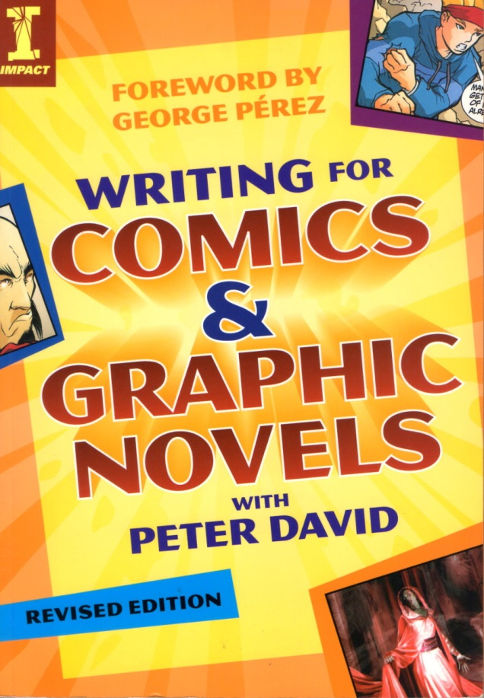

[Peter David](https://en.wikipedia.org/wiki/Peter_David) got his start in writing comics quite a bit later than most, beginning his career in the Marvel sales department before getting his break in writing some brief pieces for *The Spectacular Spider-Man* book. His real break came when Marvel assigned him to take over the writing reigns on *The Incredible Hulk*, which had been a lack-luster title for decades (perhaps not always in sales but most always in content).

David creatively re-imagined the whole incident that turned Bruce Banner into the Hulk as a manifestation of a multiple personality disorder stemming from childhood abuse, thus turning Bruce Banner into a comic book version of [Sybil](https://en.wikipedia.org/wiki/Shirley_Ardell_Mason). This approach not only revitalized *The Incredible Hulk* but it established Peter David as a writer of note and opened doors for him to write in other venues as well.

His strengths are focusing on characters and the small things details that make them seem real and believable. Not surprisingly, the first half of his working on comics writing is focused on character and theme. The second half deals with the more mechanical aspects of story structure, plot, and scripting. I’ll be looking at the first half in this post and followed by part 2 next week.

It is fairly easy to summarize David’s point-of-view on the comics writer by simply looking at what he has to say on page 15

Consider this simple fact: Writers are the only part of the creative team of a comic that begin with absolutely nothing. The penciler has the script with which to work, the inker has the pencils, the letterer has the dialogue, the colorist had the finished art, and the editor oversees it all. But the writer is the only one who must pull his contribution out of the ether, drag it kicking and screaming from the recesses of his mind and put it down on paper… so that everyone else can do his job. The writer can’t be bypassed.

David sees a lot of similarity between movies and comics since the writer must think visually when crafting both. He claims that the storytelling arcs and techniques he’ll cover in this work are applicable to both. This claim may be true but I doubt the overlap is a broad as David asserts. As discussed in earlier columns on Alan Moore, the comic affords the reader with the same ‘choose your own pacing’ and ‘wait let me review that’ features that written prose does and I think that makes a great deal of difference. Nonetheless, there’s no denying the strong visual component that both mediums demand of their writers.

In terms of characters, David believes that what readers want are characters to whom they can relate; characters that will cause them to make a personal investment of time and emotion. In his own words, a writer’s story stands or falls on his characters. However, he recognizes that the reader will often force an unrealistic consistency on a character – a kind of consistency that they themselves can’t live up to since their human. He also recognizes that there are times when, either by design or inadvertently, the writer has the character acting contrary to established norms. During those times, the writer must keep the reader ‘in the loop’, as it were, and provide some mechanism to clue the reader that the creative team hasn’t lost its collective mind, even if that mechanism is obvious as having the offending character acknowledge “I just don’t know what’s come over me.”

Peter David also feels that a story is not real or meaningful unless the conflict is real and balanced. No straw men arguments – all sides need to be meaningfully represented (even if not endorsed). I suppose a reasonable way of interpreting his thoughts are that everyone has reasons for what they do and the better stories present the motivations found on all sides. He summarizes this approach with the maxim: ‘Make Everybody Mad’.

One way that he presents for getting every side heard is to craft a villain who stands in opposition to the heroes perspective and then to give a credible reason for that villain to hold that view. This approach often leads to the villain not really being a villain but rather a character in opposition to the hero. So conflict between two heroes is a viable plot point and common occurrence.

Another ingredient for realism is to express the small things in a character’s life openly. The examples he cites are the Hulk’s love of baked beans and the Martian Manhunter’s fascination for Oreo cookies.

These humanizing details are one of my favorite facets of David’s work and easily his greatest strength. One of the best examples of this type of craft came while he was at the helm of X-factor. In issue #87, he found a way to make Quicksilver truly memorable as a character. Up to that point, the Marvel speedster had always been either whiney and unsympathetic or sinister and unsympathetic. In one fell swoop, David managed to reinterpret Quicksilver’s entire past in one easy to understand scene

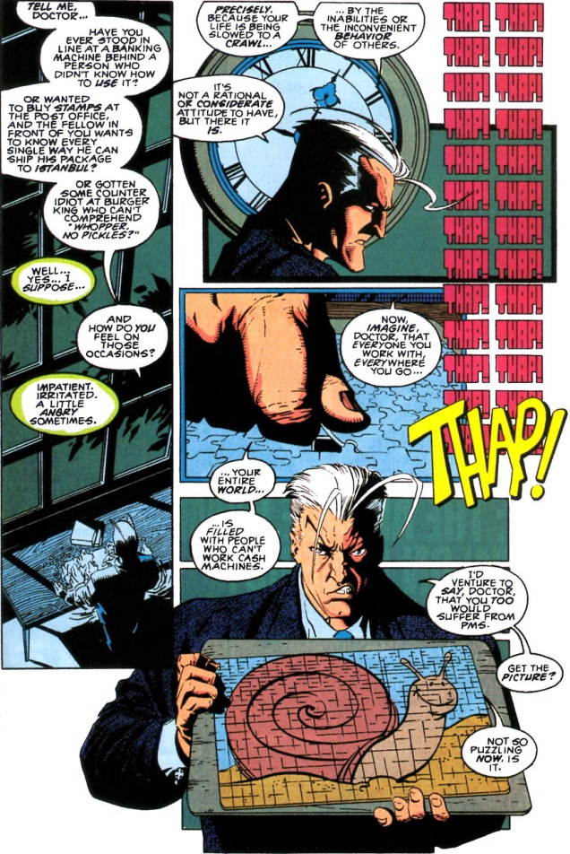

I recall this very scene as vividly today as when it hit the streets in 1993. In my opinion, it is the textbook example of what can really be accomplished in the comics medium; a method of storytelling that could only be done in a comic.

The other key component of the first half of his book is David’s universal analysis of stories and their relation, through conflict, to theme. At the most basic level, he views all stories as being able to be described in terms of what he calls three fundamental conflicts:

* Man against man
* Man against self
* Man against nature.

Since all drama is conflict, he views that these three archetypal forms as the building block for drama. And the purpose of the drama is to flesh out a theme. The conflict illuminates the theme. Here, David provides a concise anecdote to describe his terminology.

“Your theme is that aspect of the human condition that serves as the spine of your story, and as many elements of our story as possible serve to illuminate that theme. … What’s *Spider-Man* about? Well, the plot is about Peter Parker getting bitten by a radioactive (or genetically altered, take your pick) arachnid and being transformed into a human spider. But the theme is, “With great power comes great responsibility.””

How the writer actually reveals the theme is a delicate endeavor. And even what could be thought of as a clearly elucidated theme is always subject to the final interpretation of the reader. Nonetheless, the writer has to have a well-defined theme, so that, even if others disagree about the interpretation, they still agree about the general notion. For example, if the theme is about ‘with great power comes great responsibility’ then the drama should focus on showing the conflict between a duty-bound hero and his long-suffering wife who complains that the extra time he spends on his job should be spent with her.

Specific techniques that David advocates for managing conflict include:

* Tapping into family matters – father & son, mother & daughter, etc.
* Keeping the conflict small – small equals real
* Allow the characters to gaze in disbelief at the outlandish things happening to them – maintains reader buy-in
* Outfitting a hero with a personal weakness to accentuate his struggle with himself
* Try to generate a mix-and-match, six-sentence precis as a prelude to a full story.

Of course, there are lots of fine points that I’ve omitted and some very interesting exercises that are worth examination. But on the whole, the first half of David’s book is fairly structured with him emphasizing and re-emphasizing the same points about character, conflict, and theme discussed above.

Next week, I’ll finish my review of his book by covering the more technique-focused second half of the book on plot and scripting.

# Story Construction 11– Peter David on Plot and Script

This week’s column completes a two-part study of the work *Writing for Comics & Graphic Novels* by Peter David.

David defines the plot as having two aspects. The first is the development of the hero as an individual. The second is the events that serve as a vehicle for that development. This later piece is called the plot.

According to David, the plot doesn’t necessarily require choice from the character. For this he cites the movie The Terminator which forces Sarah Connor to grow up. I find this somewhat hard to swallow, as Connor always had the choice to just lay down and die rather than stiffen and fight back. I interpret that he is trying to say that whether the character is predestined to be subjected to a set of events or that the character’s choices shape those events is not important. What is central is that the character evolves inside as the events evolve outside and that it is this internal evolution that readers find compelling.

On plot pacing, David suggests that all scenes be trimmed down to the essential information. To this end, he advises, like O’Neal, to start and end on the action, whether that action is physical (i.e. a slug fest) or mental (i.e. a test of wills) or emotional (i.e. a fight between husband and wife).

Like Moore, David also advocates for connectors (as he puts it) between scenes have a thematic overlap, like using the same words, albeit in different contexts, to end one scene and begin the subsequent one. Another feature that David advocates in common with Moore, is to end a scene at the end of a page where possible.

At its most basic level, the story structure that David recommends is one that is a combination of ups and downs (roller coaster) superimposed on an overall rising action to the climax with a small release at the end for the denouement.

To this end, he offers the three-act structure is a good model. Unfortunately, he defines the essential pieces of the three-act structure using the movie the Karate Kid, which makes it a bit difficult to understand the theory as a whole (unless you know the movie exceedingly well or are willing to watch and rewatch as you read his books). As near as I can render it, David defines these essential pieces as:

* First act used to introduce the setting and cast
* First-act turning point where the essential problem is introduced
* Second act used to define the stakes of the problem and intensify the tension
* Second-act turning point where some complication arise or where the hero gets some insight into what lays before him
* Third act where the problem resolution crystalizes into a simple choice
* Climax where the here chooses and the problem is resolved one way or another

As a textbook example of the three-act visual storytelling, David proffers issue #51 of the Fantastic Four. Since it was a standalone issue, it was easy enough to dissect, and David includes many of the pages from that issue to illustrate the main points. I’ll try to summarize them verbally and visually, although it should be noted that I draw the line between the second act turning point and the third act differently than David.

* Act 1 establishes the situation. We start with the Thing standing in the rain and feeling sorry for himself. He eventually meets a mysterious man who invites him in out of the rain and who, through some heavily drugged coffee manages to get the Thing to fall asleep.

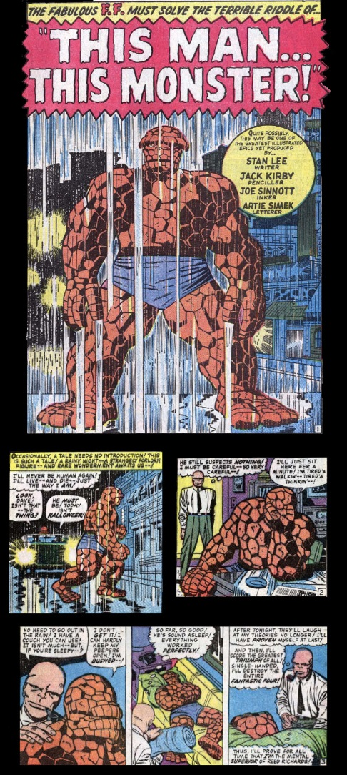

* As we near the end of Act 1, the turning point is reached where we now see that the mysterious man (called the Changling) is going to steal the Thing’s powers in order to exact revenge on the Reed Richards

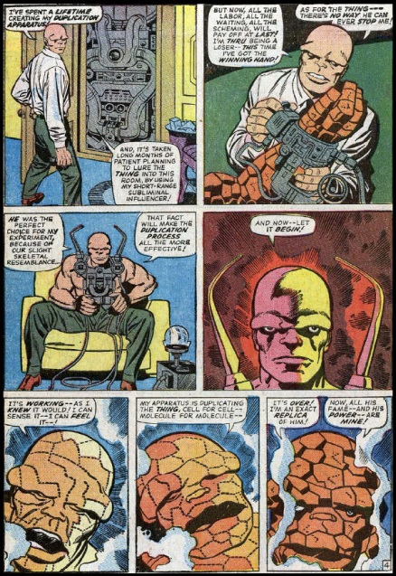

* Act 2 deals with the consequences of this switch. Being able to pass himself off as the Thing, the Changling infiltrates the Fantastic Four and suspense builds as his plans for revenge go unnoticed by everyone but a now all-to-human Ben Grimm.

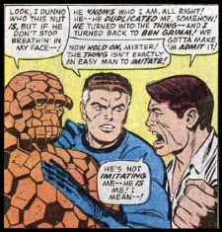

* Act 2’s turning point comes, when the Changling finds himself able to affect his revenge simply by inaction. Reed Richards, having invaded sub-space, approaches a region where all the negative matter, including him, is being annihilated with positive matter. Reed will be destroyed if the Changling doesn’t reel him back in with the tether, one end of which is attached to Reed’s suit and the other is in the Changling’s hands.

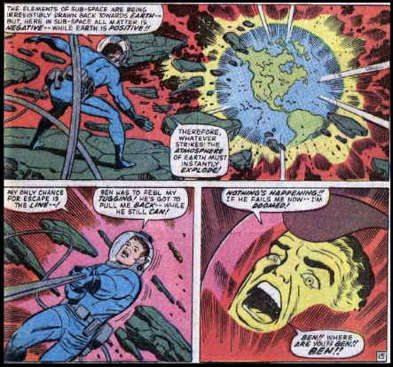

* Act 3 plays out when Reed’s tether breaks and the Changling and a horrified Sue watch as Reed plummets towards certain doom (that is actually an oxymoron in comics but never mind that now). The Changling has s single choice to make. Do nothing and reap his reward as Reed dies or make an effort to save the man he has hated for years. Here the thought balloons scripted by Stan Lee show the Changling’s internal conflict.

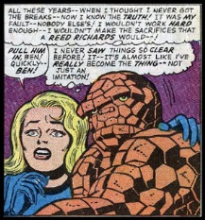

* The Climax comes when the Changling decides to save Reed’s life at the expense of his own.

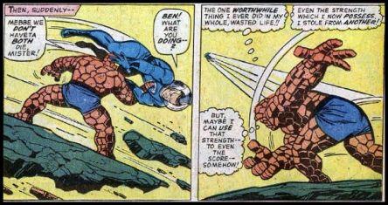

The clean-up and denouement of the story re-establishes the status quo until the next issue where it is disrupted all over again.

As a side note, it is interesting that David mocks the standard plot construction put forward by Jim Shooter (although he doesn’t cite him by name) that the poem Little Miss Muffet was a perfect form of storytelling as it has all the needed elements:

* The set-up or the establishment of the status quo (“Little Miss Muffet sat on her tuffet, eating her curds and whey)
* The action motion (“Along came a spider and sat down beside her”)
* The reaction and resolution (“And frightened Miss Muffet away”)

David also discusses at some length the idea of having intersecting story lines that rise and fall independently when they are not overlapping each other. I found this discussion a bit hard to understand in practical terms but I suppose that it comes with practice.

Finally, David has a detailed section on the mechanics of the script writing. Here he is also not markedly different from the earlier works examined. He cites the two conventional approaches: Marvel Style and Full Script. However, his coverage of these two approaches is far more detailed than either O’Neal’s or Moore’s work. In addition, he offers a comparison and contrast between the two methods using his Spy Boy comic.

Marvel Style

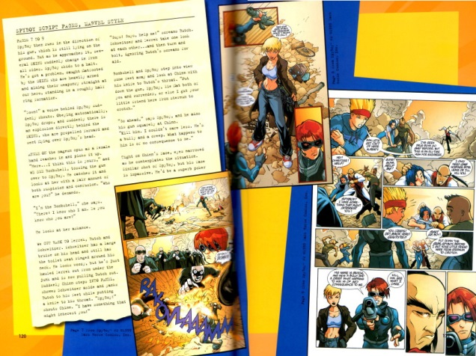

Full Script

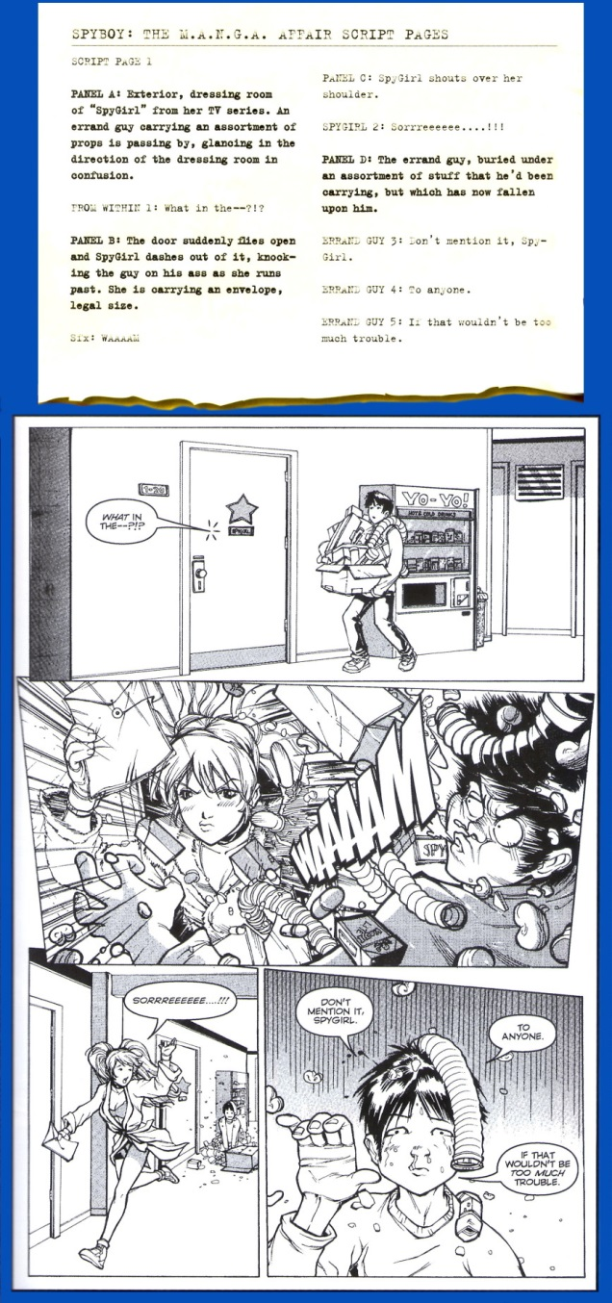

Finally, and a bit surprisingly, David discusses the stylings and placement of word balloons. Most of what he says here is not found in any other work and it was refreshing to see this point dealt with in such detail. Once again, he provides practical examples explaining the how-tos including this presentation from The Incredible Hulk #424.

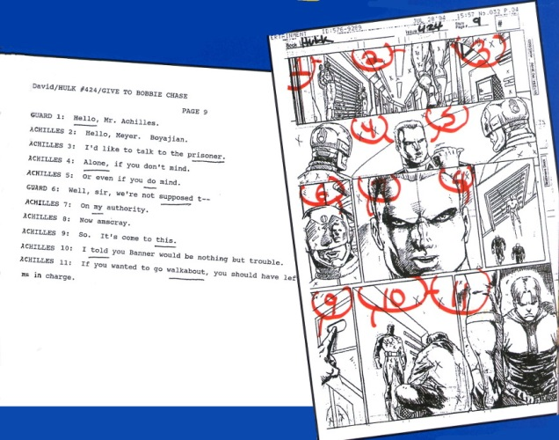

Overall, I’ve found David’s book to be the best of its kind so far reviewed. It is a good read, fun and easy to get through and filled with information unavailable in either scope or detail in any of the other works I’ve reviewed so far.

# A View From a Con

This week’s column is a departure from the ordinary thread on comics creation that had been the focus for the last few months and, instead, deals with that once-a-year happening of attending the Baltimore Comic Con.

Last weekend, I headed north to the Baltimore Comic-Con with three friends to check out the lay of the land.  Despite the fact that the usual state of the average Maryland driver sits somewhere between distracted and negligent, the trip on the highways and byways of the Free State was accomplished without incident or even a close call.  Parking was also fairly easily settled at the lot just behind the Days Inn.  A short walk later found our party just outside the Convention Center.

Surprisingly, there really wasn’t anything in the way of lines and it was only a matter of few minutes before we received our wrist bands and were heading in.  The majority of the action at Comic Con happens in the lower level of the convention center where the vendors, comic creators, and independent artists, creators, and associated personnel have their tables set up. The upper levels are setup for panels.

In the course of wandering through the crowd that showed up I came away with a variety of impressions; most good, a few bad.

First off, the overall state of the con had a real family feel. The number of small children present was amazing to me after the usual state of affairs at Anime conventions, where the target demographic is more focused on the slice of our population from older high-school students, to college-age attendees, and the proverbial young adults. It was a common sight to see parents and children cosplaying together and that was also stood in sharp contrast with the usual Anime program. There were several Raven cosplayers who were in their earlier teens at about the time many kids get shy these girls felt that they could express themselves. In addition, there was a kid’s area in the lower level where the attendees could do some arts and crafts led by a comics creator. I didn’t really see much of this but I sat in on [Andy Runton](http://www.andyrunton.com/owly/)’s drawing lesson and it was nice to see his interaction with the kids and his encouragement and coaching about drawing.

Another really nice observation was that the quality of the cosplay was quite splendid. I didn’t take many photos but there was a nice couple who came dressed as Hawkeye and Black Widow

They were really friendly and chatted with my wife and me for a while about how they assembled their costumes, where they found their props, and how long it took for them to get it all together. The repurposing of common household items that ‘Hawkeye’ did to make his quiver was impressive.

Equally impressive was the fellow who came dressed as the Man of Steel version of Superman.

It was uncanny how well he ‘nailed it’ in costume, look, and overall how he carried himself. He was also very friendly.

In the vendor’s area, there were the typical wheely-toting fanboys carrying their latest prized-find in large suitcases from setup to setup. Despite the lack of social graces, generally they were well-behaved and tried to avoid running you over with their rolling treasure chests. The vendors were engaging and quite a few went out of the way to find or search for things. So overall, a real plus there.

The most unusual table was manned by a guy who works full time at the NASA Langley Research Center in Virginia. His table, which boasted screen snaps from 3-dimensional renderings of some of NASA’s most experimental aircraft, was actually devoted to his doctoral research. I’m not sure what degree he was pursuing but it clearly was in one of the psychology-related fields based on the questionnaire that he asked con-goers to fill out. The subject of the questions was the responder’s attitude to the mental state of Bruce Wayne versus Batman. Is Batman the dominant role and Bruce Wayne a mask? Is it the other way around? Is Bruce crazy? Things like that.

This guy wasn’t the only NASA presence at the convention. Numerous people had NASA paraphernalia on – NASA tee-shirts, NASA pins, etc. I wonder if the agency knows its reach?

Only one thing rubbed me the wrong way the whole day. Unfortunately, it came at the end of the con and there really wasn’t enough time to wash the bad taste out of my mouth. My wife and I intended to go to the last panel of the day and, being a bit tired, decided to stop in at the end of the panel prior to it and grab a seat. This was a mistake. A cast of creators, mostly from DC comics I believe, were indulging a raunch-fest. The program clearly said the panel was 16+ so that fact that there was adult material wasn’t so disturbing. Rather it was the mean way that the panelists interacted with each other and with the audience. It was akin to watching Don Rickles in his old Las Vegas act without any of the cleverness and charm – just the vulgarities. I wasn’t so much offended and embarrassed. Not for myself but for the creative guys who formed the panel. These guys hold dream jobs, getting paid to create art in a fashion that makes them admired by others and only bitterness seemed to come forth. True each line had a laugh surrounding it but still there seemed to be no graciousness from most of them (the one panelist who tried to be gracious was roundly mocked…sigh).

Overall, it was a good experience but I should have stayed in the kid’s area surrounded by people who still see the charm and wonder of the medium and not the edginess of teenage rebellion and shock value that just never quits.

# The High Cost of Magic

One the most interesting things about the recent reboot the Big Two have just completed is the reestablishment of their premiere magicians in new, ongoing monthly series. More interesting is how the ad copy reads when the books are solicited in Previews. The description of each rebooted title included a common theme, expressed in almost the exact same words – the idea that the use of magic comes with a cost.

The quote that Marvel offers in their online description of the [new Doctor Strange series](http://marvel.com/comics/issue/55415/doctor_strange_2015_1)

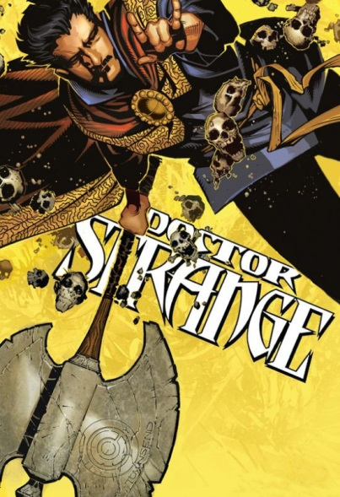

<Who do you call when things are coming out of your dreams and trying to kill you? Or when your daughter is cursing in Latin and walking like a spider? Or when your dog keeps screaming at you to strangle your neighbors? Doctor Strange, of course. He's the only person standing between us and the forces of darkness, but has he been paying his tab? Every act of magic has a cost and Jason Aaron (THOR, ORIGINAL SIN) and Chris Bachalo (UNCANNY X-MEN) are going to put Stephen Strange through hell to even the scales. – Marvel Comics Description for Doctor Strange (2015) #1>

Similar phrasing was used in the solicitation for the New 52 reboot of *Constantine the Hellblazer* and that sentiment has been at least spoken of in the new book. Below is a single panel from issue #4, in which a drunken Constantine, haunted by both ghosts of his memory and real ghosts from his past, reflects on a time as a young man where he had a special relationship with a young girl who he had pulled into his magical lifestyle.

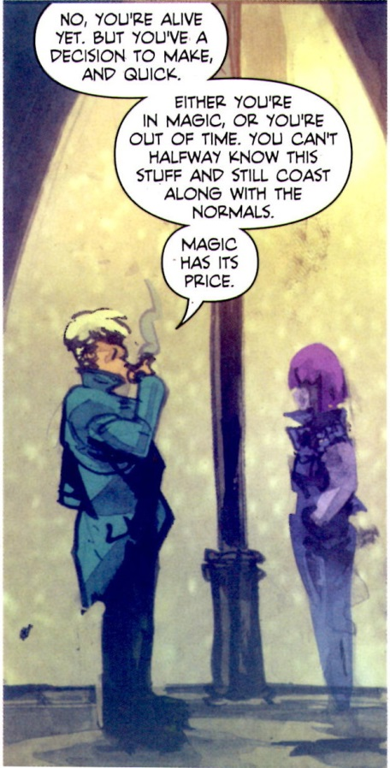

The interesting question to consider is why should the relaunches of both of these titles go out of their way to emphasize that magic has a cost? The answer lies in the observation that [magic as a storytelling device is a disaster waiting to happen](http://aboutcomics.blogwyrm.com/?p=47). All too often, the use of magic, unless used sparingly, becomes an unworkable *deus ex machina*. Since neither of these series can ‘use magic sparingly’, another mechanism must be sought in the form of a ‘cost’ or ‘price’ that limits magic use and codifies its rules.

One need only look at the turbulent publication history of these two characters to see the pattern that indicates that portraying them as unfettered users of magic causes problems and that they work better as characters the less that they actually appear.

Consider first the twisted publication history of Stephen Strange. In the roughly 50 years since his introduction in Strange Tales as a main character, no less than seven separate titles have been devoted to him as the lead (*Strange Tales* (1951), *Doctor Strange* (1968), *Marvel Premiere* (1972), *Doctor Strange* (1974), *Strange Tales* (1987), *Doctor Strange: Sorcerer Supreme* (1988), *Doctor Strange* (1999)). In each of these short-lived runs, he’s been redesigned and rebooted. He’s been portrayed variously as a reserved and aloof conjurer with the self-control of a Tibetan monk, a masked-crusader complete with super-hero poses and accompanying melodrama, an emotionally conflicted soul with a gnawing darkness at its root, and an aimless womanizer with insecurities a mile long. His most memorable stories have more to do with him as a bystander, witnessing the grandeur of the universe (*e.g.* Eternity & the Living Tribunal from *Strange Tales (1951)*, the Sise-Neg story from *Marvel Premiere*, or the psychedelic brush with Death in the *Doctor Strange (1973)*) than they do with him as the lead.

The publication history of John Constantine has done better, at least in terms of the number of books. His tally is only three (*Hellblazer (1988), Constantine (2013), and Constantine: The Hellblazer (2015)*), although he’s actually on pace to have as many restarts when adjusting for the fact that he’s only been around since 1985. In addition, the recent television series Constantine, failed to find an audience and was cancelled after 13 episodes.

What makes magic appealing in small doses but unappealing as the main course centers on what magic actually represents. While there is no exact, universal characterization, magic, as used in literature, tends to embody the certain vaguely facets in the human existence:

* Undefined faculties of the human being (e.g. insight and intuition)
* Non-rational mode of human existence (e.g. feeling and emotions)
* Wish fulfillment
* Mysticism and the desire for spiritual connection with something bigger

The much larger success of John Constantine as a magician compared with Stephen Strange is attributable to the fact that the Vertigo imprint, as a whole, tends to emphasize emotions and feelings over logic and reason. But emotion and feelings can only take a story so far, there still needs to be a consistent and logical progression of events precisely because the world in which we live is subjected to those very constraints. We may indulge in a fantasy about wish fulfillment but we must still eat. We may have insight into a particular situation but we still express it using logic. We might explore our spirituality but we still need to go to work, pay the bills, and all the other things living in a material world with well-defined rules forces us into.

So this time around, the creative teams are trying to address these issues by placing limitations on the magic. In effect, they are trying to turn magic use into a different type of science, complete with a new set of rules that are consistent even if they are initially unknown to the reader. I suspect the creative teams and the powers-that-be at the big two have paid attention to and have been influenced by the success of the anime and manga entitled [*Full Metal Alchemist*](https://en.wikipedia.org/wiki/Fullmetal_Alchemist)(FMA). FMA uses a rule-based magic as a vehicle to explore questions about war, love, and ethics in a way that has engaged audiences. The magic is merely the vehicle it uses as a means to ask deep and philosophical questions. Whether these two reboots can succeed remains to be seen.

# Sixth Gun Review

*The Sixth Gun* is an ongoing series from the creative team of Cullen Bunn and Brian Hurtt which is published mostly monthly by Oni Press.

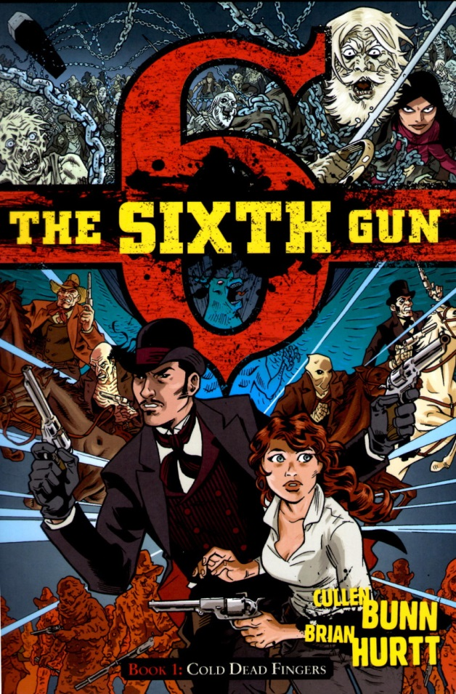

*The Sixth Gun* falls firmly into the Wild, Weird West genre that I’ve spoken about it the past with my reviews of [The Deadlands](http://aboutcomics.blogwyrm.com/?p=77), [East of West](http://aboutcomics.blogwyrm.com/?p=109), and the ‘weird’ offerings in the [Jonah Hex limited series from Vertigo](http://aboutcomics.blogwyrm.com/?p=54).

Somehow, this series escaped my notice for quite a while until I stumbled across an entry in Previews and the light bulb finally went off. I’ve spent some time getting caught up on the initial set of issues which are conveniently collected in nicely produced and affordable trade paperbacks.

Having sampled about 20 issues, I can say that I am definitely puzzled by my reaction to the series – in short I am conflicted. There are many things that the series does right; the art is fine, the narrative is reasonably well-paced and intelligent, and the characters are interesting albeit they are presented a bit more like caricatures rather than real persons. If I had to put a finger on it, I would say that the series is neither cozy & creepy enough nor is it epic enough.

In a nutshell, *The Sixth Gun* is formed around the premise of 6 weapons from perdition whose influence on man has existed since time immemorial.

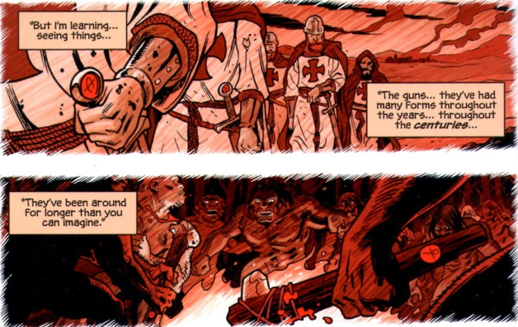

Their introduction into the old West is affected through the workings of a Confederacy general by the name of

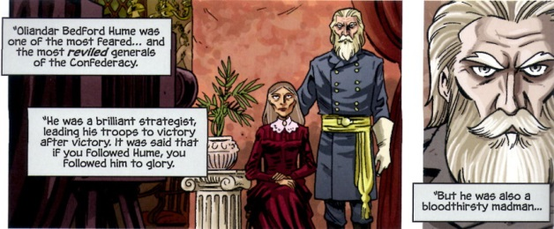

General Hume apparently has made a deal with the incarnation of the evil behind these weapons -

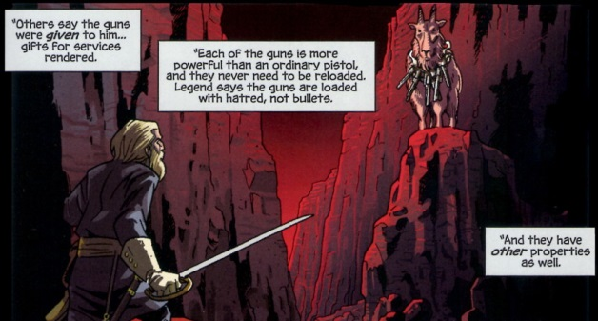

which appeared to him in the form of the demonic ‘Goat’ bearing the 6 guns about its neck. What the general got was incredible power but why the Goat was willing to grant this power to him remains unclear to me.

In any event, once the 6 guns were in his possession, General Hume forms a merry little band of psychopaths as his core team, each member wielding one of the guns. Each gun grants its possessor physical toughness and a unique special ability at the cost of their bodies, minds and souls.

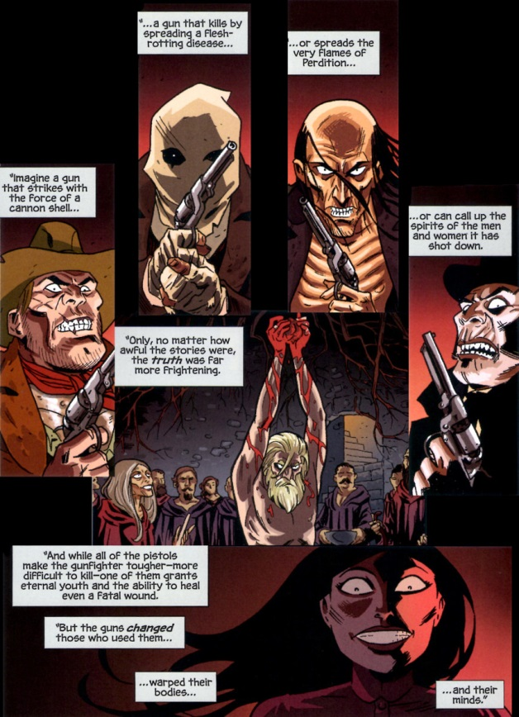

Of course, the general reserved the sixth gun, perhaps the Devil’s own, as his.

The story starts well after the defeat and subsequent death of the general at the hands of a group of men who ambushed him and managed to separate him from the infernal firearm. One of those men, Drake Sinclair, becomes a leading protagonist in the series, although it is perhaps better to view him as an anti-hero who begrudgingly does what is right – while he is far more handsome that Jonah Hex in looks (who isn’t) his morals and personal conduct are similar. Opposite to Drake is Beck Moncrief. A daughter of one of Drake’s fellow conspirators, Becky accidentally takes possession of the sixth gun when her father is killed by agents sent by the general’s widow to find and restore the revolver from hell to her husband who, despite the fact that he was ‘murdered’, looks pretty spry for a corpse

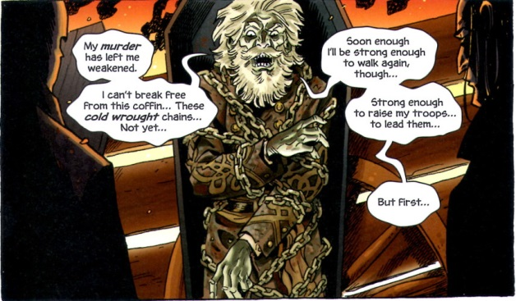

And so the mayhem begins. Along the way, the reader is treated a variety of spooky images, including: a gallows tree, where the ghosts of hanging victims can be consulted as an oracle; Louisiana voodoo monsters and shape changers; a vault holding riches or perhaps a portal to hell; and so on.

The mechanics are good, the production value high and yet the series lacks something. One on hand, it seems to want to be character-driven with stories of revenge, love, lust, and hate being the central lynch pin. On the other, it seems to want to be a grand epic about the coming apocalypse brought about by these six guns.

A very skilled writer can make the immense questions about life and death quite cozy and creepy. The best example of this is [*The Waiting Room*](http://www.tv.com/shows/night-gallery/the-waiting-room-77184/), a short film from the old *Night Gallery* television show in which a gun-fighter finds out the ultimate cost of his violent ways (and his ultimate fate) during a brief visit to a saloon. Shot entirely within this ‘cozy’ waiting room, the dialog and mood do more to deal with the grand questions of heaven, hell, redemption, and damnation than many stories set in a grander landscape. Likewise, a very skilled writer can marry character to immenseness within the context of an epic. The small personal scene’s found scattered throughout *The Lord of the Rings* (book only) are masterpieces that bridge the gap between the large and universal and the small and personal.

The Sixth Gun, at least the portions I’ve read so far, seems to be unsure where it belongs and so suffers in its presentation. Nonetheless, I’m going to continue to read the series hopefully expectant that Bunn and Hurtt will manage to produce memorable stories in one of the best genres out there.

# Nameless or Aimless

I have a sort of love/hate relationship with Grant Morrison. I generally like his trippy, out-there concepts and the way he links and connects symbolism from various sources. I suppose I get this latter tendency from my interest in semiotics. On the other hand, he tends to confuse profundity with complexity; his verisimilitude is disjointed and unreal; and he has an axe to grind politically and religiously that often leaves a bad taste in my mouth. My reaction to him is similar to my feelings towards Beavis and Butthead; I like to watch their antics and listen to them babble but I but don’t heed a word they say.

So it was with some trepidation that I signed onto another Morrison (perhaps he thinks he’s Jim Morrison – hmmm) excursion into the unknown called *Nameless*.

Nameless is both the series title and the ‘name’ of the lead character in this ongoing series Illustrated by Chris Burnham and published by Image Comics. To call Morrison’s storytelling non-linear doesn’t do justice to the dream-within-a-dream method by which he stiches a large array of Jungian archetypes together. I suppose I could warn of spoilers to follow but I doubt it. His basic method is to lay it all out there and let suspense be the guiding principle rather than surprise.

The basic motifs employed are ones of horror, ancient ruins and elder gods, philosophical revulsion, and the kind of righteous indignation only an alienated, existentialist can exhibit. I get the notion that Morrison sees himself in the role of the nameless protagonist.

Issue #1 open with a connection of world-wide violence to sinister other-worldly forces reminiscent of Lovecraft’s mass hysteria episode in *The Call of Cthulhu*. Particularly graphic is the scene with the father who has brutally slain his family before ending his own life just after he posted to Facebook.

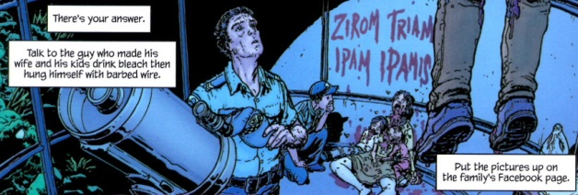

The phrase ‘*Zirom Triam Ipam Ipamis*’ is one of these common motifs that links the visual story telling together – much like a hidden object game. The language in which this phrase is expressed is [Enochian](https://en.wikipedia.org/wiki/Enochian), the language of angels. The source of the otherworldly and sinister influence is [Xibalba](https://en.wikipedia.org/wiki/Xibalba), the Mayan home of fear wherein exists there underworld. In Morrison’s telling, Xibalba is a large asteroid heading for a collision course that will wipe out all life on Earth.

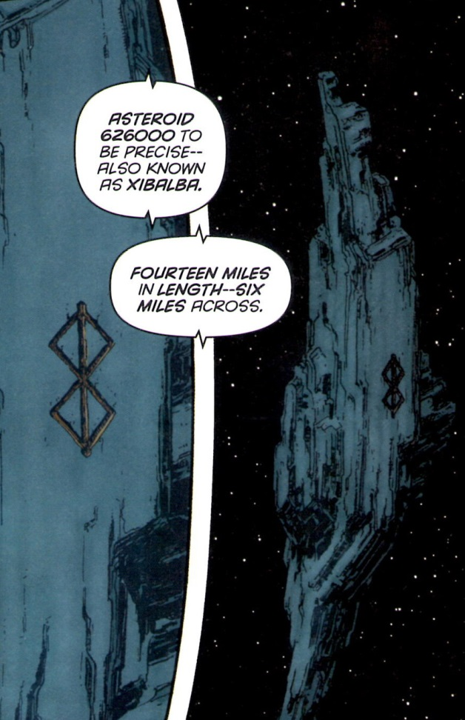

Of course, the asteroid bears a sigil warning of the evil inside.

Nameless finds all this out (maybe) as he finishes a job retrieving a Dream Key from the Veiled Lady.

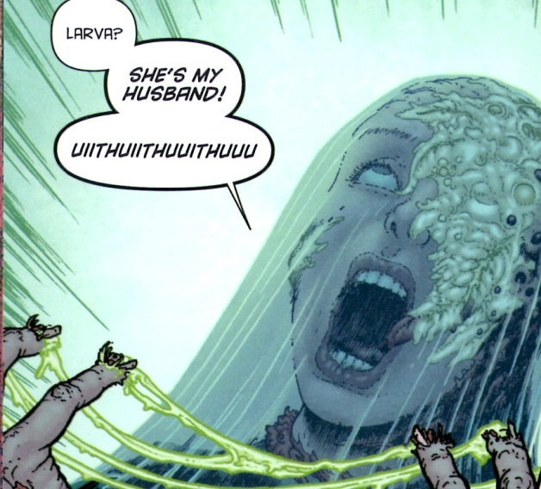

What exactly is a Dream Key and why the Veiled Lady has it is not very clear. What is clear is that the theft commissioned by a billionaire by the name of Paul Darius, who then offers a position in his save-the-world mission to Nameless since the latter has now proved his ‘cred’ to the former.

Nameless is soon whisked off to Darius’s moon base, which will serve as a staging area before they journey to intercept and divert Xibalba. Upon his arrival, Nameless learns why he was summoned –his predecessor has been murder at the hands of another uber-genius in the employ of Darius.

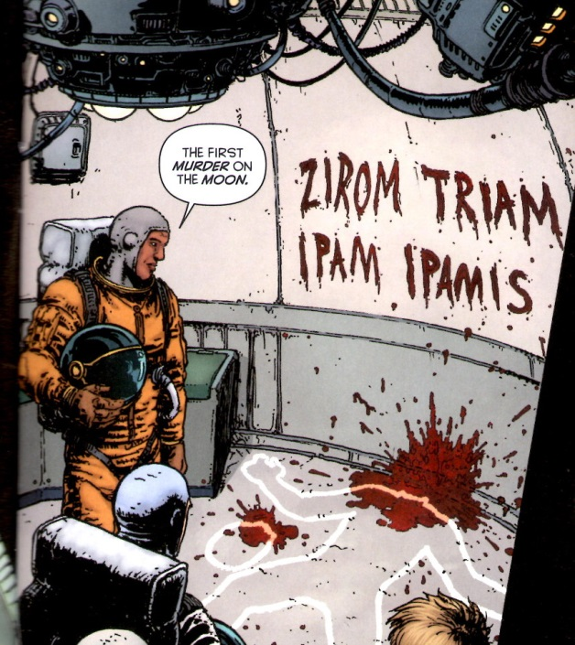

Again the Enochian phrase ‘*Zirom Triam Ipam Ipamis*’ is present at a scene of horrific violence (*Cthulhu F’htagn*). During some subsequent briefing, all is revealed

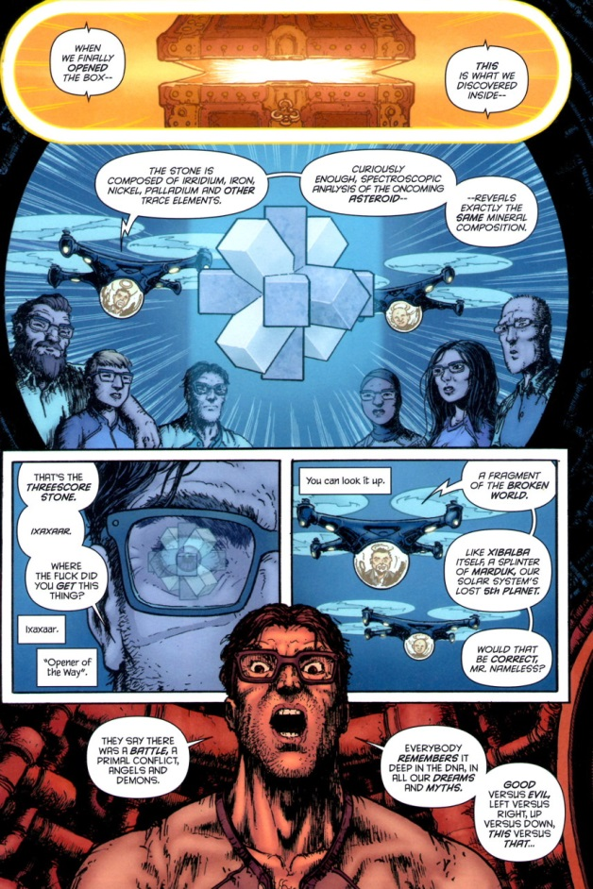

and we find that the Dream Key opens a box that contains a splinter from our solar system’s lost 5th world of Marduk, which was destroyed in an epic conflict between angels and demons dating back into time immemorial.

Undaunted by all these revelations that team readies their plan (some absolute nonsense in the way of science fiction here) to use a conventional bomb to slow the asteroid and then their anti-gravity tractors to move it away from Earth. So they have anti-gravity tractors, implying that they’ve harnessed quantum gravity, but they can’t obliterate the asteroid outright.

As the team gathers for their journey to Xibalba. Each, horronaut (my phrasing) is outfitted with occult protection in the way of symbols and signs on their suits

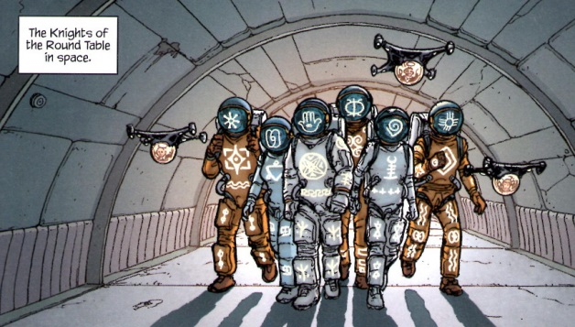

and off to the asteroid they go. Here the story slows down and the pacing becomes overbearing. We are treated to frame after frame of ominous warnings with nothing more than ‘happy drugs’ administered by the suit to explain how the crew continues to stay calm and ignore their senses. How they can’t get the clear warning from the asteroid’s landscape is beyond me.

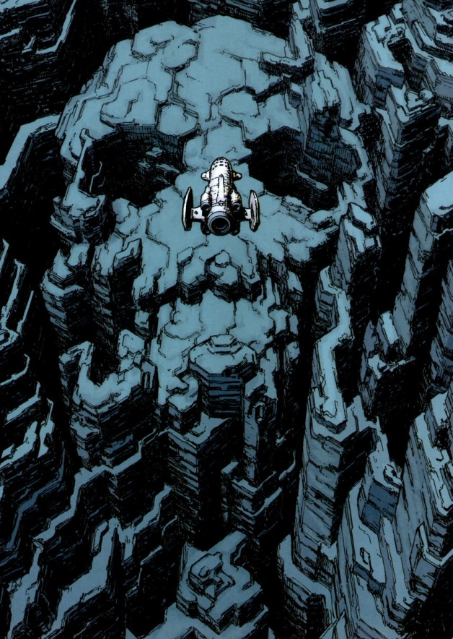

Even when they figure out that Xibalba is a prison where the angels bound the worst demons and that the Threescore Stone they possess is a key to open the locks and let the evil out they continue their mission.

Lots of gruesome corruption of mind, body, and soul ensues and then the really trippy part begins. Nameless begins dreaming dreams, within dreams, within dreams, and so on. He’s suddenly in a doctor’s office being treated for some type of post-traumatic stress.

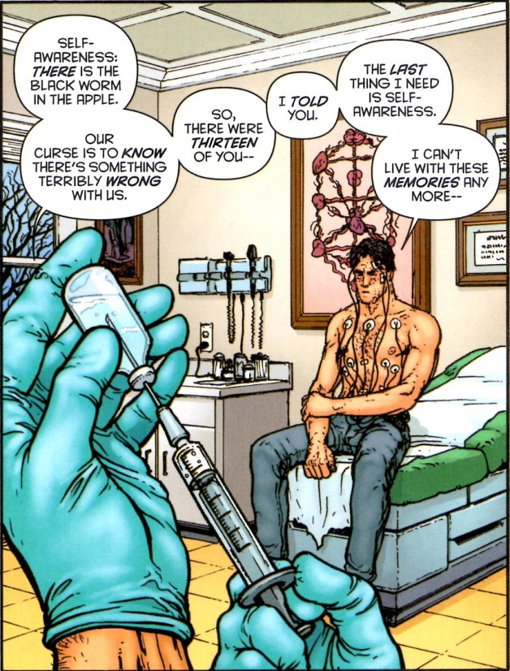

Note the [Sephiroth](https://en.wikipedia.org/wiki/Sephirot) in the background compose of organs (perhaps hearts) – yet more visual semiotics in play. The stress that Nameless is trying to forget is a botched séance years before in which he and twelve others tried to make contact with the entity found within Xibalba using the Threescore Stone.

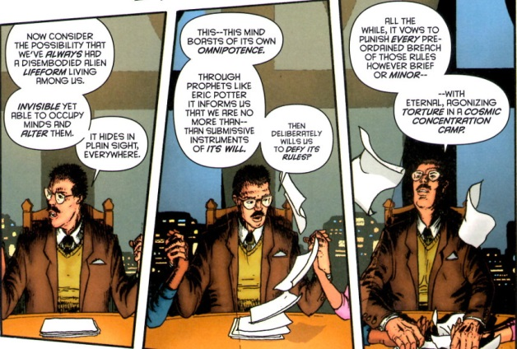

It is during this long-winded diatribe that Nameless realizes, with complete philosophical revulsion, that the lifeform that the head researcher is taking is God. And here Morrison jumps the tracks and let’s his hostility to religion get the better of him. God in the Western Tradition is too large to fit within the Universe as a whole let alone be imprisoned on an asteroid. Each of the séance participants is from the Western tradition and yet none objects or points out Aquinas’s statement that [God is not in a genus](http://wmbriggs.com/post/14557/). This doesn’t require that any of the participants believe in God but simply that they actually showed up in college when they taught college.

Anyway, shots of the doctor dream and the séance dream are interspersed with Nameless’s suffering within Xibalba (whether this is also a dream is unknown)

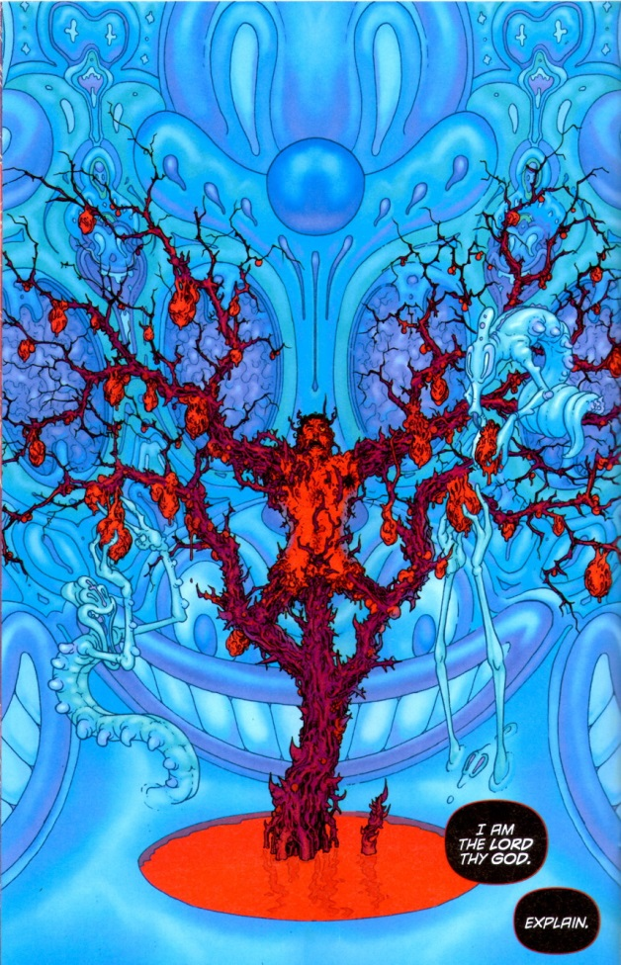

Sure looks like Mickey Mouse as the top of that torture pillar with a grinning Donald Duck below. Perhaps Morrison was scared by the Matterhorn or Space Mountain on a visit to Disney Land as a kid, perhaps he hates Disney Corporation for its success, who knows or cares.

As Issue #5 closes, we once more see the Veiled Lady playing a role in Nameless’s physical, mental, and psychological suffering.

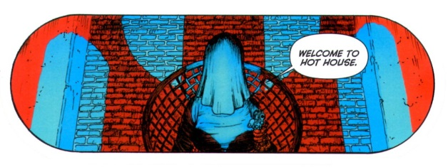

Where the story goes from here I’m sure I don’t know. All I do know is that a set of interesting premises, intriguing symbols, and inspired visuals are aimlessly flopping around under the creative direction of Grant Morrison.

# Whatever Happened to Exposition

I suppose that this week’s column can be easily interpreted as the rantings of an older reader wishing, nostalgically, for the good old days while simultaneously contemplating how to tell the youngsters of the neighborhood to get off my lawn. But that is just a chance I’ll have to take.

In a nutshell, I long for the days when exposition was a lot clearer. I don’t mean that it has to be pedantic or employ a captain obvious character. But even in the good ole days where the art was high caliber and the visual layout very well done, sometime a few words was worth a hundred pictures.

For example, take this action shot from the Spider-Man newspaper column.

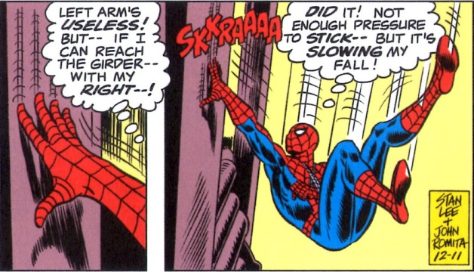

It would not be at all clear what Spider-Man was trying to do without the thought bubbles that shared his inner narrative with the audience.

I appreciate that thought bubbles are considered old school now but is the story really enhanced by eliminating them? Also, I reject the contention that thought captions are actually new school as well. Consider the following two panels from Marvel Chillers #6 (1976)

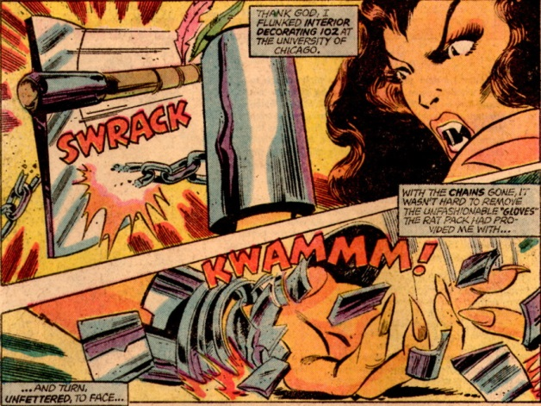

These captions with a narration voice over are used consistently by Tony Isabella and John Byrne throughout the entire issue. Not one thought bubble to be found. While visually less jarring and cluttered – the captions being filled with color as opposed to bright white like the thought bubbles – the exposition is not significantly enhanced. Compared to the Spider-Man two-panel excerpt above, the Marvel Chillers piece contains essentially the same amount of inner dialog. Of course, the captions allow Byrne to zoom-in on the action but both sets are visually appealing and one might argue that which is used is a matter of taste. Has anyone mixed thought bubbles and captions? I don’t know.

Regardless of the answer, in both cases the writer had enough space to keep the reader comfortably current with the action. Unfortunately, that is not consistent with the current trends in comics. Too often, a minimalist approach is taken to the exposition which leaves me scratching my head as to how to interpret what I am seeing.

Consider the fairly recent attempts to knit together multiversal stories at Marvel. Certainly everyone is familiar with The Secret Wars event running through Marvel, but the original foray into that realm seems to have been the 12-issue run on the Defenders by Matt Fraction, Jamie McKelvie, and Mike Norton. I know that the Defenders had been cut loose from their mooring lines and cast adrift into the multiverse and I know that the experience is supposed to be disorienting to them. But it need not be disorienting to the reader. In issue #10, the reader is dropped into a scene of devastation

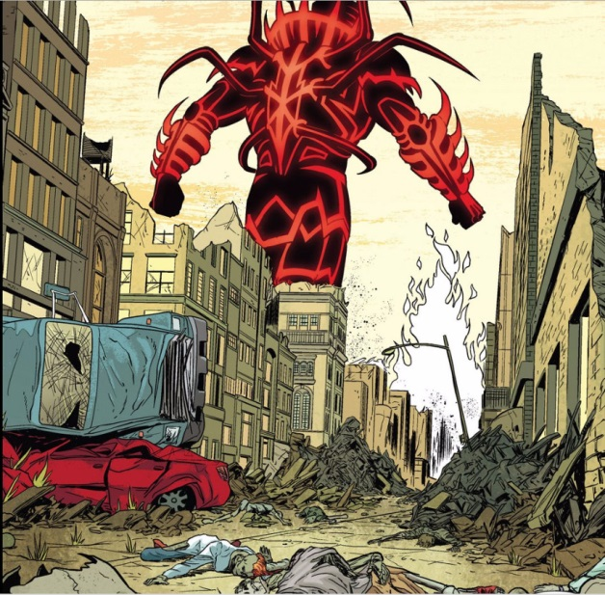

and left to fend for himself. Some bits of exposition are given later but too little to really shed light on what’s happening. Sure, real life is like that but so what? I don’t read comics to get real life – no one does. This problem is amplified by the Jonathan Hickman run on The Avengers and The New Avengers which culminated with The Secret Wars event that recently ended. I challenge anyone (even Hickman) to really make heads or tails of what Hickman was trying to say – to really make it make sense. To paraphrase Chesterton, the writer is under a contract to explain the events to the reader. The reader takes delight not in the mystery but in the explanation that makes it clear.

Couple minimalist story with bad art and the situation gets even worse. The art on Roche Limit was so minimalist that I often had a hard time telling one character from another. All of them had distinguishing characteristics so that when viewed side-by-side they were distinguishable but none were memorable enough to jump off the page and stick in my thought until the next issue came out. I don’t want to reread the comic each time a new issue is added to the fold.

I miss the days when master artists made each character distinct.

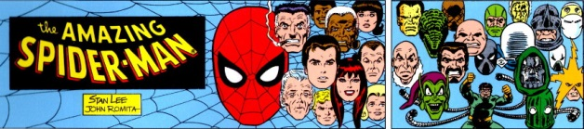

Today, even in reasonably well-crafted books like The Sixth Gun, there are still scenes like

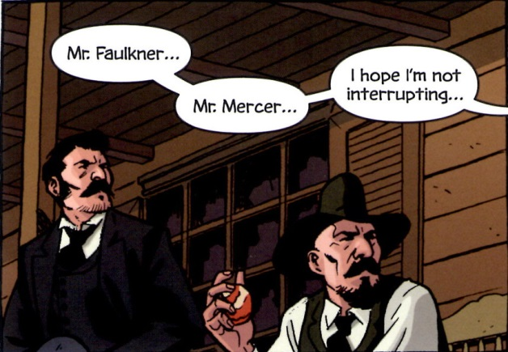

where I wonder if I am reading a comic or playing the old children’s game Guess Who (does your cowboy have hair. Does he have a hat? Mustache of full beard? Don’t tell me – they have the same nose).

So if any creators actually stumble on this post, please do your readers a favor, do your sales figures a favor, and do yourself a favor, work on the exposition.

# Inhumans v. Mutants

Well I must admit that the directors, managers, and caretakers of the Marvel Cinematic Universe (MCU) really have their act together. I’m not speaking about their dominance in the movie theaters, as unprecedented and impressive as that may be. Nor am I speaking about their ability to spin-off successful Netflix series like *Daredevil* and *Jessica Jones*. I am speaking about the adroit way that they are weaving a compelling storyline into Agents of S.H.I.E.L.D. while simultaneously dealing with a business decision that had the potential to sour the whole fan-boy experience they’ve built.

The business decision that I am discussing is the licensing of the X-Men franchise to Twentieth Century Fox lo’ those many years ago.

At the dawn of the 21st century, Marvel had essentially ceded the title of king-of-comic-book-movies to DC comics. The handful of made-for-TV films and unreleased projects served only to emphasize the inability of Marvel to bring its brand to the big screen. Even the hottest commodity of the 1990s, all things X-Men, didn’t get more than a couple of animated series during that same time frame.

That was all to change with the release of *X-Men* in 2000. Suddenly there was proof that the Marvel brand could make it big on the screen and the Twentieth Century Fox hold on the Children of the Atom was cemented. This hold was reinforced was by the success of *X-Men 2* (2003) and became so steadfast that it was able weather the disastrous storm that was *X-Men: The Last Stand* (2006).

Perhaps Fox would have given up on the X-Men, but the continuing success that they were having with the Fantastic Four and success of the Columbia Pictures Spider-Man and Ghost Rider movies most likely made them sit tight until the best way to mend the fence could be seen.

In the meantime, Marvel launched *Iron Man* in 2008 and the MCU was born. Profits flowed in, legends were born, and grand plans evolved. Suddenly Marvel had money and Fox had a commodity that would either earn money for them directly through film or indirectly if Marvel Studios would purchase the rights back.

Whether Fox decided to keep the X-Men franchise or Marvel refused to but is unknown to me. What is clear is that Fox had another go everyone’s favorite mutants and has had good successes (*X-Men Origins: Wolverine* (2009), *X-Men: First Class* (2011), *The Wolverine* (2013), and *X-Men: Days of Future Past* (2014)) with the fan-favorite Wolverine being an instrumental character in the recovery and reboot.

And so it looked like the MCU would just have to do without misunderstood, genetically modified, misfits in trendy and flashy costumes. Where would the MCU go to reach out to the young adult audience?

And here is where my admiration for the MCU architects comes in. They realized that the Inhumans could be repurposed to functionally fit the hole left by the absence of the X-Men. How did they do this, you ask? They’ve done it through a slow-and-steady retconning of the Inhumans within the structure of Agents of S.H.I.E.L.D..

Perhaps the single largest aspect of the Inhumans that had to be restructured was the whole concept of the isolated and insular nature of the original society as conceived by Lee and Kirby. When the Human Torch first meets Crystal, he has no idea that she is part of the royal family and is cousin to Black Bolt, who is the king in exile. As the Inhuman mythology evolved, their separateness from the human race became more pronounced. They weren’t like us; they were aloof, and apart, and distinct. Being genetically modified by the Kree, they weren’t alienated from mankind they were alien. While gaudy in garb and awesome in power, the Inhumans just weren’t relatable as human beings – they were more like forces of nature.

Part of the appeal that the X-Men during the decades leading up to the first Fox movie, was this idea that mutants were born of human parents and either were gifted with their powers from the get go or had them thrust upon them at puberty. They were easily identifiable with teenage rebellion and feelings of awkwardness. Most of the stories centered around ‘normal’ kids coming to grips with their abnormal gifts and being mentored by like-gifted grown-ups who offered a safe ear for the secrets and changes that they were going through when their parents couldn’t or wouldn’t. Clearly the classics Inhumans didn’t fit this bill.

This is exactly where the MCU architects hit their master stroke. What if anyone could be an Inhuman? Sure there could still be a hidden refuge or two and a ruling class, but the average Inhuman looks like us, fits in with us, even thinks that they are us until exposure to the Terrigen mists. Then all manner of changes occur – changes with which they need help and guidance. They live among us in plain sight but they hide their gifts when able. They feel that marginalized and alienated and… suddenly the Inhuman dynamic looks and feels just like the mutant dynamic. The only difference being the trigger not the response.

They also came up with an excellent way to push that trigger out to the entire world. In the old Fantastic Four days, the Inhumans zealously guarded the Terrigen mists. In this new regime, the Inhumans want to expose as many of us as possible to the mists. Just like the randomness associated with the accident of birth so too is the exposure to the mists.

And so we see how adroit the MCU architects are. They managed to circumvent a potentially harmful business decision by creating a compelling substitute for one of the most sought after franchises and all that was required was some modest retooling.

Inhuman versus Mutants? Doesn’t seem like there is much difference now.

Sandman: Overture

Back in 1989 Neil Gaiman breathed new life into some old characters that had been gathering dust on the DC shelves. All that was required was a reimagining of the character Destiny, a nudging of the Sandman character into universal, cosmic status, and the rounding out the 5 other ‘Ds’ (Delirium/Delight, Despair, Death, Destruction, and Desire) to form the 7 Endless. Each of the Endless were portrayed as anthropomorphizations – human-looking embodiments of the elemental forces of the same name.

His tale starts with the imprisonment punk-rock looking Dream by an Allister Crowley knockoff and his coven of demon worshippers in 1916. The subsequent humiliation/education that Dream endures and the changes that it engenders in him forms the central tragedy of the bulk of the series. A tragedy presented on human terms.

Initially, the stories had an intimate feel; a feel reminiscent of the classic British Cozy made so popular in mystery stories of the first half of the twentieth century. Action was confined to small venues with real human issues. The horror of John Constantine’s former lover who abused Dream’s pouch of sand, the twisted events that Doctor Dee brings to life in that lonely dinner, and the convocation of serial killers headlined by one of Dream’s own nightmares were excellent examples of what could be done within a small scope.

Unfortunately Gaiman couldn’t stay small and he tried to grow Dream to something more cosmic and universal. The beginnings of this were evident when the he paid a visit to J’onn J’onzz the Martian Manhunter in Sandman #5. 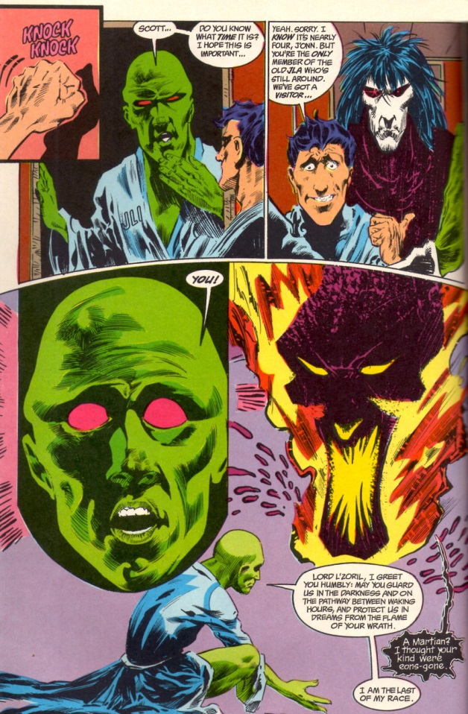

Dream was perceived as the Martian dream god Lord L’Zoril by J’onn. On one hand that makes perfect sense as Dream is a universal concept and how should an universal concept be apprehended by a Martian except in Martian terms. But on the other hand it is clearly untenable. How can Dream be in on specific place let alone be captured and imprisoned for over 70 years. After all, Dream is an Endless – he is an incarnation of a universal concept. If he were an agent or an avatar it might make sense but not as an incarnation.

As the series progressed, Gaiman swerved from the intimate to the large but never to the truly universal. All of his concepts were firmly rooted in the kind of classics education one might get at Oxford or Cambridge. Even Dream’s undoing comes at the hands of the Furies; embodiments of the spirits of familial vengeance from ancient Greece.

So it was with ever diminishing interest that the series wound on until its end in 1996 with the death of Dream and the subsequent installment of a new Dream.

Little of note occurred over the better part of two decades until Gaiman decided to revisit the Sandman with his prelude entitled Sandman: Overture. In this limited series, he seemed to want to really ‘fix’ all that ailed the original run; addressing both the universality of Dream and how came to be captured. In order to do this, he puts Dream into a cosmic quandary, where the fate of the entire universe hangs in the balance. And while the artwork is beautiful and the craftsmanship inspired, what actually resulted is a confused story that causes more confusion than it addresses.

This time it all starts with the death of Dream in 1915 - well at least an aspect of Dream and that is one of the problems. This death triggers a gather of Dreams representing a sliver of the totality of Dream, one for each type of being in existence.

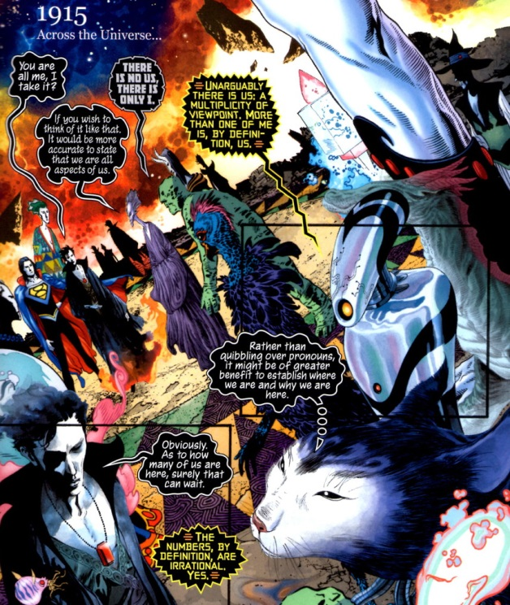

Each aspect trying desperately to understand what has caused this train of events, to understand who killed them.

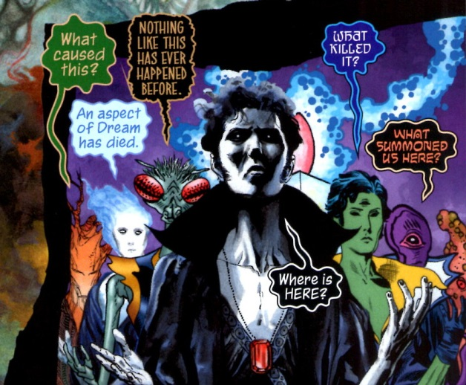

Fortunately for the exposition, an particular aspect of Dream with a strong elder gods motif, acts as the hermetic monks of old stories, and steps in to fill in the gaps.

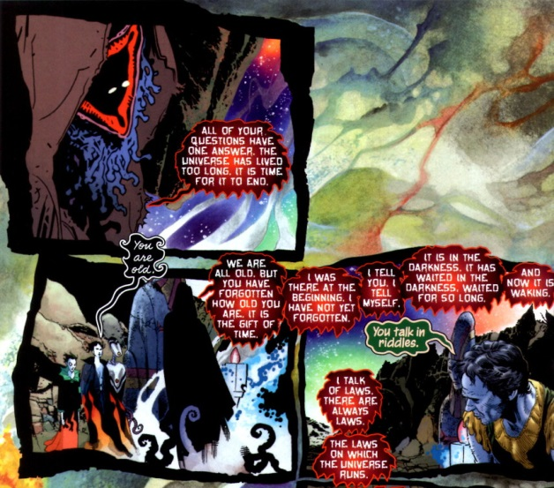

This aspect explains, in pure vagueness, that the universe is coming to an end. However, before he can speak with more clarity he vanishes. This is not an unusual occurrence, and as time moves on, the Dream population mysteriously begins to thin as each aspect disappears from the perspective of the others

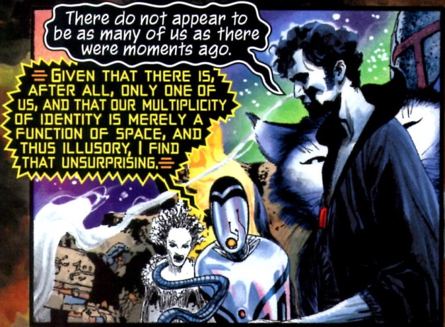

After consulting with himself/herself/itself, Dream explains that the disappearances are only a matter of a different point-of-view.

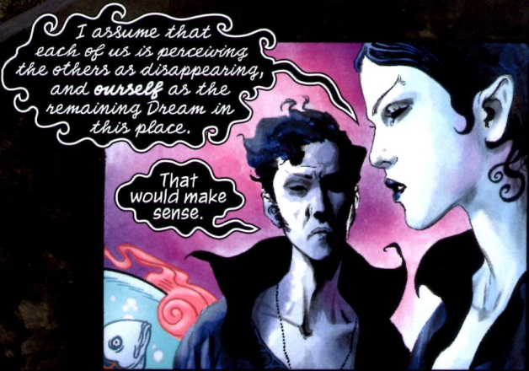

Our Dream, being proud and haughty (aren’t they all?) takes it upon himself to seek a higher authority

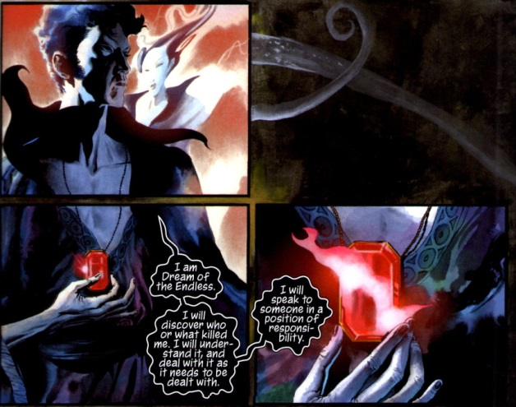

and off he goes to consult with a level of authority above the Endless. Here finally all is revealed. This uber-entity informs Dream that the cause of the death of one of his aspects is due to a cancer eating away at the heart of the universe. A star – stars are sentient in this telling – has become mad and is driving existence to Armageddon.

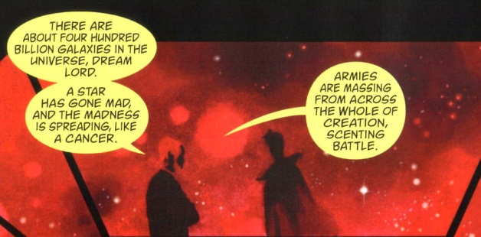

And it turns out that one need look no further than Dream to find the cause of this disaster. By failing to totally obliterate a ‘vortex’ from existence, Dream’s inaction has led to this sorry state of affairs.

And so begins a quest in which dream looks for a way to correct his mistake, fulfill his duty, and save the universe. Along the way, he encounters his father, Time, and his mother, Night; he’s cast into a black hole, and rearranges the entire spacetime continuum as he literally erases his error from history. The action leaves him so drained that capture shortly after is all but inevitable.

I suppose that Gaiman thinks he’s done something remarkable here by ‘tidying up’ all the loose ends but that’s not how I see it. Splitting Dream into multiple aspects waters down the original run, making our emotional investment in the original insignificant. Philosophically, the whole concept of a multitude of aspects of universal concept is also dodgy. If they are the same but different, why should any care if one is annihilated, and which one was captured, and so what if he was? Why couldn’t a new aspect take over in his place? And if he was the aspect peculiar to the Earth, then why did a Martian see his as a Martian dream god? Too many questions with too few answers.

Gaiman is also open to criticism on his physical cosmology. The work is not strictly a work of fantasy since he uses the trappings of science to make his story have a veneer of credibility. He even went so far as to have pictures of bubble chamber tracks superimposed on Hubble-like pictures of stellar nebulae on the insides of the front and back covers.

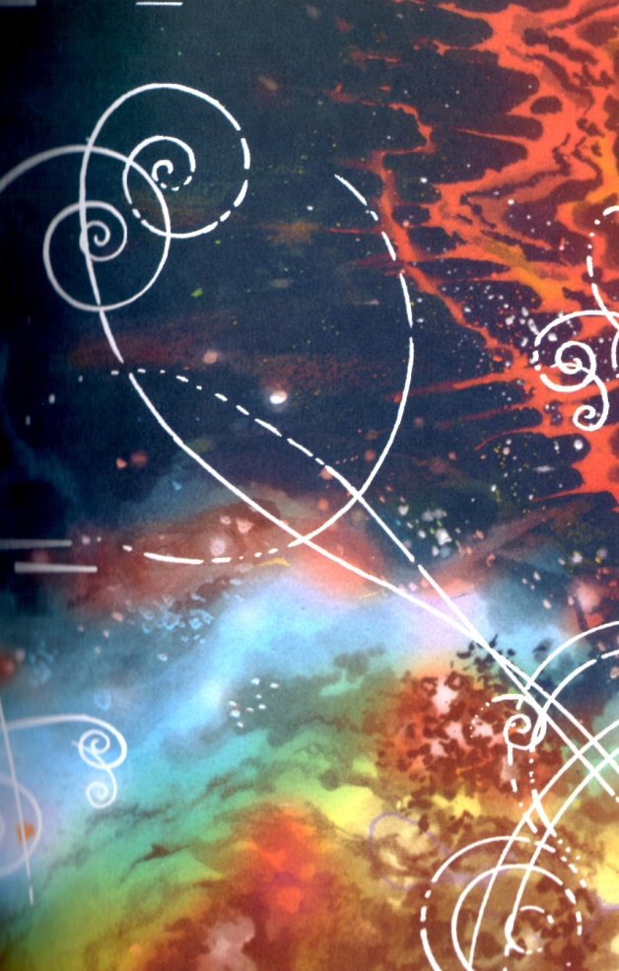

How can it be 1915 everywhere in the universe? What about relativity and the finite speed of light. I guess getting the science right doesn’t matter as long as it sells.

Many months ago I talked about the [three most foolproof ways to screw up a comic](http://aboutcomics.blogwyrm.com/?p=47). Here Gaiman indulges in all three. He’s got illogical magic, a multiplicity of doppelgangers, and time travel with a universal reboot.

I’m not saying that the whole thing is a waste. Certainly as a flight of fancy it’s worth taking a look and the art is gorgeous.

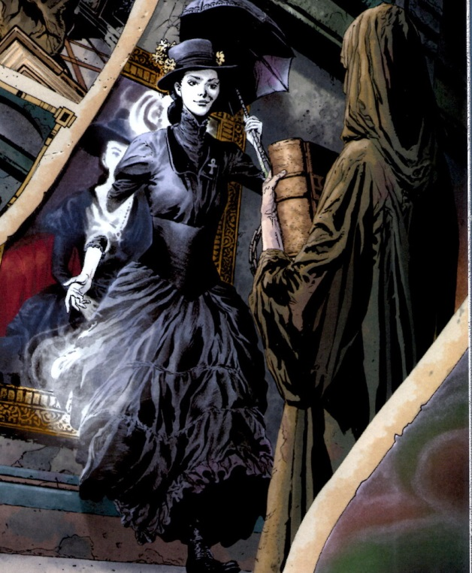

But as a story, it comes up quite short of the mark. Gaiman’s Sandman was always much better when it was confined to the small and when it embraced its classical, Western roots rather than trying to be universal.

# Giving Shooter His Due

There aren’t many people as controversial (or for that matter maligned) in the comics world as [Jim Shooter](https://en.wikipedia.org/wiki/Jim_Shooter). And for years I’ve heard about the issues associated with his run as Editor-in-chief at Marvel Comics. But looking at the current state of creator-owned comics are in, I think that it is high time that the Shooter’s legacy was revisited and some points clarified.

For those who don’t know much about Jim Shooter some relevant facts are worth discussing to set the stage for why I think his influence on comics should be re-examined and revised. Shooter, in his own words, was interested in comics as a child but lost interest around the time he was eight. Roughly four years later, he picked up comics again and studied how Marvel told its stories. Using these as a guide, he wrote and drew a story featuring the Legion of Superheroes for DC Comics with the idea that DC needed his help to start competing with Marvel. This unsolicited approach worked for him and at the age of 14 he was working for DC. His tenure at DC was marked with the creation of a lot of enduring characters and ideas that continue to this day.

After some 10 years spent kicking around the comics industry, advertising, and graphics design, Shooter was offered a job at Marvel comics as an editor. About two years later, he became Editor-in-chief. During his time in this position (1978-1987) Marvel prospered, most notably in two areas.

First, Shooter ushered in some of the new ideas in the business end of comics. Recognizing the growing specialty shop presence, he took the chance of distributing several Marvel titles strictly through direct sales to comic book stores, bypassing the usual newsstand approach. He also setup royalties for creator-owned material in *Epic Illustrated*, which help address the long-term feud between management and labor about how profits were distributed. And finally, he championed the large-scale, imprint-wide, crossover event with the first *Secret Wars*.

Second, Shooter provided a consistent editorial voice and approach in the creation what is and should be the main product of any comic book line – good, compelling stories. To this end, he emphasized two points above all others: the exposition needed to be clear and deadlines needed to be met. Unfortunately, imposition of structure on creative types is often ill-received and this aspect of Shooter’s reign is often mocked (e.g. [by Peter David](http://aboutcomics.blogwyrm.com/?p=541)) and cited as the reason for his firing in 1987. Of course, I don’t have any clear picture of what it was to work for Jim Shooter. Rather, I would like to talk about the editorial points from the point-of-view of a longtime reader and collector.

I started collecting comics in late 1973. At that point, Marvel had already 12 years of publication history under its belt. Getting onboard with the story lines was one of those difficult enterprises akin to merging onto a superhighway on your first outing with a car. There was a daunting ‘history’ to deal with and often I couldn’t tell who was who and just took in on faith that it was going somewhere. I suppose Marvel counted on having a loyal following, that they were the ‘in thing’, and that young kids would just have to ‘pay their dues’. I can’t speak for all of my peers, but I was often too stupid to understand that the exposition was lacking. However, I wasn’t too stupid to realize that I had only a fixed sum of money and I often avoided those books which required too much background. Note that this was in the age before the internet, when the acquisition of back issues was a laborious thing, and the idea of reprint series like *Marvel Masterworks* or *Essentials* had yet to occur to anyone.

There was another complication that needed to be addressed. Even when I had the money I couldn’t always get the issue that I wanted. The news stand approach was always hit-or-miss as to what titles were going to be carried and how many of them would there be on the rack but Marvel overly complicated an already thorny situation with erratic publication schedules. For example, the figure below shows the publication cadence for Doctor Strange (1974).



The series started in June; skipped the month of July; had five issues in a row from August to December, one of which was a reprint; then took 3 months off; settled into a bi-monthly schedule; flirted with a monthly output; before settling finally into a bi-monthly pace. Whew! How does a reader know when to show up and how to budget.

Things on this front got better once Shooter took the helm. By all accounts, he enforced meeting deadlines, even at the expense of a reprint issue now and then. He insisted on stockpiling work product to help when things got tight.

An excellent example of this approach is found in *Avengers* #169, which falls in the middle of the famous Korvac saga (*Avengers* #167-8, #170-77). This one-shot issue, open with an explicit statement that this story is interrupting the current arc and gives a plausible reason for doing so.

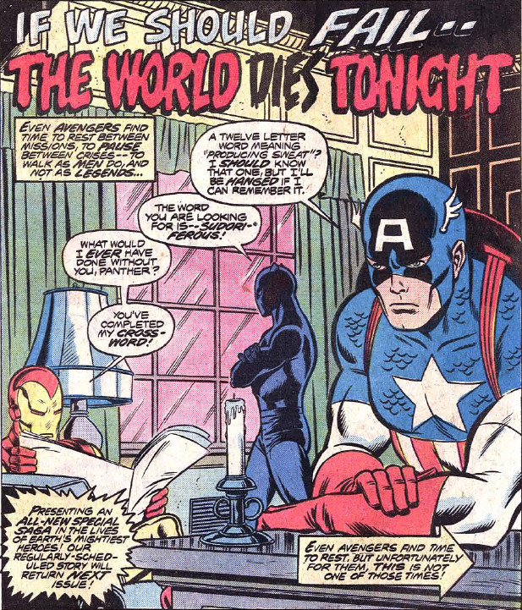

The creative team was not the regular crew but rather a guest team, who may have created this ‘filler’ issue months before with the sole purpose to relieve a looming deadline that couldn’t be met. By ensuring the regular publication schedule, Shooter demonstrated an acumen for business whereby the reader base gets something on a consistent basis – even if that something is not exactly what was envisioned.

In addition, the tone of stories issued under his direction changed quite a bit. There were more flashbacks and explanatory dialog/captions than ever before. Most of it was done artfully without being too intrusive but it was a welcome change to me, even in those cases where I knew what had happened before (by this point I had paid most of my dues).

Although I don’t know for sure, I also believe he was behind the man ‘album’ issues that came out during this time. These served as mini-summaries of the key historical points in the series (and to whet the appetite for back issues). Two primary examples of these are *Fantastic Four* #190 and *Spider-Man* #181 (both from 1978)

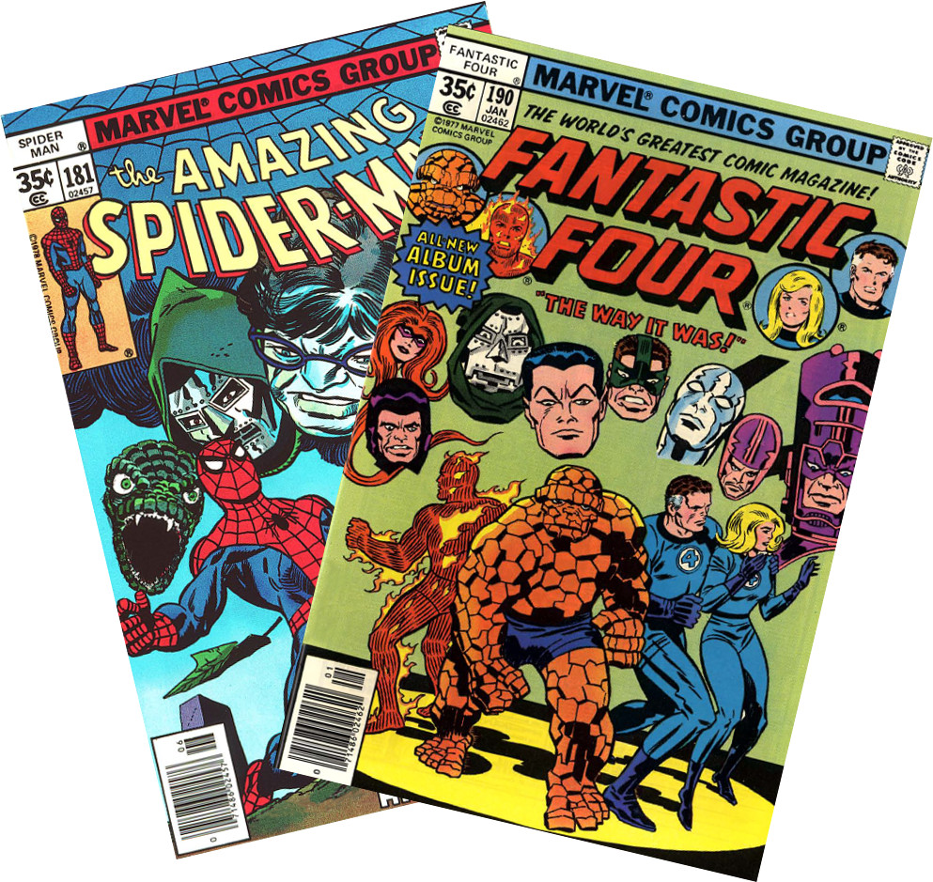

The basic premise of both issues is a reflection on the past by a lead character. In the case of the Fantastic Four, the Thing reminisces about the past while thumbing through his diary with Alicia Masters. In the case of Spider-Man, the cause of his look back to the past is the anniversary of the death of Uncle Ben.

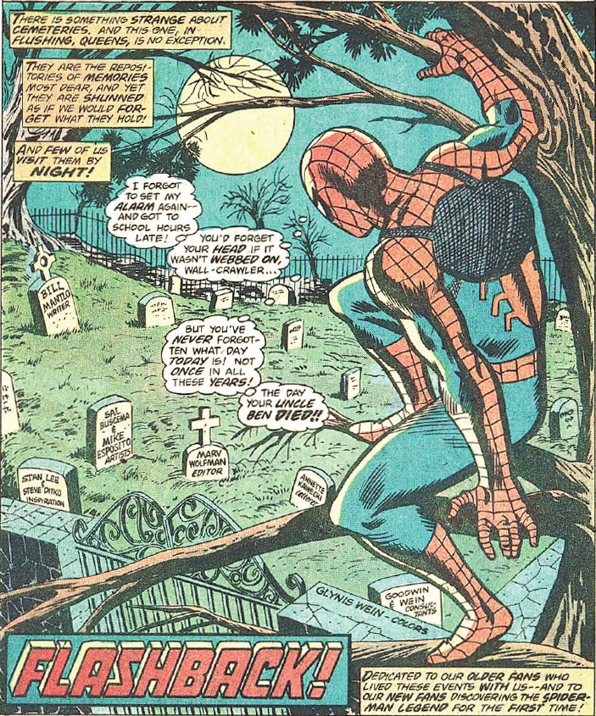

Note the lower-right caption in particular reads

<Dedicated to our older fans who lived these events with us – and to our new fans discovering the Spider-Man legend for the first time!>

A quick skim through the Avengers run with Shooter at the helm as writer also shows that he knows how to ‘eat his own dog food’. His stories are tightly constructed and have a good balance in exposition, neither getting pedantic nor obscure.

Considering the number of creators who fail to construct compelling stories and the [absence of clear exposition](http://aboutcomics.blogwyrm.com/?p=620) in many of todays, modern titles, I think it may be high time to revisit the legacy of Jim Shooter.

# The Wicked and The Divine

*The Wicked and The Divine* is an ongoing series from the creative team of Gillen McKelvie (writer) and Wilson Cowles (main artist), published by Image Comics. The basic theme of the comic is to examine the question ‘what price fame’ and the basic mechanism for performing this evaluation is that the most visible pop icons are literally gods – 12 paranormal beings with names plucked from every belief system on the planet (although not all 12 need be present at the same time – their emergence being staggered).

However, there are rules and a catch. The rules are few but important. These twelve gods are part of The Pantheon which promotes them as pop stars, affords them access and privilege, handles their fan interactions, and cleans up after their ‘miracles’, all at the expense of subjecting them to the oversight of a mysterious, masked old woman. The catch is based on the old saw that says that a candle that burns brightest burns for the shortest time. Two years is all you get as a god before you die.

At the time of this writing, the creative team has completed 3 major story arcs and, truth to tell, I am still unsure as to how I feel about the effort. In order to understand my ambivalence, I need to sketch not only the events that have been revealed in the text but my own inferences based on them.

The method of storytelling is predominantly sequential with flashbacks thrown in at various junctures to fill in a bit of characterization or to answer an open question. There are at least twenty important characters but most of them seem to be of the same essential temperament – greedy, petty, and generally unsympathetic. The major distinction between them is how they approach the fame associated with being super-powered gods/pop stars. These characters fall into three groups: the famous, the wannabes, and the enablers. There seems to be no considerations of other types like, say, a character who shuns fame because he truly knows the difference between the good life versus the high life.

The plot is actually quite simple at its core, although the creative team does a nice job of decorating the events with enough flesh that the skeleton doesn’t peek out much. The events of the story start tantalizingly enough about 90 years earlier with a previous recurrence (such is the name given to the cyclic return of the gods). While twelve gods comprise a recurrence, at the opening scene we see only four of them at their gathering table. The remaining spots are manned with the skulls of their deceased comrades.

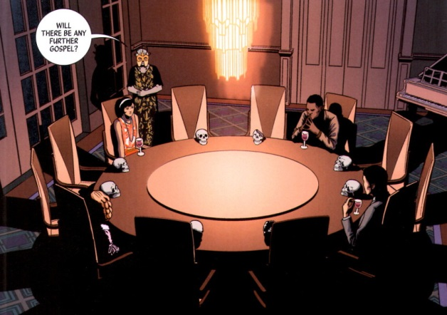

The older woman, dressed something like a middle-aged flapper sporting a mask,

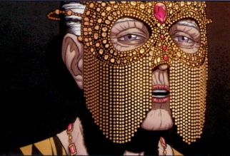

addresses them with some final words before stepping outside the house which then proceeds to explode. So much for the gods of the 1920s!

The scene moves forward nearly a century to the next recurrence and our attention is now focused on perhaps The Pantheon’s biggest fangirl, Laura Wilson, who skips classes at her local university in order to be caught up in the excitement that is The Pantheon.

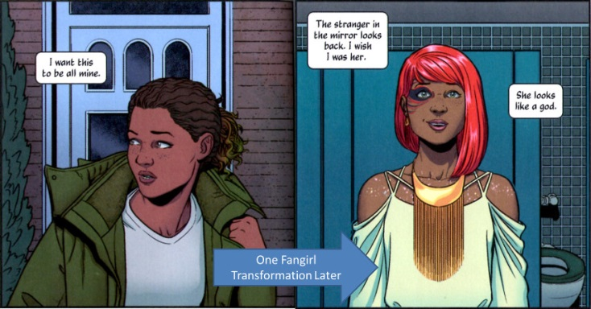

Laura distinguishes herself in the eyes of The Pantheon by being the last person to pass out due to excessive ecstasy during a concert performance by Amaterasu (Japanese sun god). Waking up after her swoon, she becomes acquainted with Lucifer and, in typical Faustian fashion, promises to ‘do anything’ for a chance at meeting with other members of The Pantheon.

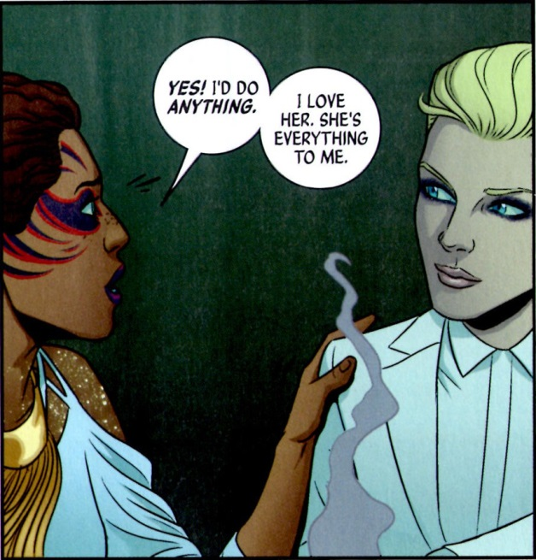

Whether this little slip amounts to anything remains to be seen but why have a Lucifer in the story to begin with if rebellion, soul-selling, and quibbling about terms isn’t needed. In any event, the L’s go off to a Pantheon post-performance party. The fun barely gets going, when two gunmen, shooting from a rooftop across the street, open fire on the intimate little gathering, provoking Lucifer’s ire. In due course, the assailants collect what they have coming when Lucifer steps out onto the balcony, snaps her fingers, and proceeds to vaporize their heads.

A short time later, the jurisprudence system has convened in a court room to decide whether the blond-haired hellion is guilty of murder. In a characteristic act of defiance, Lucifer taunts the judge, asking how anyone could kill another by simply by snapping his fingers like so. Unfortunately, Lucifer’s snarky speech is cut short when, at the moment she snaps her fingers, the judge’s head also explodes. Lucifer, as shocked as anyone, realizes she’s in real trouble now and, as she is being led out of the courtroom past Amaterasu, she whispers a request for Amaterasu to get Ananke to help.

Despite her protestations that she didn’t kill the judge, the public at large concludes Lucifer is guilty. And off she goes to prison. Sitting in a cell and sporting finger cuffs that prevent more snaps, Lucifer remarks dourly on the fact that her only visitor is Laura. Still beggars can’t be choosers, and Laura manages to get the Lord of Lies to open up to her. Plucking up her courage, Laura asks about the whispered name of Ananke that she had overheard in the courtroom. Lucifer curtly responds with an answer that would find more a home in *Harry Potter*.

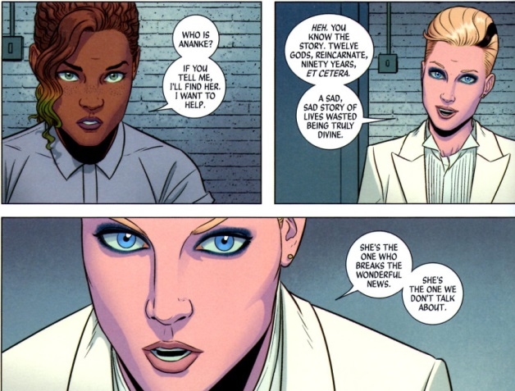

Not to be deterred and intrigued by a member of The Pantheon who is outside of the limelight, Laura turns to her phone and to Wikipedia to find out all.

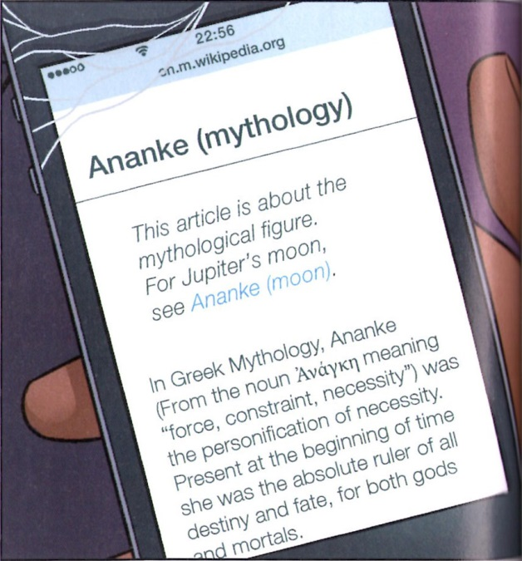

Meanwhile, back Valhalla the headquarters of The Pantheon (yes that means there is an Odin), the reader is treated to just what Ananke’s position is as she expresses herself to the other members of the Pantheon.

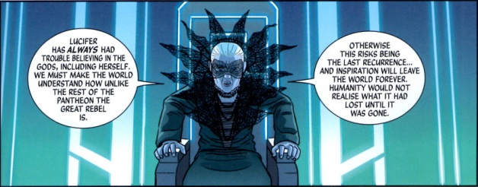

While her last words about the recurrence and human inspiration are cryptic at this point in the story, their meaning becomes clear much later on when Ananke explains that the reason for the god’s return every 90 years is so that they can combat the darkness and secure a better future for humanity. I suppose this is the writer’s way of explaining the various golden ages that have cropped up in human history and then collapsed and disappeared. Ananke also explains her role. As goddess of necessity, she is tasked with sheepherding the new incarnations of the gods, who emerge from the general population at the appointed time but with no awareness of their previous incarnations. She is the only one who persists from recurrence to recurrence.

The public clearly have bought into the beneficial aspect of the recurrence, with some members even asking

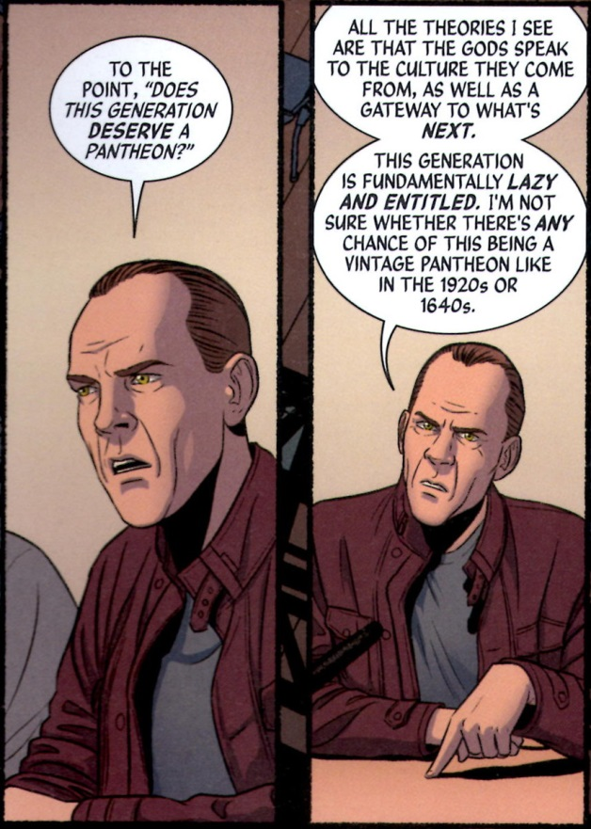

This recurrence myth may be a reasonable explanation for the characters in the story, but the reader is purposefully left with a sense that much of this ‘truth’ is simply Ananke’s propaganda, which she uses to cover more sinister machinations.

This last point is further emphasized by the single central event of the story. Lucifer, left to rot in prison with no attention from Ananke, predictably breaks free and spreads chaos everywhere. Claiming she has no choice, Ananke ends Lucifer exactly the way the gunmen and the judge do; by vaporizing Lucifer’s head.

And so begins the second arc, a motive-driven, whodunit investigation instigated by Laura, who is aided by an investigative journalist named Cassandra. Their aim is to discover who really killed the judge, framed Lucifer for the death, and thus brought about her end.

At first their investigation is productive. They quickly find evidence that points towards the notion that the gunmen’s motive was the Prometheus gambit, which is a way for a mortal to steal a god’s power by assassinating the god. They also witness the arrival of a new Pantheon member – Dionysus. Unfortunately, they are not privy (unlike the reader) to the Ananke’s manipulation of the death god Baphomet,

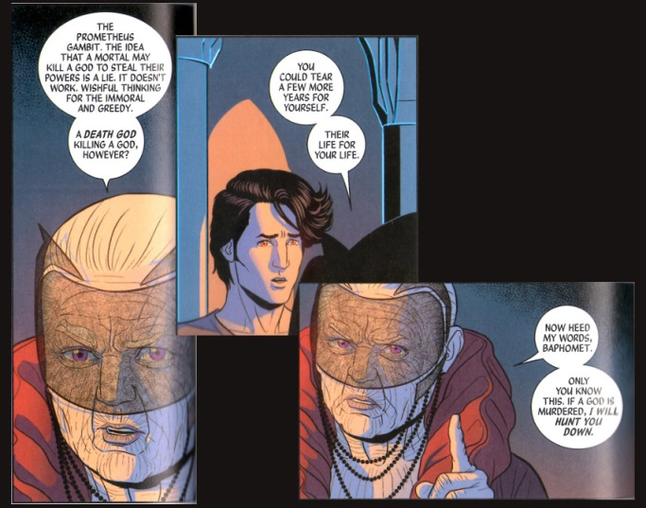

which sets the death god at odds with the rest of The Pantheon. All hope of Laura and Cassandra discovering this ploy is dashed when Ananke declares Cassandra (and her two assistants) to the be the last member of the recurrence – the Norns.

Laura can’t help feel disappointed that she wasn’t chosen/revealed. However, soon afterwards, Ananke declares Laura to be Persephone.

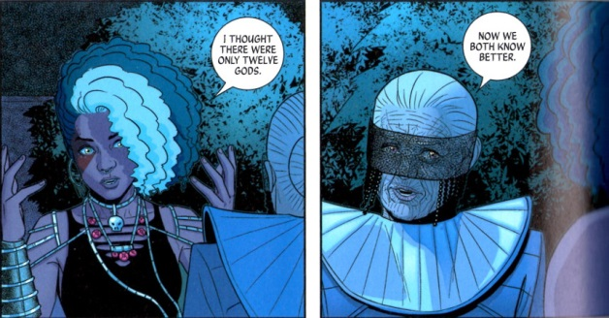

Immediately after, Ananke kills Persephone and her parents. Heavy is the price of fame, of finding you are special.

At this point, it becomes clear that Ananke is manipulating the Pantheon to kill each other to fulfill her own ends. These haven’t been revealed but no doubt her motive is either jealousy (she’s forced to live perpetually in the shadows as an old crone while the rest cavort in the public eye) or gain (she’s stealing their life force to gather power or perpetuate her own existence – it’s not clear whether there have been repeating gods in the recurrence).

The third story arc supports this conclusion as it is definitively revealed that Ananke is the party responsible for the judge’s untimely death and that Odin is an accessory after the fact. It is also a reasonably supported conclusion that we haven’t seen the last of Laura. After all, in the classic Greek myths, Persephone returns from the underworld. Foreshadowing of this outcome is found at the end of the current issue (#17) where a Pantheon act is booked for performance and the headliner is

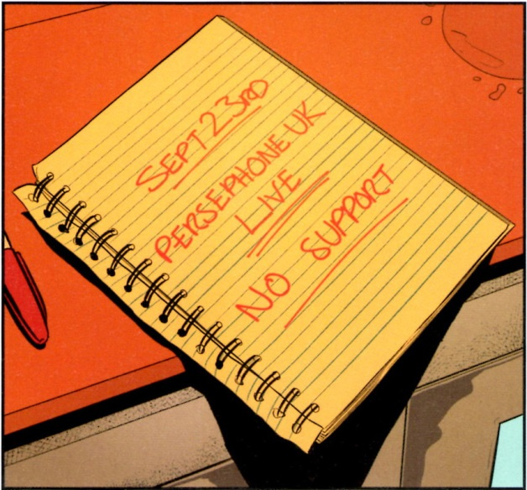

I suspect that the coming issues will feature Laura/Persephone’s return from the dead, the revelation of Ananke’s manipulations and schemes, a dramatic confrontation between the two, and a final resolution in which the gods are either able to exercise free will or where the recurrence is permanently broken and the gods are no more. And therein sits the problem. I’m pretty sure I can see what’s coming and it’s all so predictable and tedious. In the end I fear that the story will be neither wicked nor divine but simply banal. Oh well time will tell and hopefully sooner than 90 year from now.

Added bonus: The complete 12-god wheel from the series is:

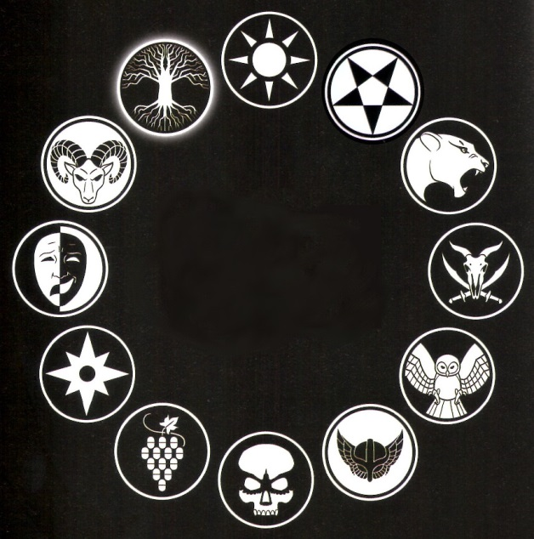

This composite image is not available in the series itself. The gods in the modern recurrence are (starting at the top and going clockwise): Amaterasu, Lucifer, Sakmet, Baphomet, Minerva, Odin, The Morrigan, Dionysus, Inanna, Tara, Baal, and the Norns.

# Unfollowing *Unfollow*

It begins mysterious enough. A well-dressed man, wielding a semi-automatic weapon, and wearing an Oni mask has just tracked down and murdered one of his fellow beings. The dead body having fallen over a cliff, our assassin confirms the kill by glancing down onto the rocks below. Satisfied that his job is done, he utters:

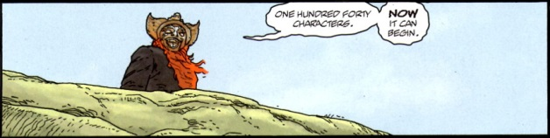

And so begins *Unfollow*, the new, ongoing Vertigo series by Williams, Dowling, and Winter.

Of course, the phrase ‘one hundred forty characters’, immediately conjures images of Twitter but one suspects that there is more. After all, there is no evidence that the launch of Twitter was any more harmful than to cause mild damage to the diets, eyes, and familial relationships of the many programmers that made it possible.

Playing on two different meanings of ‘character’, *Unfollow* is really a Lord-of-the-Flies look at what happens when a rich entrepreneur, by the name of Farrell, leaves his 18-billion-dollar fortune to 140 random persons.

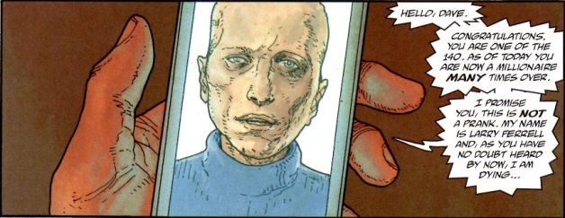

Rubinstein, our Japanese-faced enforcer, works for Farrell but seems to be a loose cannon. His function is the clean up around the edges so that Farrell’s morality play can develop as planned.

The rest of the action so far (issues #1-3 are out as of this writing), is devoted to the identification of the key winners, the gathering of them to Farrell’s island (what else) and the setting of the stage.

The story focuses on five key characters:

* Dave, a stereotypical inner city kid;

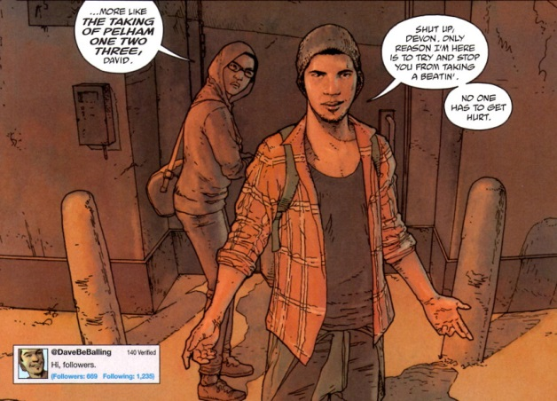

* Courtney, a rich, disaffected young woman who is a perpetual thrill-seeker;

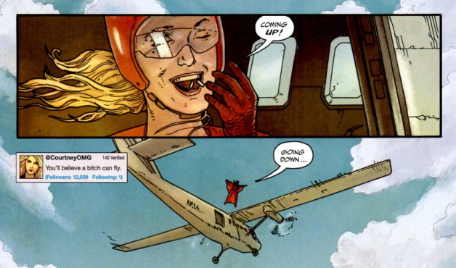

* Deacon, tough, evangelical-survivalist hybrid;

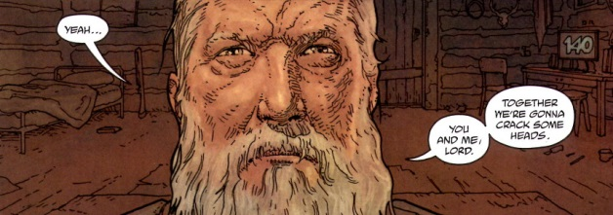

* Akira, a sexually ambiguous Japanese artist, with gentle delusions of godhood;

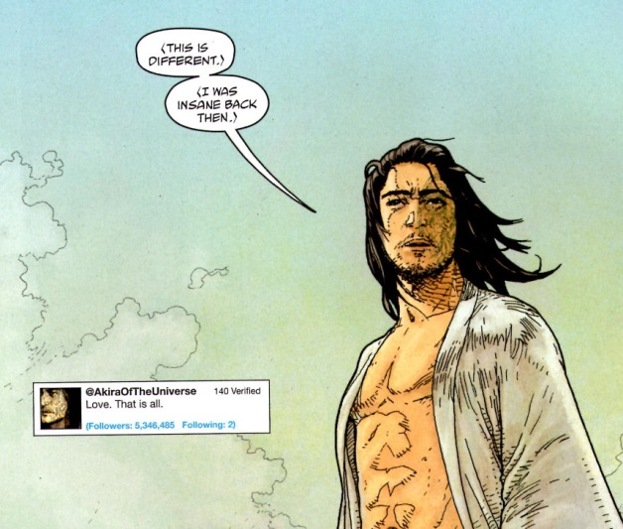

* and Ravan, an Iranian woman who, as BBC reporter, has just covered the public execution of a 10-year old girl and is now trying to go underground to avoid the authorities.

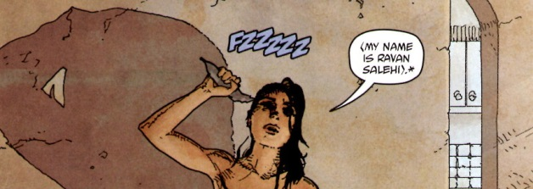

Some additional characters are also introduced, including an enormous Nigerian oil worker, with a propensity to violence.

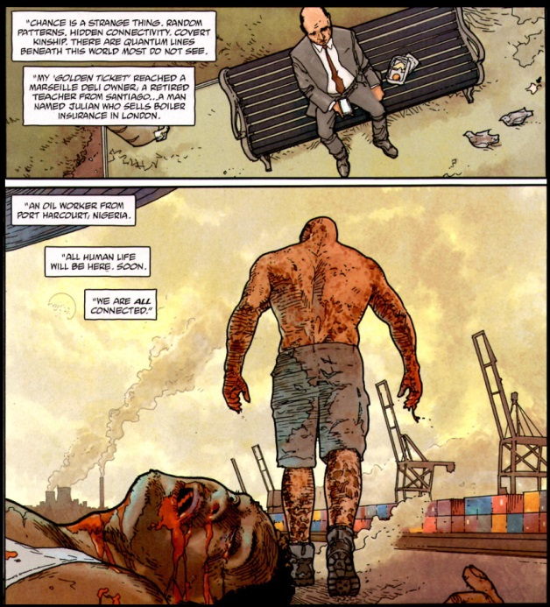

Early indications point to this latter winner as the villain of the piece, at least the catalyst for violence.

After summoning the winners to his Caribbean island, Farrell addresses each of them with provocative message. Pointing out that only 139 of the original 140 winners remain alive, Farrell goes on to say that each of them has now increased his fortune to the tune of about a million dollars.

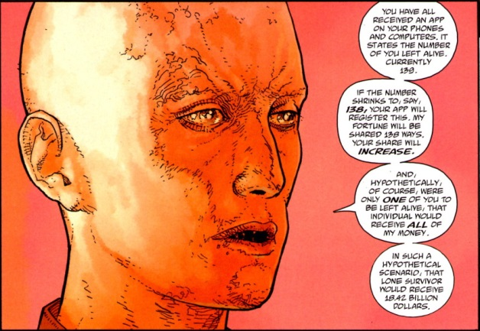

He ends his speech by observing that should only one of them be left alive, that ‘last man standing’ would get the whole pile of cash – all he or she would have to do would be to kill the others.

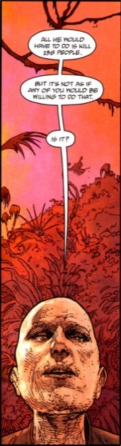

On the surface, *Unfollow* has elements familiar to the western mind. The creators make multiple allusions to the Golden Ticket of Willy Wonka fame. And, no doubt, the theme of power pitting people against people reminds us of stories like *The Hunger Games* or *Lord of the Flies*. All these elements are now blended into something new. So what’s not to love?

Well, *Unfollow* isn’t new. It’s really patterned after is a fairly recent and unheralded amine called *Eden of the East*. The plot is almost line-for-line the same, with *Eden of the East* having a good 4 or 5 years on the scene before *Unfollow* came out. Now derivative isn’t a criterion for rejecting but content is. While Unfollow has acceptable art, its characters are cookie cutter, archetypes. One can predict what each character will do, how each will behave, simply by knowing what each looks like of where each hails from. In addition, these characters are unsympathetic (with the exception of Ravan) and the only entertainment is in seeing how the spectacle will unfold. On this point, I doubt that *Unfollow* can match *Eden of the East*. So with the aim of keeping my experience with *Eden of the East* alive and unsullied, I’ll be unfollowing *Unfollow*.

# A Marvel Epic: Part 1 - Overview

Well it’s over. It’s been a few months now since Marvel’s company-wide, total reboot of their creative universe has drawn to a close with the last installment of *Secret Wars #9*. I thought it was a good time to pause, survey the new landscape, and reflect on how we got here. Over these next four installments, I’ll be analyzing just what Jonathan Hickman, the writer and creative glue, tried to do, what the high points and the lows were, and whether or not it really came off as expected.

In this article, I want to set the stage for Hickman’s undertaking by giving an overview of what he tried to implement and the creative and commercial tensions under which he operated. In a nutshell, Hickman attempted what could only be called comics first, true foray into the epic. This may seem a strange thing to say since ret-cons and reboots have been fairly common on the comics scene for several decades now and mega-crossover events are nearly as common. But I stand by this assessment since an epic is not and should not be judged solely by how large it is. It is true that size and scope are crucial elements, but an epic must, simultaneously, also deal with the big questions in both big and small ways. Hickman’s work on what I will call the *Everything Dies* storyline (the reason for which I give below) meets both criteria, albeit not always successfully.

The question of size and scope is the easiest one to understand and support, so let’s discuss this one first. The scope of *Everything Dies* was unprecedented in the comics industry. To appreciate that claim, consider that the first of these continuity cleanups, DC’s *The Crisis on Infinite Earths*, was a 12-issue limited series with important links to the existing titles but with a storyline comprehensible and digestible as a standalone event. Subsequent reboots of the big two have grown even more and more complex and more cosmological with dimensions, universes, and multiverses being taken apart and put back together within most if not all of the current series, but the size and scope has always been limited to at most a year of crossover events. What Marvel did in the *Everything Dies* storyline literally dwarfs everything that has come before combined.

The core *Everything Dies* storyline actually starts publication in starts in the winter of 2013 with launch of the twin Avengers publications *Avengers* and *New Avengers*. Both of these titles, which were written by Jonathan Hickman and drawn and inked by a host of artist teams, ran for almost 3 full years; spanned 78 issues (plus additional ancillary tales); played host to two separate company-wide crossover events: *Infinity* and *Original Sin* (each of which brought even more issues into the fold); and eventually led into the final *Secret Wars* climax.

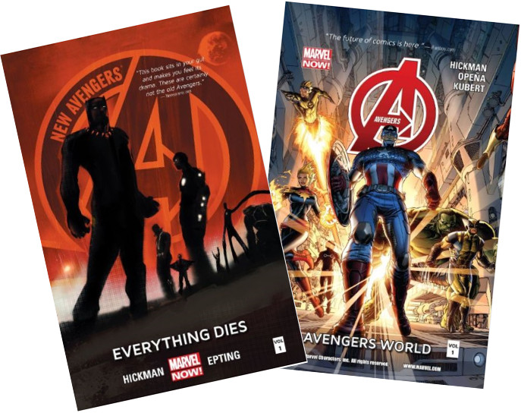

Obviously *Everything Dies* storyline was required to be more than a creative, literary success; it also needed to be a commercially lucrative, since it would set the stage for all future Marvel titles. In addition, although not explicitly stated, it also needed to be done in such a fashion that allowed Marvel to downplay the X-men, Spider-Man, and Fantastic Four franchises since none of these was in the stable of Marvel Studios at the time of the publication. As a result, the core of the tales centered on the Avengers, Inhumans, Black Panther, Doctor Strange, and the Sub-Mariner, with only bit appearances by the X-men and Spider-man. The Fantastic Four are almost completely absent as a ‘brand’ and only Reed and Sue Richards really play a role.

Of the two of these titles, the *Avengers* title is more action oriented, more classic, and more wholesome. The *New Avengers* is a darker and, perhaps, more interesting title. At the core of both of them is the ethical dilemma called the [Trolley Problem](https://en.wikipedia.org/wiki/Trolley_problem), which asks when is it permissible, or even imperative, to sacrifice some life so that other life may be saved.

To set the stage for this form of the dilemma, Hickman had to invent a new type of cosmology. The following composite image, pieced together from material taken from the *New Avengers,* Hickman tries to explain the roots of the quandary.

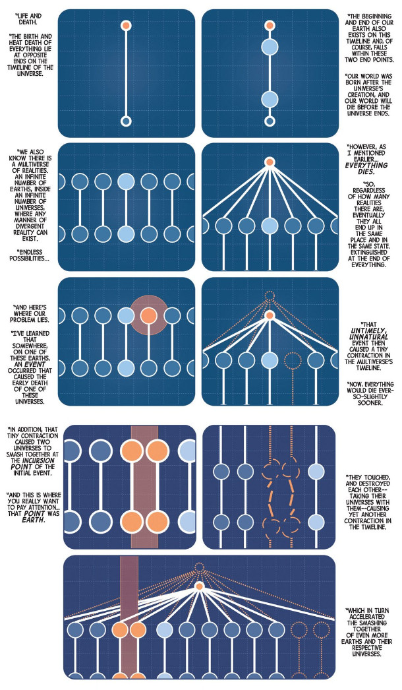

The pinching together of two universes happens along the specific timelines (worldlines in the technical jargon) of their respective Earths. Left unchecked, such an incursion destroys both universes. However, if there were a way to destroy one of the Earths, the both universes would survive as another discussion of the multiversal fate informs us

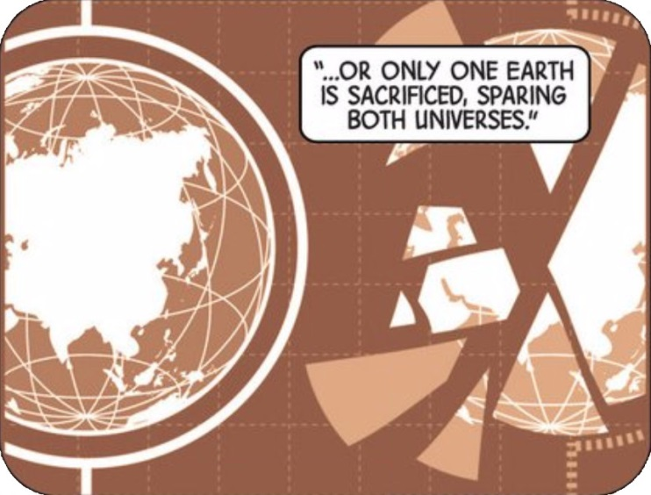

On the surface this may seem to be no different than the continuity cleanups but the Trolley Problem aspect, which is now so large as to engulf the entire published output of Marvel comics, provides a nuance not in the earlier reboots. It is no longer a good versus evil race-against-time, but an authentic situation wherein men of good conscience can view the same set of facts from different points-of-view and take widely different actions, as a result.

Of all the infinite possible universes, the reader is, of course, privy to the events surrounding those men who live on the most familiar and beloved Earth of the Marvel universe (dubbed Earth-616). The core characters who wrestle with this ethical conundrum are Captain America, the Sub-Mariner, the Black Panther, Doctor Strange, Hank McCoy the Beast, Reed Richards, and Tony Stark/Iron Man. Their anger, fear, comradery, indecision, and bold actions link the huge with the small and turn what would have been an ordinary cosmic opera into a full-fledged epic.

Next week, I’ll present a careful look at the timeline of events that comprise the full story. In third installment, I’ll be looking at the personality conflicts and revelations that make up the human element of the story. And in the final installment, I’ll discuss what I thought worked and what didn’t in both the literary and commercial fronts.

# A Marvel Epic: Part 2 – The Start of the Tale

This week I resume the detailed look at Jonathan Hickman’s architecture for the *Everything Dies* storyline in which he orchestrated the massive end and reboot of the Marvel publication universe. As discussed in Part 1, the genre that best fits what Hickman engineered is the epic. Epics, by near-universal agreement need to be big in scope and have high stakes outcomes and have to deal with the big questions of life.

Classic epics have dealt with the savage siege and subsequent fall of Troy in the *Iliad*, the long, world-encircling journey home of Odysseus in the *Odyssey*, and the establishment of the roots of the Roman empire in the *Aeneid*. But no scope is broader than and no stakes higher than the total end of all there is. And that is exactly what Hickman deals with in Everything Dies.

The plot is complicated, in a fashion that befits the epic, but it is possible to summarize it fairly succinctly and I’ll be doing so over the next three posts. The central idea, which was discussed in the last column, is the fact that, for reasons mostly unknown during the bulk of the story, the multiverse is coming to a premature end. Although published second, the *New Avengers* is the logical place to start.

The first tangible evidence of the coming catastrophe occurs in the African country of Wakanda. The Black Panther is out in the Wakandan jungle observing a ‘coming of age’ ritual in which teams of young adults attempt to solve a treasure hunt. Proud of the winning team, T’Challa approaches them and speaks to them of what the future holds. Suddenly, a rhinoceros appears out of nowhere and nearly runs the lot of them down. Investigating, the Black Panther soon finds himself caught up in an incursion, a multiversal collision between Earth-616 and another Earth from another universe. As he looks up into the sky, he sees several figures fall from the other Earth and he catches his first look at a character that will dominate the storyline: Black Swan.

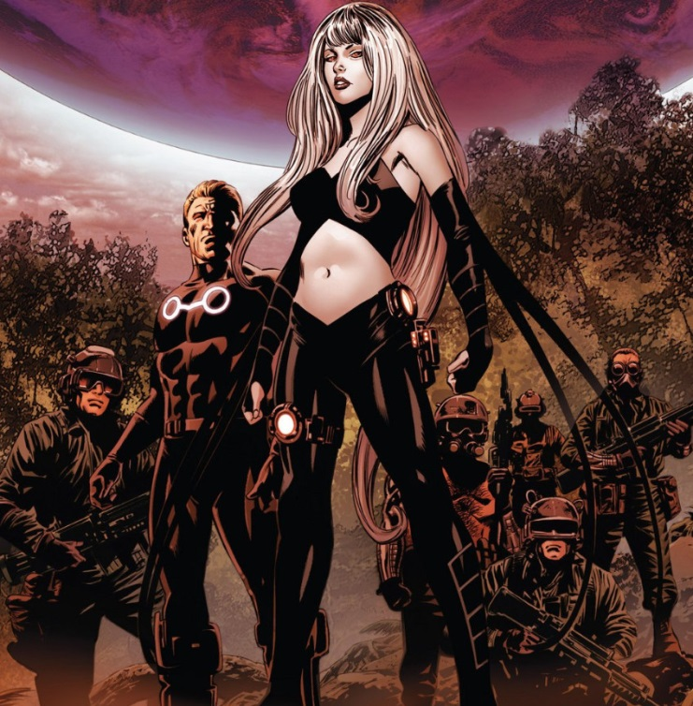

Being quite ruthless, Black Swan soon orders her team to kill T’Challa and his young subjects. In short order, only the Black Panther remains alive and while he is fighting to avenge the fallen, Black Swan takes the opportunity to destroy the second Earth, thus ending the incursion.

Taking her into custody, T’Challa summons a gathering of the Illuminati, comprised initially of Black Bolt, himself, Captain America, Doctor Strange, Iron Man, Namor the Sub-Mariner, and Reed Richards. Their first meeting opens on the ominous observation by Reed Richards that

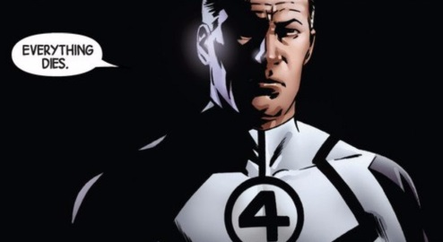

It becomes even more ominous, when Richard explains the central dilemma of their situation. They can either kill or be killed. They have only eight hours to pick between the two possible outcomes.

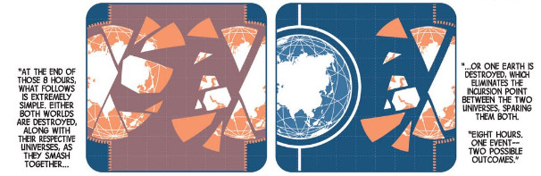

Captain America, repulsed by the notion that the rest of the Illuminati are actually entertaining the possibility of destroying a whole planet to stay alive, argues passionately that there must be a way to get out of the dilemma without crossing that line. Under his urging, they resolve to reassemble the Infinity Gauntlet as a way of fending off an incursion. At first this seems like a hopeless task as the Mind Gem is missing as it was in the keeping of Charles Xavier and he was died. Fortunately, Xavier arranged for Hank McCoy, the Beast, to become the keeper of the gem and soon the ranks of the Illuminati have grown by one.

Shortly after the Infinity Gauntlet has been restored, a new incursion begins. Citing that belief in the plan is central to its success, the rest of the Illuminati insist that Captain America wield the gauntlet and fend off the end of the world. He successfully does just that, but in the process the gems are shattered and their power lost

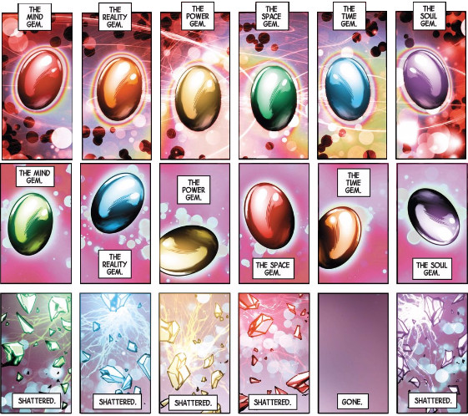

(The above is a composite of the Infinity Gems from New Avengers #3 and yes the color scheme for the gems changes during the course of the issue. I don’t know if that was an oversight or intentional, a point that I will return to later.)

Now faced with no answer but the unthinkable, the Illuminati wipe the memory of Captain America clean of all traces of the death of the multiverse and then they set on the path of building world ending weapons of mass destruction.

Against the back drop of this facet of the story, the *Avengers* title presents a unusual collaboration between Tony Stark and Steve Rogers. Perhaps feeling guilty for what they did to Captain America, Tony Stark embraces Steve’s idea to grow the Avengers to a team truly capable of dealing with the big threats.

The first such threat is the appearance on Mars of the team of three aliens: an Aleph, an Ex Nihilo, and an Abyss. There is considerable debate amongst the three of them as the Aleph wants the Earth destroyed while the Ex Nihilo, who has already terraformed a portion of the red planet into lush garden, would rather send origin bombs towards the Earth to transform it.

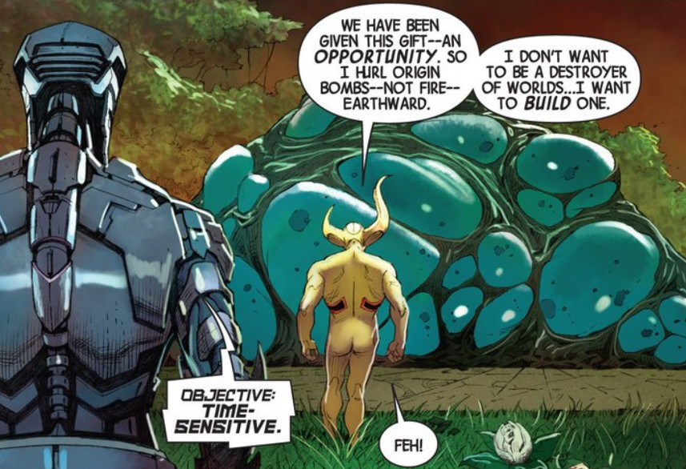

Ex Nihilo then asks Abyss her opinion. Her response is that humans have learned to use tools and, as a result, have become dangerous creatures. She continues by pointing out that a group of them are on the way to find the source of the origin bombs that are radically altering the Earth’s biosphere.

A short battle ensues, in which the Avengers are soundly defeated as the power of these aliens is too much for them. As will be revealed later in the series, they are representatives of the Builders, the first race of the universe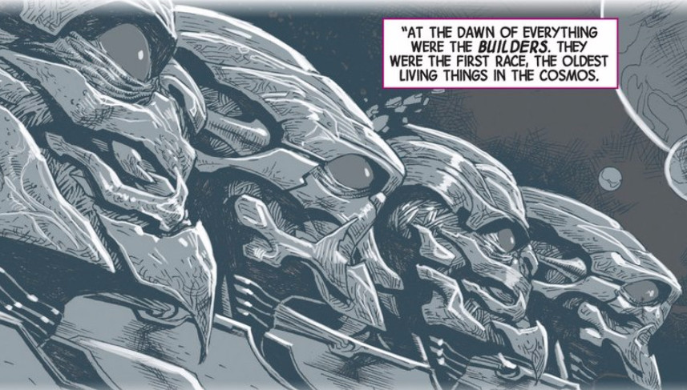

Originally they simply worshipped the ‘mother-maker’, the universe itself. But later they fell away and took it upon themselves to create new, universal systems of a more aggressive character that promoted evolution and change. The Aleph is one such system. This automaton destroyed countless worlds it judged as unworthy, but finding one worthy world, it released two entities, Ex Nihilo and Abyss, to nurture and shape it.

Bruised and battered, the alien trio sends Captain America hurtling earthward. However, his indomitable spirit soon has him on his feet again, gathering a different team, and heading to Mars to rescue those left in the clutches of Ex Nihilo, Abyss, and Aleph. One member of the team is Captain Universe, the living embodiment of the universe, and the deity that the Builders once worshipped. Once spotted, both Ex Nihilo and Abyss bow in worship but Aleph refuses. Captain Universe subsequently destroys him and forbids Ex Nihilo and Abyss to destroy or transform any more inhabited worlds. Ex Nihilo and Abyss comply and are granted permission to stay and play with Mars.

As the Avengers are leaving to return to the Earth to contend with the damage already done, Ex Nihilo can’t suppress asking a question of wonderment.

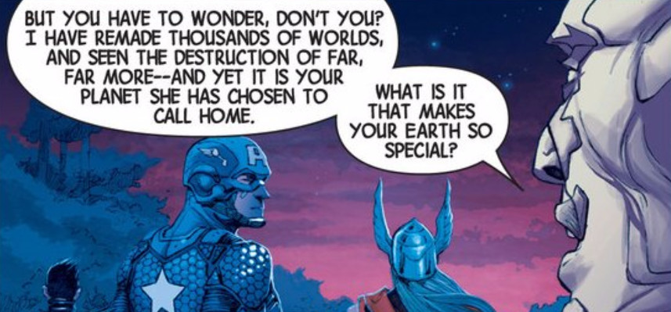

This question of what makes Earth so special is one that Hickman comes back to again and again, Avengers can’t defeat them but they convince them to play only with Mars.

These two pieces, the incursion-driven multiversal death and the universes response to this inevitable occurrence, form the backbone of the *New Avengers* and *Avengers* titles respectively during their run. Next week, I’ll be looking at the second stage of the tale, in which tensions mounts in the Illuminati as they try to muster the will to kill and entire world and the Builders, seeing the Earth as the lynch pin in the coming destruction, launch an all-out campaign to destroy the blue marble once and for all. This second stage includes all the events in both titles leading up to and including the *Infinity* event.

# A Marvel Epic: Part 3 – The Opponents Gather

The last column covered the basic tension in the *Everything Dies* storyline – namely that incursions between two universes in the Marvel multiverse pose a imminent threat to the existence of each and, ultimately, of the multiverse itself. This threat forms the key element and the various ways in which it is dealt pose the central moral conundrum.

But every good epic needs more than a framing problem, it needs human conflict large and small. There needs to be many sides, strong loyalties and shifting allegiances, personalities working together and struggling against each other. In Homer’s Iliad, there is often as much conflict within the Greek camp as there is between the Greeks and the Trojans.

By setting the stage with the biggest ‘save something’ scenario, Hickman provides himself with the vehicle to generate the conflict he wants. Since the stakes are bigger than saving a group of people, a city, a planet, a galaxy, or even a universe, he can reach into any dusty corner of the Marvel publication history he likes. In addition, since he is going to reboot the entire franchise, he can safely add new elements to the mythos without fear of being retconned. In some sense, he is retconning the whole thing, so why worry about the last details of a string of soon-to-be-obsolete publications.

The single biggest new element is the idea of the Builders. As discussed in Part 2, the Builders are the oldest race in the universe.

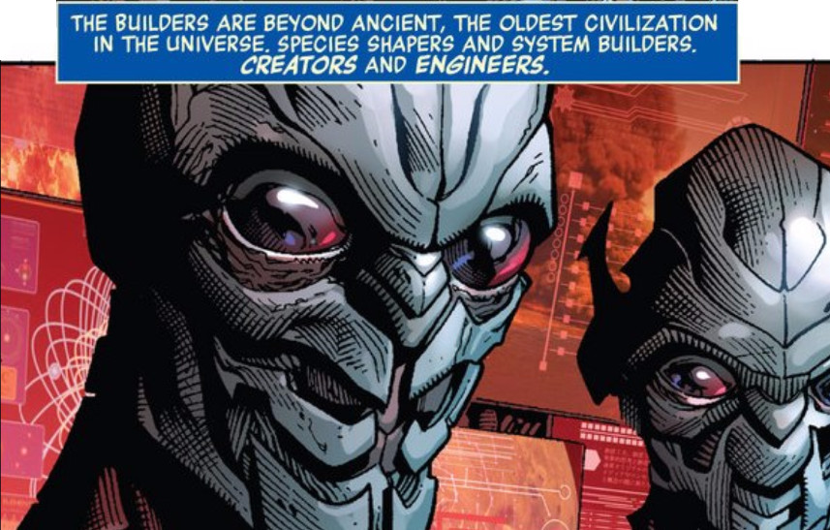

Originally content to worship the mother-maker, i.e. the universe, the Builders soon became the creators of a universe-wide system to ensure the protection and stability of the universe. How exactly their systems mesh with the avatar-based systems involving the abstract entities – such as Eternity, Infinity, Master Order & Lord Chaos, Galactus and the Celestial, and so on – is not detailed to my knowledge. But the universe is big and it doesn’t really matter now anyway.

What does matter is that the Alephs, Ex Nihili, and Abysii are one aspect of that system. Another aspect is a type of planetary defense built into the fabric of the universe and set to trigger when a world becomes advanced enough. The Ex Nihili encountered on Mars triggers that system through his origin bombs and his creation of what he described as the perfect human. This perfect human is born speaking Builder code so it takes a while until his name can be translated. When it is, the reader is treated to the revelation that his name is Nightmask and that he is a herald of the White Event.

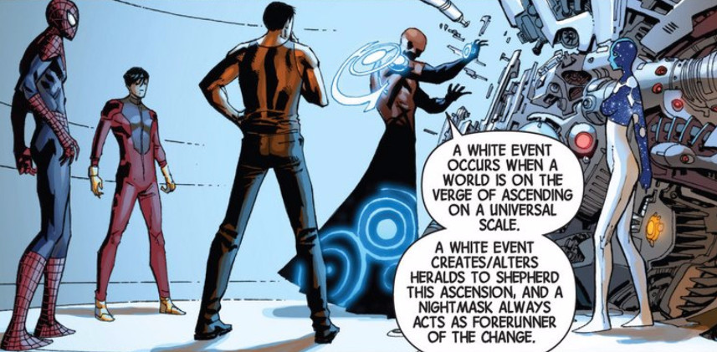

In this way, Hickman is able to pull the New Universe titles into the main Marvel publication universe in a smoother way than Mark Gruenwald attempted in *Quasar*. Of course, the New Universe is not complete without a Starbrand and, fortunately, soon after the introduction of Nightmask, one appears.

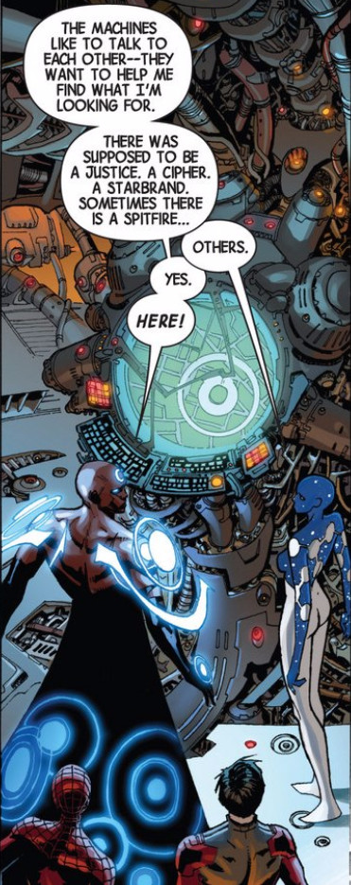

Unfortunately, his appearance is accompanied by a catastrophic disaster that claims the lives of thousands of people. When the Avengers arrive, the new Star Brand is out of control and they can’t control him. Finally, Captain Universe steps in and shocks some sense back into him.

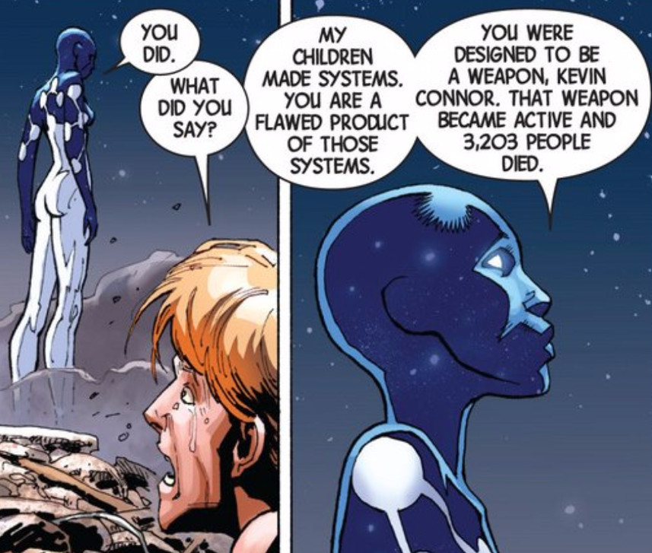

Here is one of the themes that Hickman returns to again and again. That the system is broken, which itself is a pale reflection of the fact that the universe is dying, that everything dies. Against this backdrop, he then casts all the actions and motivations.

One such set of actions are a whole set of new happenings around the sites of the origin bombs. People located with the impact radius of the bombs are transformed into new, evolved entities as the system fights to find a remedy for what ails it. One such, poignant story is when the Canadian super-team Alpha Flight penetrate a region where an origin bomb had detonated. Some of the team are repurposed for the new system response and the painful goodbye between Vindicator and her father is punctuated with

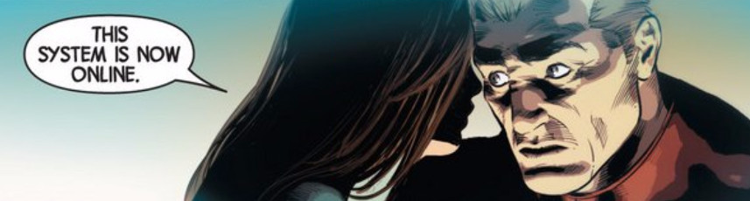

These smaller stories provide the human interest but for shear action, Hickman returns to the motions of the Builders, who, sensing the demise of all that is, seek to destroy the Earth hoping that since

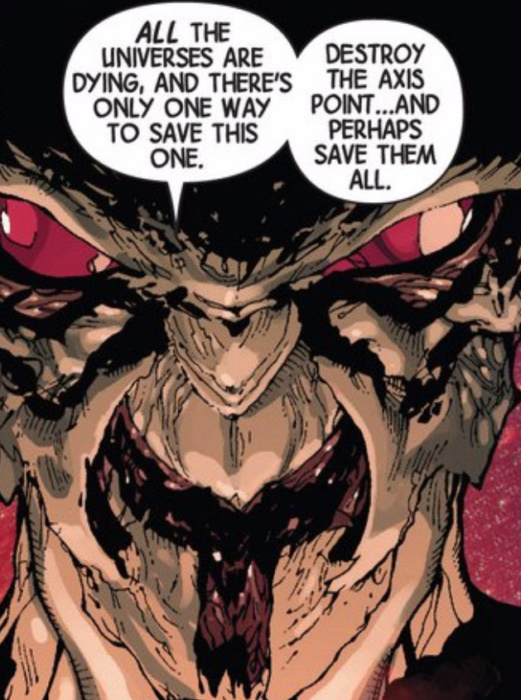

This reaction is not unexpected. In addition to the incursion dynamic, the reader of the Avengers has been reminded numerous times by Captain Universe that the Earth is special. Two such tellings are

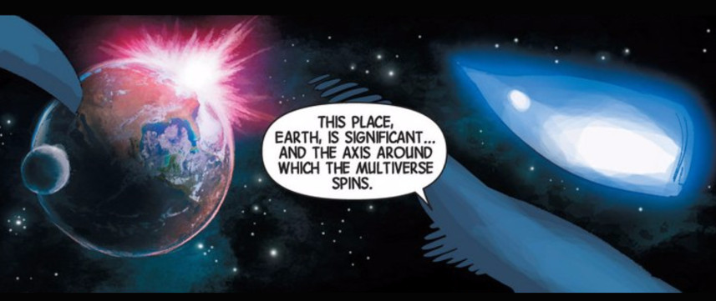

and

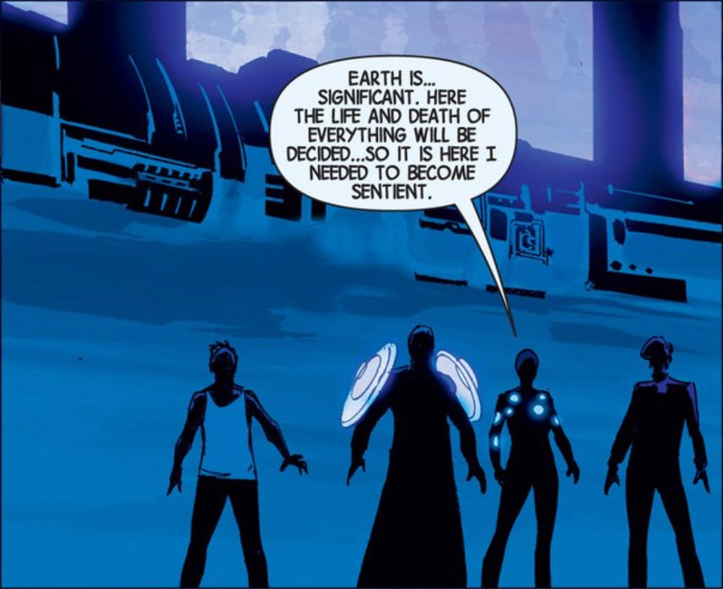And so begins the Builder war. Despite the alliance of the Avengers with the most advance star-faring races – the Shi’ar, the Kree, the Skrulls, Spartax, the Brood, and Annihilus , the Builders are still essentially unstoppable. The primary reason for the unprecedented coalition is that the Builders are moving from one end of the universe to the Earth and are destroying everything in their way.

Hickman makes a point to explain why such an advanced race can’t just appear near the Earth and lay waste. The superflow, the fluid that resides between the universes, and which, I suppose, embeds the individual universes, is breaking down

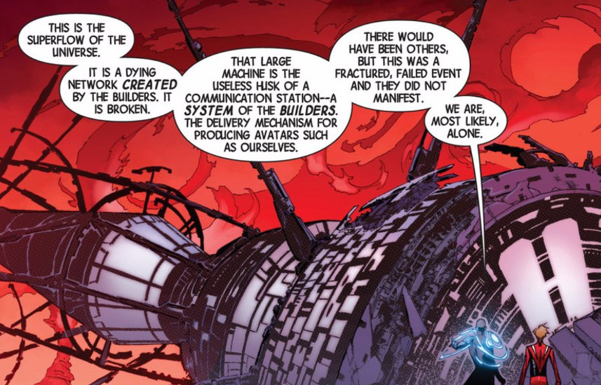

The Builders are no longer capable of using it to strike wherever they wish. A fact they lament.

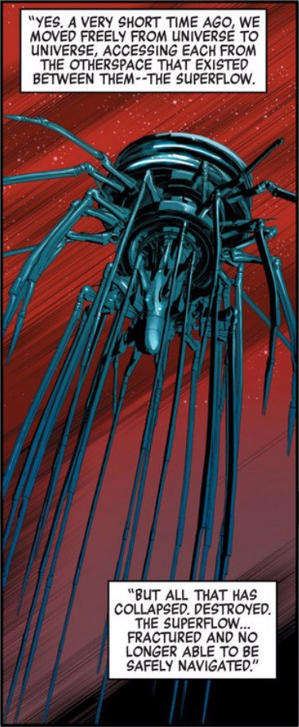

And so the Builders start from where they entered the Earth-616 universe just where they were shunted out of the superflow. There first target is Galador, of [*Rom the Spaceknight*](http://www.mycomicshop.com/search?TID=250001) fame.

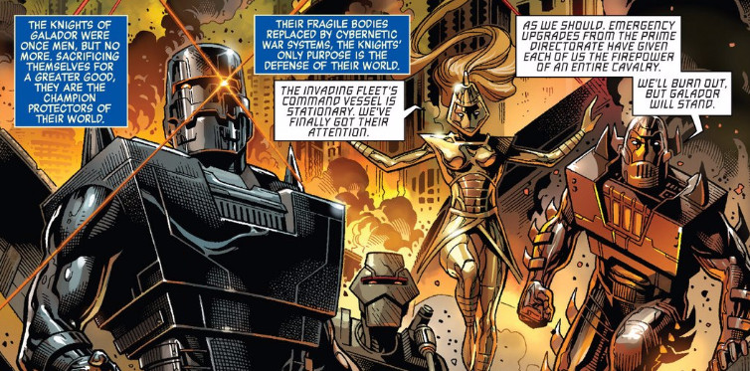

Captain Universe shows up to see the destruction saying that 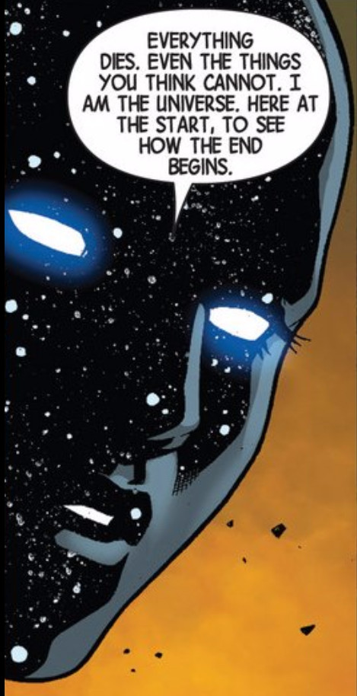

The shock of seeing Galador fall sends Captain Universe’s human host into a type of catatonia and disables her for a while and, as a result, she is not there to stop the Builders from waging war against everything in their way. The threat the Builders pose is enough to pull the Avengers from Earth and into space, leaving Earth effectively unguarded. It is at this time that Thanos and his inner circle the Cull Obsidian compel their ragtag crew to assault the Earth, despite the protestations,

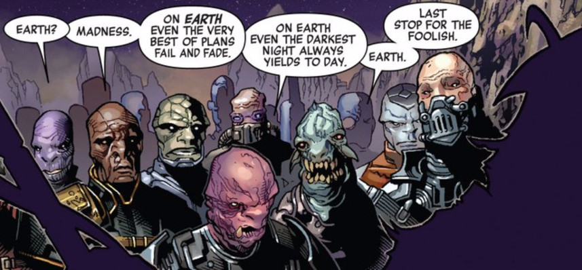

so that Thanos may kill the last of his children. A fuller account can be found in the post on [Thanos and Thane](http://aboutcomics.blogwyrm.com/?p=116).

So as the Avengers fight off-world, the Illuminati are all that is left to fend off the mad titan’s onslaught. Black Swan, her usual snarky self, derides the threat of the Builders

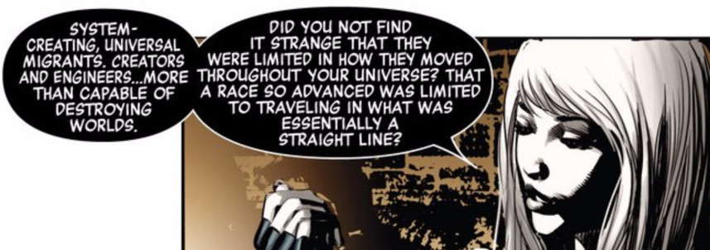

Instead she speaks with awe and fear of the multiversal threats that actually accompany the incursions. Of these, Black Swan talks cryptically about the Black Priests who destroyed her world

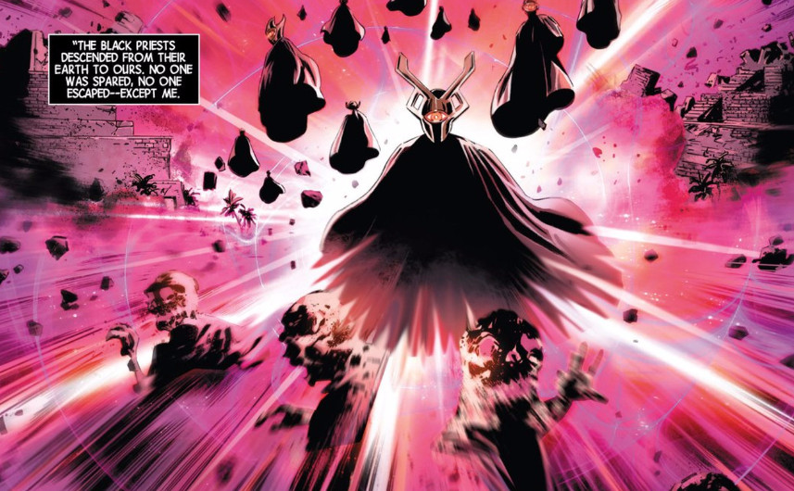

And the Map Makers and Sidera Maris, servants of the Ivory Kings, who she has witnessed destroy other Earths.

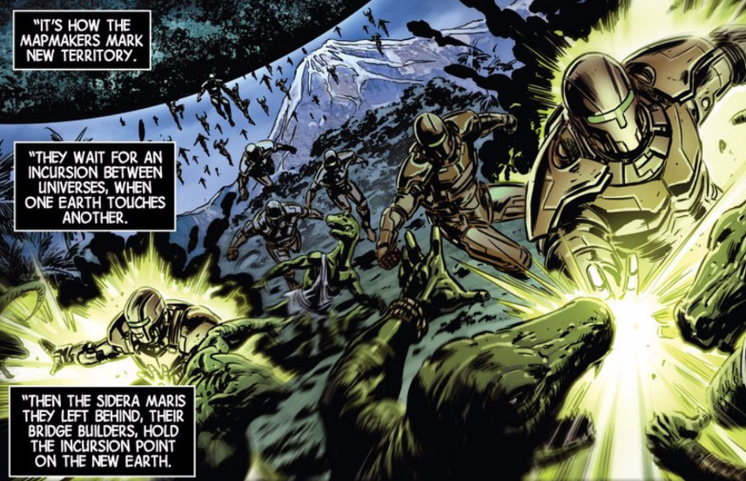

The Builder war comes to an end when they capture Captain Universe, Nightmask, Starbrand, Abyss, and the Ex Nihilo from Mars. The Builders are amazed that the humans possess the sentient systems they designed, especially an Abyss, of whom all were thought lost.

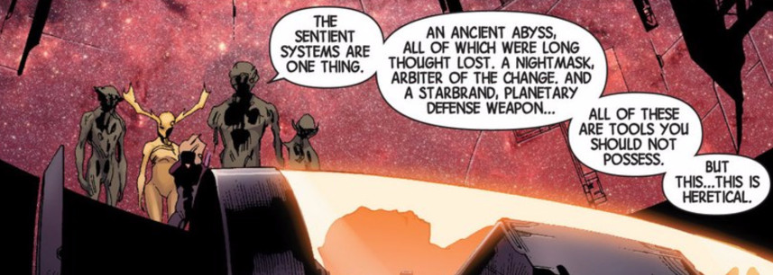

But they are absolutely flabbergasted to realize that a human plays host to the mother-maker in the form of Captain Universe.

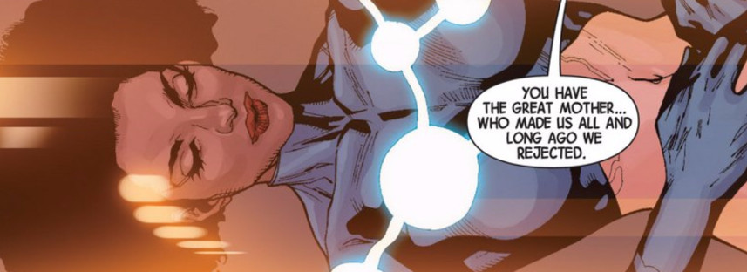

As the drama unfolds, there are two particularly pivotal events. First, the Ex Nihili, who are in the train of the Builders, are perplexed by the presence of the last Abyss. They ask the Martian Ex Nihilo how such a thing could be. Abyss answers by point out that the Builders had lost their way and had given up on life

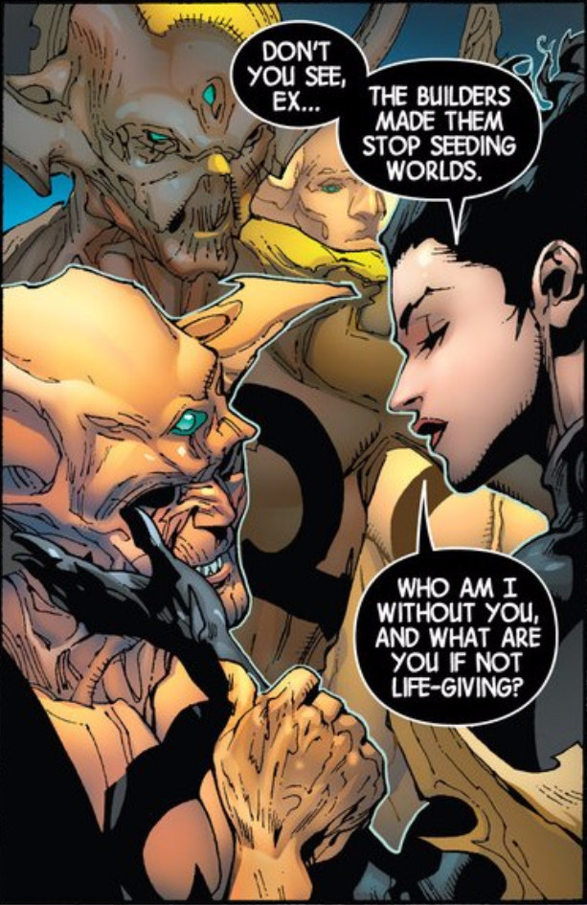

Seeing the truth of her words, the Ex Nihili unite to stop the Builders. But even their might when married to the intergalactic alliance of the Avengers and the star-faring races proves too little. At the end, Captain Universe wakes and confronts the Builders.

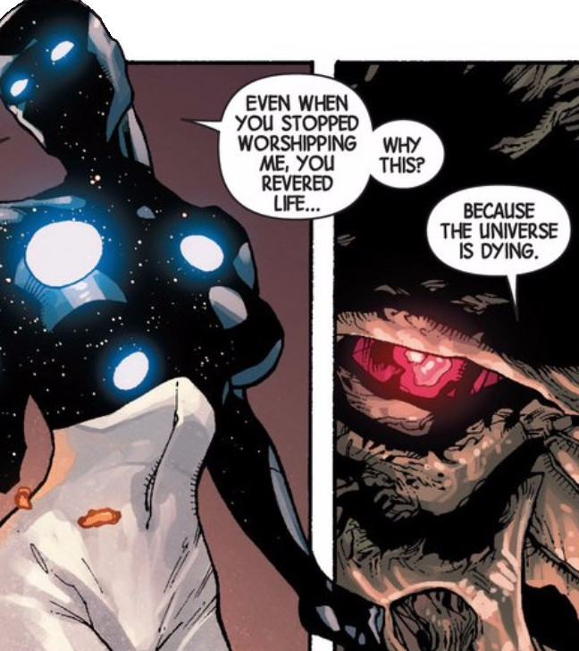

Her might brings the conflict to an end.

Back on Earth, the Illuminati are able to hold off Thanos and the Cull Obsidian until the Avengers can return. However, the costs are high including the loss of the Inhuman city of Attilan and the virtual destruction of Wakanda. Like the Builders war, the fight between Earth’s mightiest and Thanos’ death-seeking cult comes to an end through the intervention of an outsider. Thane consigns his father and two members of the Cull Obsidian to a living death (see the [*Is Anybody Up There Listening*](http://aboutcomics.blogwyrm.com/?p=116) post from Dec. 2014).

The rest of the events in both the Avengers and the New Avengers titles are designed to strip away the hidden stratagems of the Illuminati and let the entire world know that the end is nigh. Along the way, the reader finds a variety of smaller arcs. One such arc involves a time-travel story (the explanation for why the Time Gem didn’t shatter when the rest of the Infinity Gems did) wherein Captain America discovers what the Illuminati did to him after he used the Infinity Gauntlet. Another involves Doctor Strange selling his soul to dark forces to gain the power he hopes will stop multiversal armageddon. Still others involve the creation of a new type of Super Adaptoid that can move between universes, eventually joining forces with the Sidera Maris and the mining of alternate worlds for various evil Dopplegangers.

Next week I’ll review the end of both series and the whole run of Secret Wars.

# A Marvel Epic: Part 4 – Revelations

Last week’s installment covered the Universe’s response to impending doom: the mounting of an assault on the Earth, which is the fulcrum between survival and Armageddon. Several new groups were introduced – the Builders, the Ivory Kings, Rabum Alal, and the Black Priests – and some old favorites were cast into different roles. The Shi’ar, Kree, Skrulls, and the rest of the star-faring races paired with the Avengers to deal with Builder’s siege while the Illuminati stayed on Earth to deal with Thanos and his Cull Obsidian.

At this point Hickman has all the major factions in the story as chessmen on the board. But the connection between each and just who is moving which pieces is still murky. The rest of the *Avengers* and *New Avengers* runs deal with the more personal aspects of the *Everything Dies* storyline. Specific revelations put a human face to each of the factions. The shifting allegiances and resulting clashes between individual egos add the final set of ingredients to the epic character of this tale and set the stage for the grand finale in the *Secret Wars*.

While there are numerous interesting character interactions, primary focus rests on these 5

* Captain America and Iron Man
* Black Panther and Namor
* Doctor Doom and Doctor Strange
* Reed Richards and Reed Richards
* Doctor Doom and Reed Richards

## Captain America and Iron Man

It might be more apt to describe this interaction as the love and betrayal between two friends – Steve Rogers and Tony Stark. Or perhaps it should be thought of as a Civil War redux, in which the core differences in their character forces them into opposite sides of an issue. In any event, from the very beginning Hickman hints at the coming conflict between these two – conflict made much more bitter because of the great friendship they have.

In Hickman’s own words, put down at the beginning of the *Avengers* series:

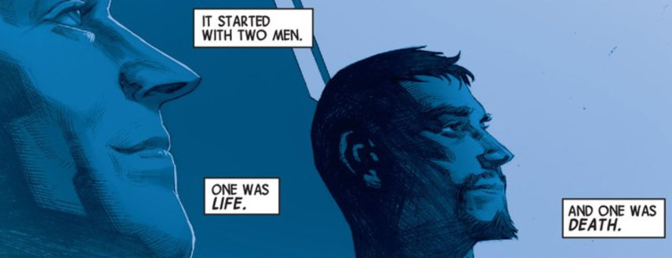

Their differing ways of facing the incursion threat is what drives them apart. As mentioned earlier, in [Part 2 of this review](http://aboutcomics.blogwyrm.com/?p=762), the Illuminati wiped Captain America’s memory of the threat of the incursions when he would not go along with their plan to choose ‘the lesser evil’.

Having nothing but bad dreams that hint at his maltreatment at the hands of the Illuminati, Captain America continues to regard Iron Man as a loyal friend up through the end of the Infinity cross-over event. However, the bad dreams eventually become full-fledged memories and the good captain, gathering a host of Avengers he trusts, confronts the eccentric genius with the cover-up

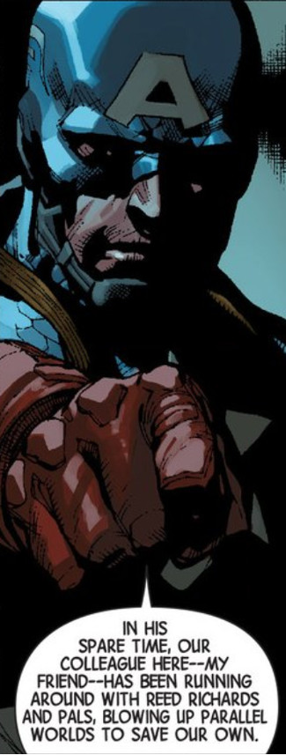

This revelation, part of the kick-off of the *Original Sin* cross-over event, immediately pits the Avengers against the Illuminati – friend versus friend – as both the *Avengers* and *New Avengers* series race to completion. It culminates in a bloody hand-to-hand confrontation to the death between the two in *Avengers* #44, the last of the series.

## Black Panther and Namor

While the events between Captain America and Iron Man were running their course in the Avengers, an even more bitter hatred was developing within the Illuminati between the Black Panther and Namor the Sub-Mariner.

As monarchs of their own empires, one might think that the conflict between T’Challa and Namor only comes about due to Wakanda and Atlantis being on the brink of war 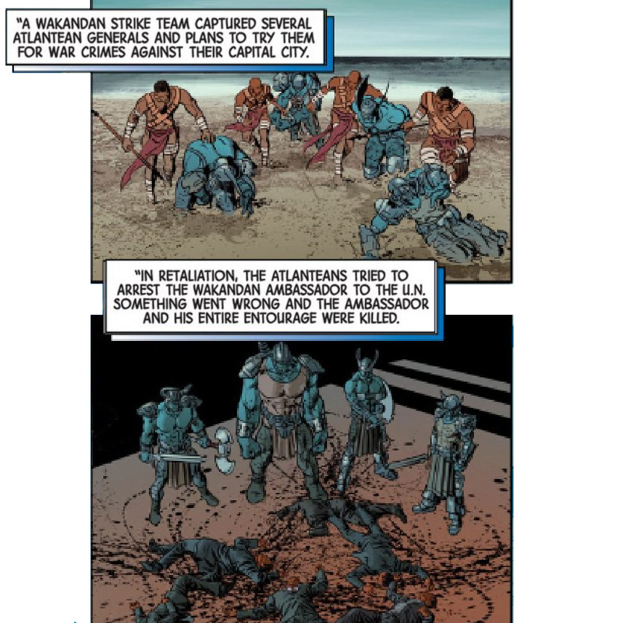

due to the [massive tsunami that Namor unleased upon Wakanda](http://marvel.wikia.com/wiki/Wakanda)

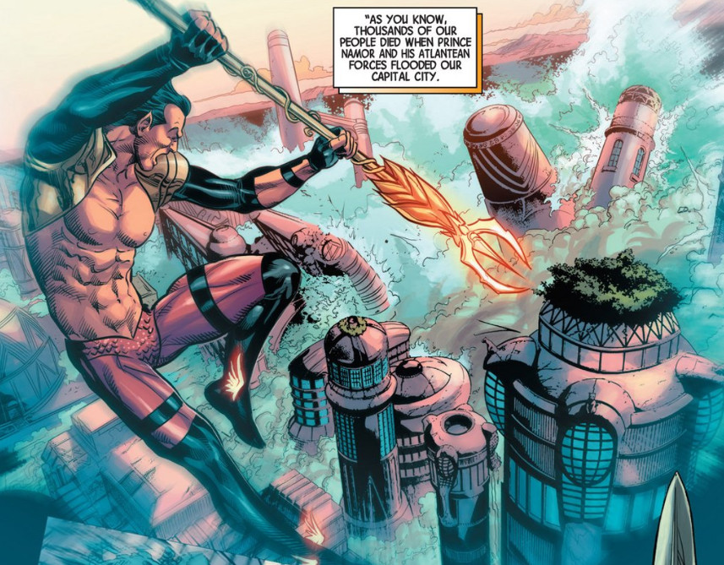

during the conflict between the Avengers and the X-Men. But no doubt their personalities have a lot to do with it as well. Both are proud men, willful men and it seemed inevitable that they would clash. In particular, Hickman portrays Namor as the one member of the Illuminati most willing to end another Earth for the sake of his own.

Their conflict and the estrangement that it brings to the Illuminati, results in Namor aligning himself with Thanos’ new group the Cabal (more details below), which has no scruples in brutally ending alternate Earths. The sadistic pleasure that the Cabal revels in eventually turns Namor’s stomach and he finally teams up with the Black Panther to provide the crucial distraction that allows Reed Richards to defeat Doctor Doom at the end of *Secret Wars*.

## Doctor Doom and Doctor Strange

The strangest and, perhaps most important inter-character relationship is the unlikely one between Doctor Doom and Doctor Strange. Upon it hinges most of the *Secret Wars* storyline. However, its roots are firmly planted in the events of the *New Avengers*.

Throughout most the events in *Everything Dies*, the two doctors – Doom and Strange – seem to be ill-fit. Doctor Strange was, of course, an original member of the Illuminati, but as the group seemed to be working towards a technological solution to the incursion problem what use did they have for a sorcerer. Likewise, even though Doctor Doom’s home country of Latveria plays host to an incursion site and he, himself, manages to hold off the Mapmakers, he is afforded no role by the Illuminati.As a result, both of them go to extraordinary means to solve the incursion problem.

The good Doctor Strange finds himself in the curious position of selling his soul for the power needed to stop the incursions once and for all.

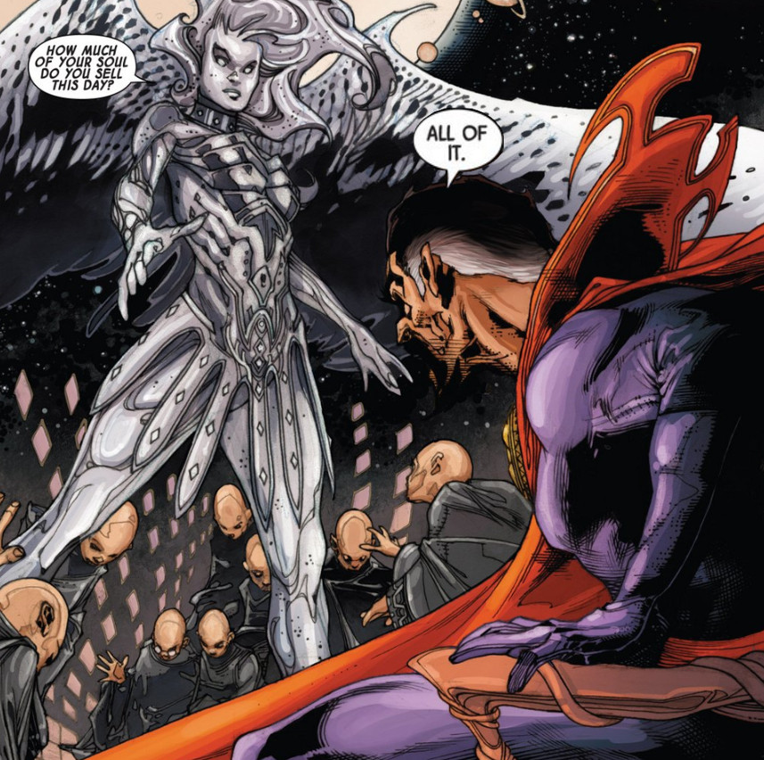

Doing so, he then assumes the head of the Black Priests, one of the two groups who destroy worlds to prevent incursions and who were mentioned with fear and awe by Black Swan.

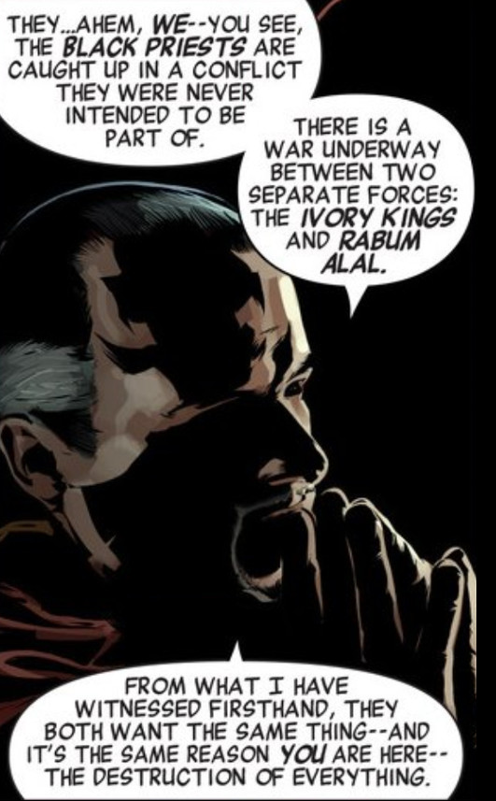

Doctor Doom takes a different route to power. Using the physical evidence left behind at the Latverian incursion, Doom pieces together, using some type of spectral analysis, the frequency signature of the Mapmakers. To his surprise, it matches the signature of the Molecule Man (aka Owen Reese), suggesting the two have the same origin. When confronted with this fact, Molecule Man launches them both into a journey through time, space, and the areas outside the multiverse. In the first leg, the Molecule Man brings Doom to moment where the former gains his powers and explains

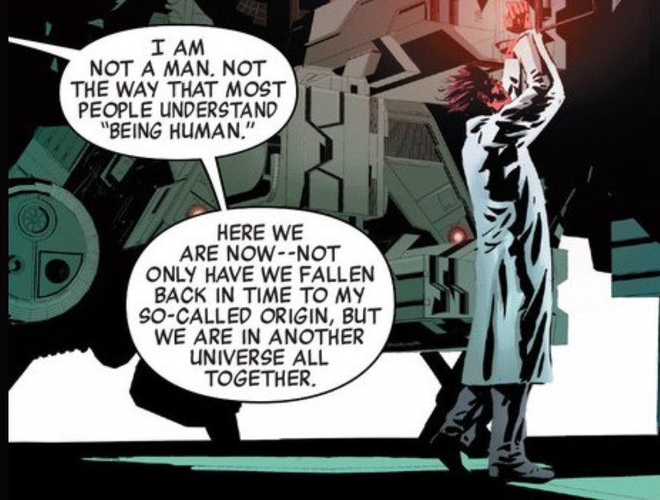

As soon as this alternate-universe doppleganger receives his powers, Molecule Man steps forward and murders him. It seems that exact copies of the Molecule Man have been placed in every universe of the multiverse by the Beyonders, the Ivory Kings of Black Swan’s warnings, with the express purpose of ending all existence.

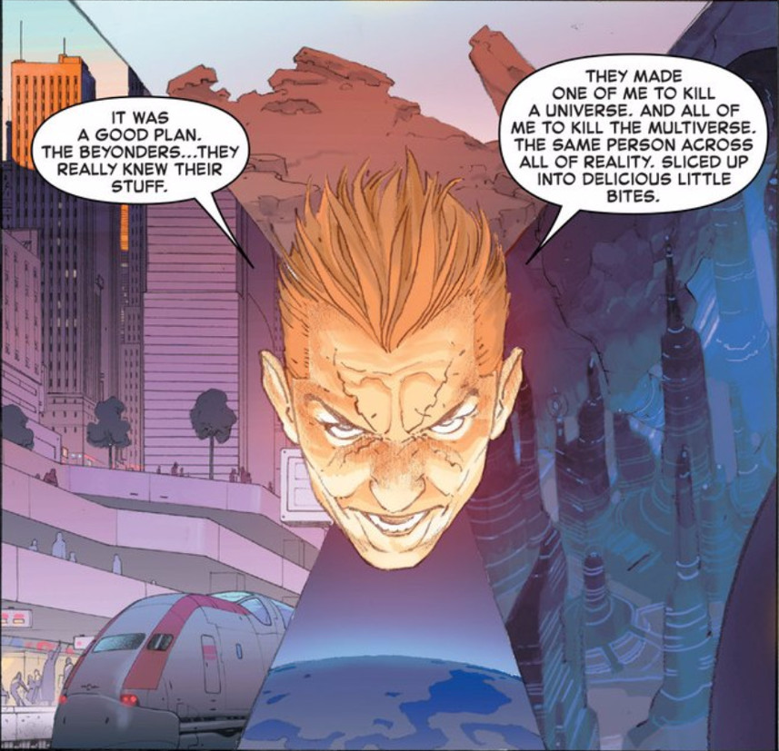

The infinite copies of Owen Reese are a multiversal bomb awaiting detonation.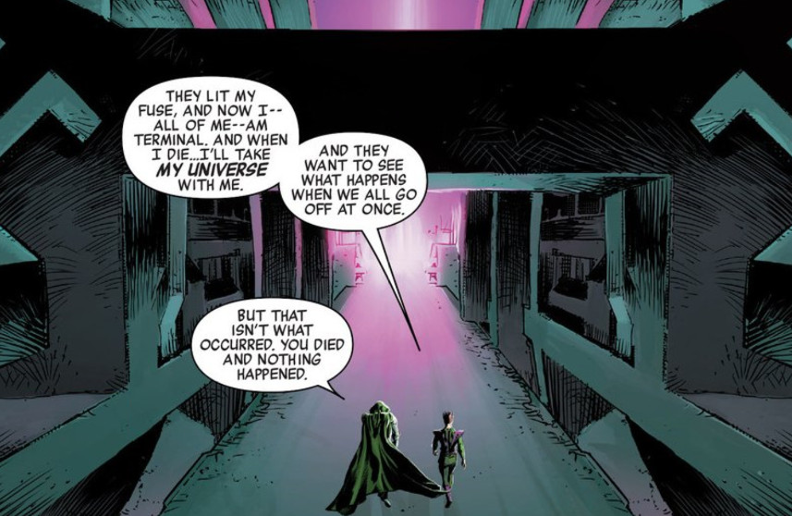

But Doom is wrong, something did happen when the doppleganger died, although the reader is left to infer this rather than having it spelled-out. When the Molecule Man killed his twin he set in motion the first premature death of a universe and started the incursion process.

The Molecule Man then brings Doom to the Library of Worlds, a place outside the normal structure of the multiverse. 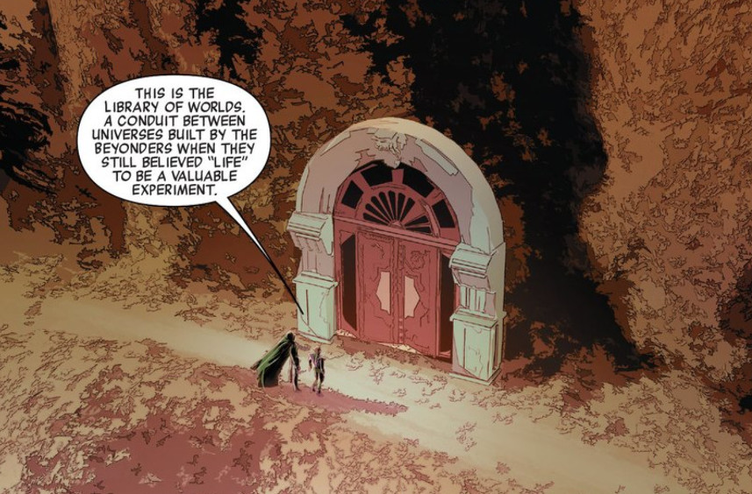

The Library of Worlds serves as a base of operations where Doom can start his own religion peopled by the Black Swans. They will call him Rabum Alal and they will serve as his hands in killing all the copies of the Molecule Man so as to stop the simultaneous destruction of the multiverse at the hands of the Beyonders. Incidentally, the creation of the Black Swans leads to the creation of the Mapmakers and the Sidera Maris by the Beyonders so that they could determine why their grand experiment was going awry.

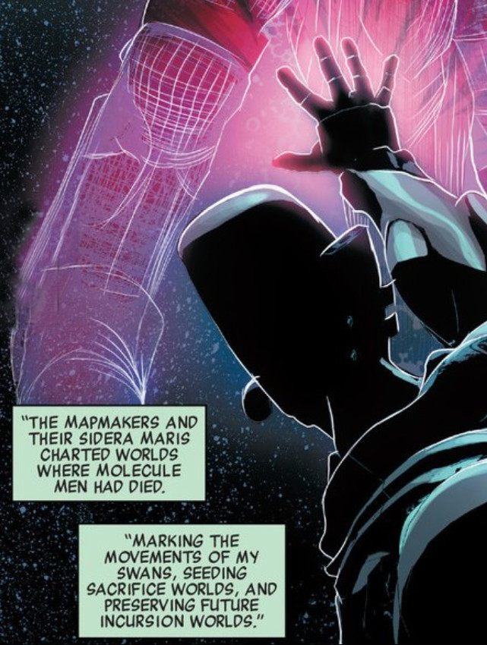

The Black Priests, who are another manifestation of the universe’s/multiverse’s attempt to prevent disaster are the natural enemies to both the Ivory Kings and Rabum Alal. They eventually find the Library of Worlds

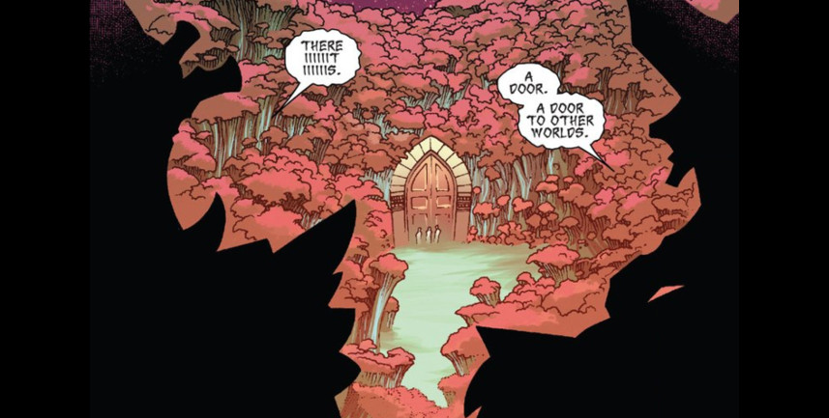

and penetrate it with Doctor Strange leading the way. Unfortunately, it is a trap

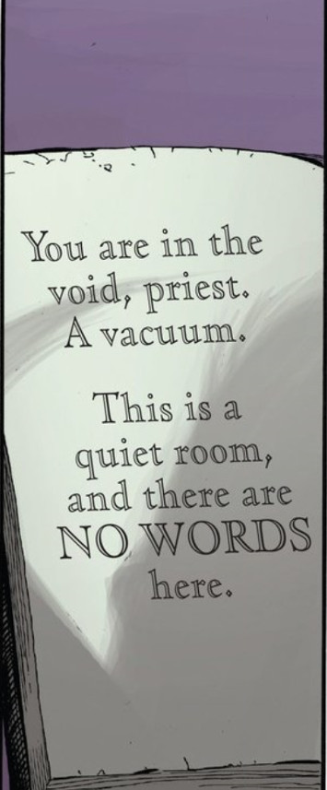

and they are overcome by not having the air they need to articulate their magic words.

Doom captures Doctor Strange and offers him a chance to help in stopping the Beyondrs. Strange agrees and a most unexpected alliance is forged, in which they, along with the Molecule Man succeed in stopping the Beyonders.

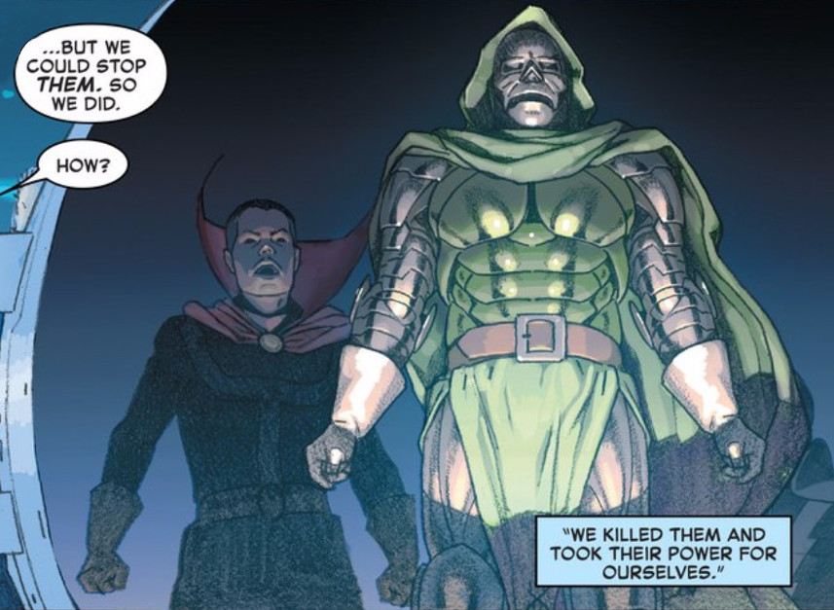

However, by this point, the multiverse had been destroyed. Using the powers of the Beyonders, Strange and Doom (a strange doom?) piece together a patchwork-quilt of existence

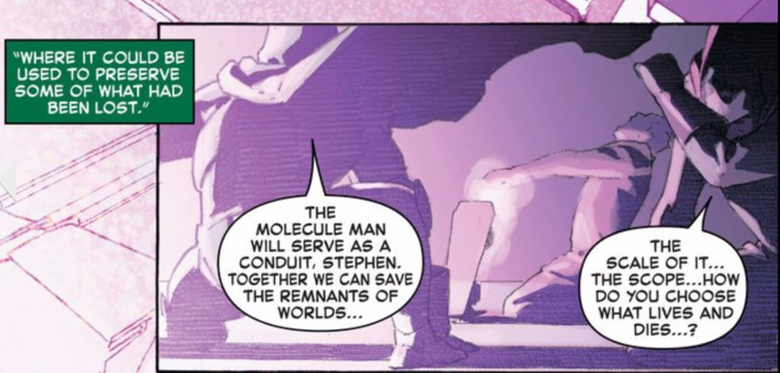

that is latter called Battleworld.

## Reed Richards and Reed Richards

Only two life rafts escape the destruction of the multiverse – one from Earth-616, which is the most familiar of the Marvel Earths, and one from Earth-1610, which was the Ultimate Universe. When Doom and Strange call Battleworld into existence, these vessels are drawn to the only reality available. The life raft from the Earth-616 carried, amongst others, the Black Panther and Reed Richards. The life raft from Earth-1610 carried, amongst others, the Cabal and the Maker.

The Cabal, a group of multiversal villains under the direction of Thanos, counts Black Swan, Namor, Maximus, members of the Cull Obsidian, and alternate-universe Terrax as its members. The Maker, is an ‘evil version’ of Reed Richards from the Ultimate Universe.

Together, both Reed Richards’s seek out Doom’s power source, seeking to dethrone Doom. They find that Molecule Man is that source.

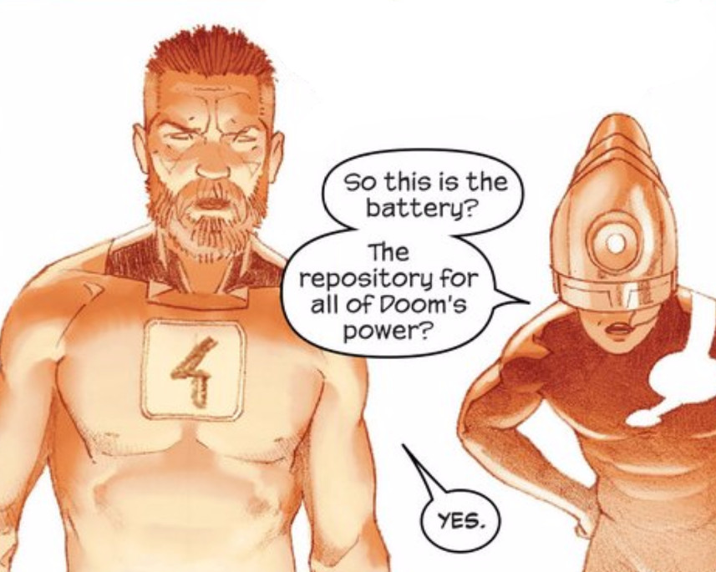

The Maker, being truly made in the image of Machiavelli, betrays Reed in an attempt to wrest all the power for himself. Unfortunately, he didn’t count on Molecule Man’s feelings and he is quickly devoured (literally as a pizza) to satisfy the former’s hunger.

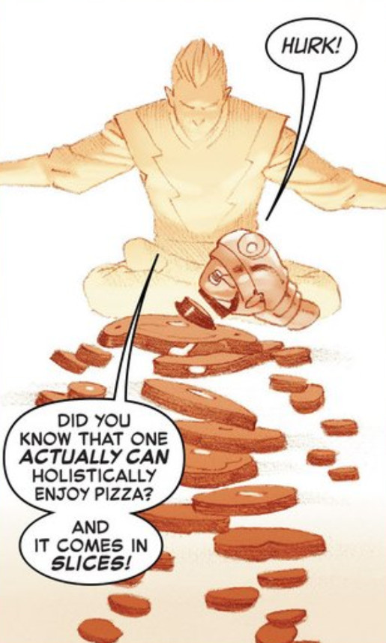

Reed is now ready for the final showdown.

## Doctor Doom and Reed Richards

In the final showdown, Reed confronts the god Doom. Willing to hear Reeds argument that there may be a better way to fix things than backing Doom, Molecule Man is willing to sit back and see who ‘deserves’ all the power that he holds. Reed and Victor slug it out both physically and mentally. Reed gets the better in this test of wills when he badgers Doom into admitting that he could have done a better job with all the power at his disposal.

At this point, Owen is convinced that the best person to back is Reed. At this point Battleworld cease to exist and Reed, vested with the power of the Beyonders, sets things right. Using the power from the Molecule Man and the natural ability of his oldest child, Franklin, Reed recreates everything. As explained by Valeria to her mother, Sue Storm,

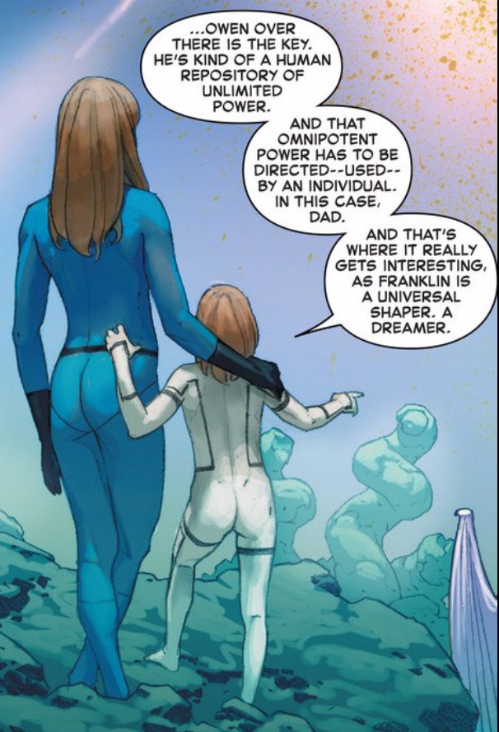

Franklin (the son) dreams up and shapes each new multiverse and Reed (the father) bestows the power to make the shape a reality and Owen (the spirit) becomes the life of the new world. A truly Trinitarian concept.

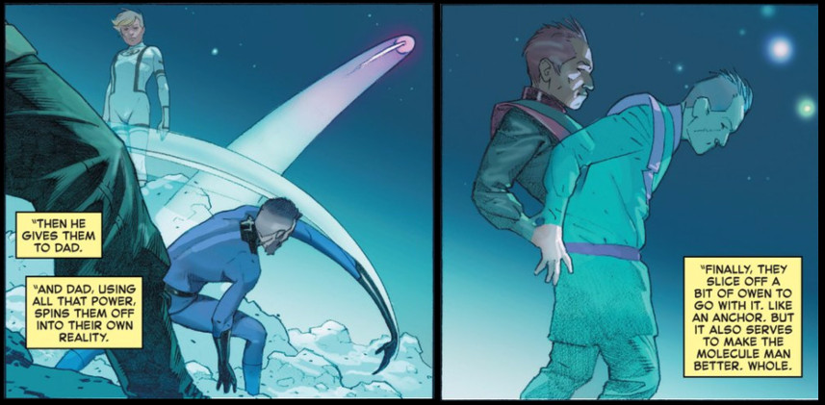

Before I draw this penultimate installment to a close, I offer the following diagram as an abbreviated attempt to show the major players in the *Everything Dies* storyline.

# A Marvel Epic: Part 5 – Wins and Losses

In this final installment of the 5-part series looking at Jonathan Hickman’s epic work on the *Everything Dies* storyline, I’ll be looking at what succeeded and failed. Since it was both a commercial and a literary undertaking in the medium of comic books, I’ll be looking at three broad categories: commercial aspects, storytelling mechanics, and story content.

## Commercial Aspects

There are two major aspects to consider when judging the commercial success of the Everything Dies story: raw sales of books and positioning for long-term viability.

In terms of raw sales of books, there is no denying that *Everything Dies* was a consistent success. As expected, when both the *Avengers* and *New Avengers* titles premiered back in Dec 2012-Jan 2013, they sold at or near the top. As time wore on, the *Avengers* title mostly hovered in the mid-teens and low-twenties in sale rank – although the near the end, perhaps due to fatigue, the sales began to sag. The *New Avengers* title consistently lagged behind, fluctuating between the high-twenties and mid-forties. Secret Wars consistently scored near the top with an average sales rank of 2.

|  |  |  |
| --- | --- | --- |
| Month | Title | Sale Rank |
| Jan 2015 | Avengers #40 | 19 |
| New Avengers #29 | 30 |
| Feb 2015 | Avengers #41 | 26 |
| New Avengers #30 | 36 |
| Mar 2015 | Avengers #42 | 24 |
| New Avengers #31 | 31 |
| New Avengers #32 | 42 |
| Apr 2015 | Avengers #43 | 40 |
| Avengers #44 | 21 |
| New Avengers #33 | 29 |
| May 2015 | Secret Wars #1 | 1 |
| Secret Wars #2 | 3 |
| Jun 2015 | Secret Wars #3 | 1 |
| Jul 2015 | Secret Wars #4 | 1 |
| Aug 2015 | Secret Wars #5 | 1 |
| Oct 2015 | Secret Wars #6 | 4 |
| Nov 2015 | Secret Wars #7 | 4 |
| Dec 2015 | Secret Wars #8 | 1 |
| Jan 2016 | Secret Wars #9 | 2 |

In terms of positioning for future success, it is hard to argue that anyone else could have done better. Hickman was able to adapt the storylines to handle changing situations in the movie-side of the Marvel mythos. When both titles were launched, Marvel didn’t own the movie rights to 3 important franchises: The X-Men, The Fantastic Four, and Spider-Man. Each of these franchises was initially downplayed in the *Everything Dies* storyline. As the relationship between Marvel Studios and the others progressed, the X-Men and Spider-Man made more of an appearance. But a large component of the *Everything Dies* storyline centered around Thanos and the Inhumans – properties that have a significant role to play in the MCU. As discussed in [an earlier post](http://aboutcomics.blogwyrm.com/?p=622), the Inhumans are essentially mutants without the name and the promotion of this property over the X-Men solidifies the MCU approach (e.g. Agents of S.H.I.E.L.D.) over the Fox Studios X-Men.

The Fantastic Four is an interesting situation. The movie franchise is not owned by Marvel nor is it developed in conjunction with Marvel Studios. The poor showing of the Fantastic Four (2015) movie no doubt reinforced Marvel’s desire to distance itself from its once flagship group. This approach is poignantly summed up in an exchange between Franklin and Reed Richards at the end of *Secret Wars* #9.

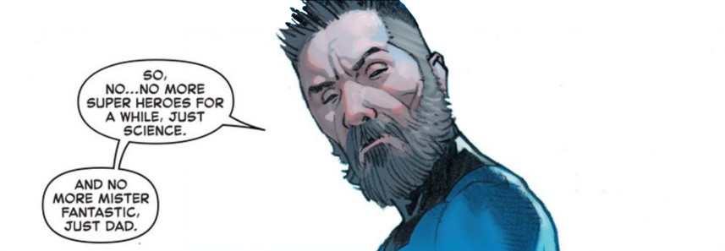

## Storytelling Mechanics

This is the one area where I would say that Hickman consistently falls short of the mark. For every really nice thing he does there are others that detract from the success. In the interest of ending on the positive, I’ll talk about the negative aspects first.

One of Hickman’s most used devices is the ‘Then & Now’ approach. A few pages are presented with the what happened in the past, either as new material for the reader to digest or in flashback form. The action then flips immediately and abruptly to the present where events happening ‘now’ are shaped by reactions and recollections from ‘then’. Used every so often, this isn’t a bad mechanic, but Hickman over-relies on it. Often times, there isn’t enough structure for the casual reader to note the transition.

In a storyline as complex as Everything Dies, a less haphazard mechanism should have been used. Something as simple as changing the border style (the old rounded borders for flashbacks with appropriate captions always worked nicely) and color scheme would have worked. When read and re-read sequentially, at one sitting, this mechanism works marginally. But it is too daunting of a task to try to parse and piece the plot together when reading the book monthly with other titles (e.g. *Infinity*, *Original Sin*, etc.) interspersed and with no clear picture of where the whole is going.

Hickman’s other short-coming is the lack of exposition even with events progressing sequentially. Although captions have fallen out of favor, a few well-placed ones would have been welcome. The best example of this comes from *Secret Wars* #9. As mentioned in earlier posts, the Black Panther confronts Doctor Doom with some version of the Infinity Gauntlet. Although defeated, T’Challa provides the necessary distraction so that Reed Richards can find the Molecule Man and shut down the Doom’s ‘godhood’. Just before Battleworld comes to an end, the Black Panther grabs one of the gems, clutches it tightly, and is whisked away.



The reader has no way of knowing which gem it was. The official list of gems from Marvel’s database is

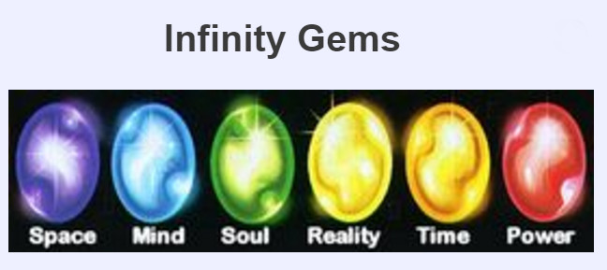

but as demonstrated in this post, the color-coding of the gems is not consistent and so the reader is left to guess. There are, of course, times to let the reader guess, but Hickman does it too often and with pivotal elements of the plot.

One the positive side, he does a nice job, given his page limit constraints, of touching upon elements that the reader may actually wonder about. In over 50 years of written fantasy storeis, the Marvel Publication Universe has a vast amount of cosmic elements. Each of these should figure into something as large as the complete and whole-sale structural rearrangement that is done in *Everything Dies*. Of course, there is no way for Hickman to explore each and every idea thoroughly but he does a reasonable job of at least mentioning what was tried and what failed when dealing with the incursions. The following composite image shows how he deals with the Cosmic Cube, the universal Avatars, and the multiversal Captain Britain squad.

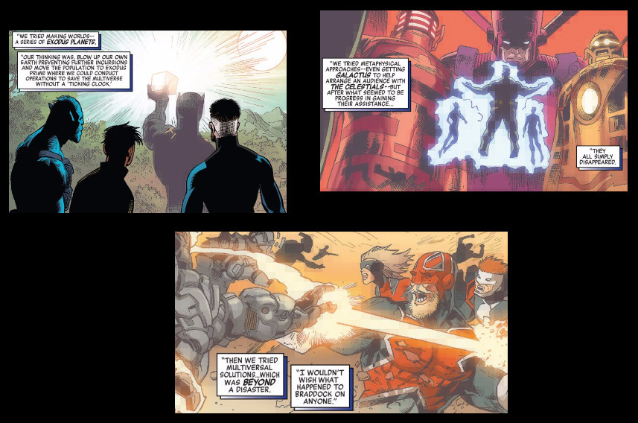

He also provides a nice set of symmetrical bookends to the tale. The incursion threat begins in Wakanda in *New Avengers* #1 with a group of Wakandan youths on a coming of age trial. Once he grabbed the undisclosed gem from the Infinity Gauntlet in *Secret Wars* #9, the Black Panther again finds himself in the Wakandan jungle where the same events play out but to a different end. In *New Avengers* #1, his speech is interrupted with a rumble of rhinoceros fleeing the first incursion and the final outcome is the death of the young Wakandans at the hands of Black Swan’s group. In Secret Wars #9, his speech is punctuated with the rumble of Wakandan rocket lifting of to space and hope.

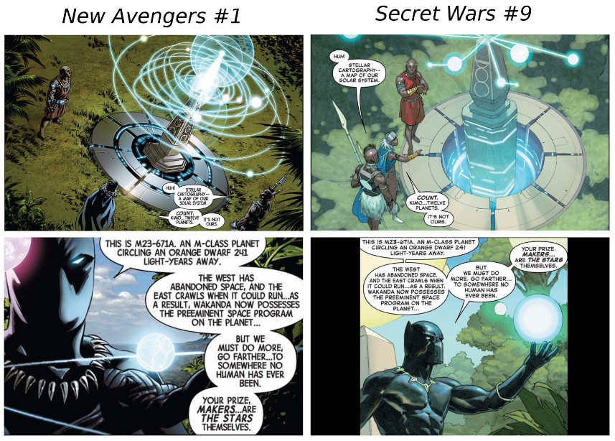

Even the Everything Dies mantra is closed out from despair to hope. One of the minor tweaks that Reed Richards performs in setting everything right again is to restore the ravaged face of Victor von Doom, ending the whole storyline with a note of optimism

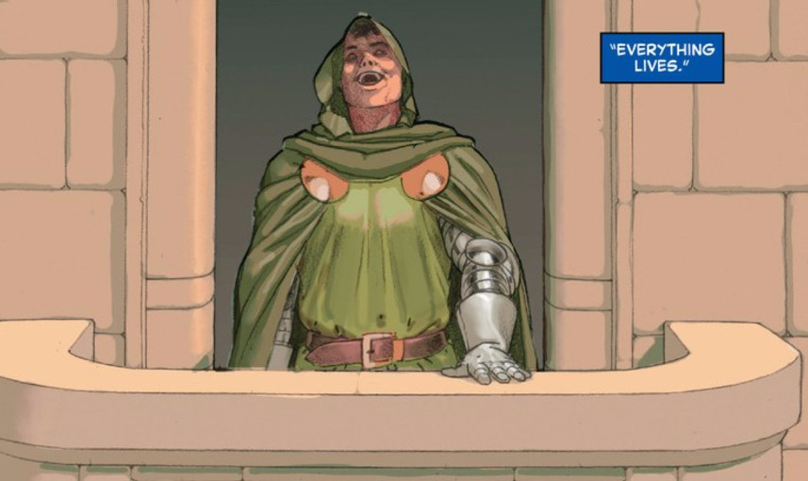

## Story Content

Overall, Hickman does well on the story content itself – particularly the logical structure and verisimilitude of his universe. He clearly shows a love and respect for much of the source material that has come before.

While the *Everything Dies* epic has the [three elements most able to destroy a comic story](http://aboutcomics.blogwyrm.com/?p=47), Hickman does a good job working with two of them: alternate universes and magic. His treatment of parallel/alternate universes is nicely done without badly undercutting the emotional content of the material. It is easy, with an infinite number of Thors upon which to draw, to make it hard to feel for a particular instantiation of Thor. Hickman mostly avoids the most common pitfalls by making the alternate versions different enough in both character and fate that the reader’s emotional investment isn’t undermined. He also credibly navigates away from much of the mechanics of the end-times and focuses instead on the reactions of his characters. In this way, he avoids the *deus ex machina* aspects of magic.

However, on the time travel front, the causality of his cosmology is quite a bit out of whack. One of the crucial storylines in the Avengers is the time travel into the future of Captain America shortly after he remembers his betrayal at the hands of the Illuminati. How the universe’s timeline/worldline can end with an incursion and yet still continue on into the future is totally unknown. I suppose he wanted/needed to deal with the time-travel aspects of Marvel’s many stories but still it comes off as illogical and forced. Much cleaner is his explanation for how Doom could stop the Beyonders. The latter were constrained to move sequentially forward in time (linearly forward as is incorrectly said in the film industry). Without going into details, Hickman simply offers this explanation for how the created can destroy the creators. Far more satisfying than a badly-constructed time-travel plot.

The little details were a really big positive. As mentioned above, he tries to cover all the bases for why a thing works in his universe/multiverse. One of the most clever things he introduces is how to construct a vehicle capable of surviving when everything is destroyed – how to make the life rafts actually work. It starts with the Beyonders assault on the Living Tribunal

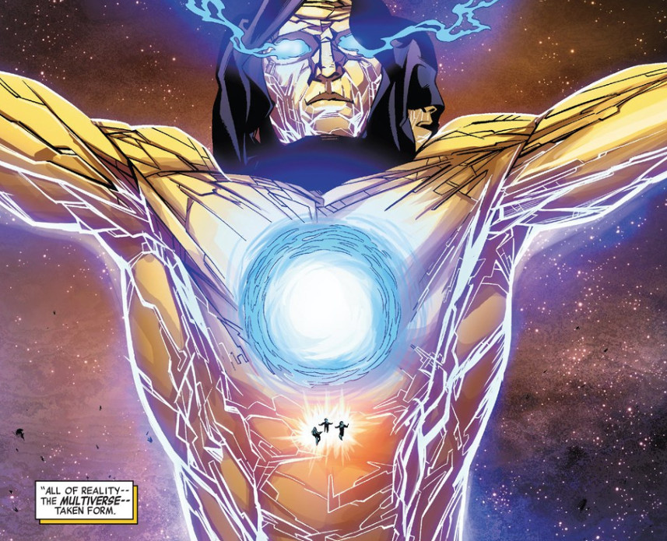

which results in the Tribunal’s demise and a fragment of him ending up in each of the remaining universes. His body forms the raw materials from which the life rafts are constructed

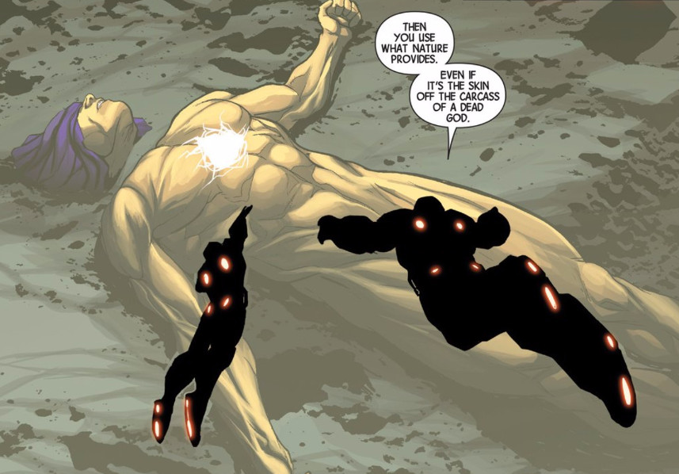

Finally, little bits of humor and homages are worked into the story in various places. Two of my favorites are the clear homage to the [‘All your base are belong to us’](https://en.wikipedia.org/wiki/All_your_base_are_belong_to_us) engrish uttered by Cyclops powered by the Phoenix force

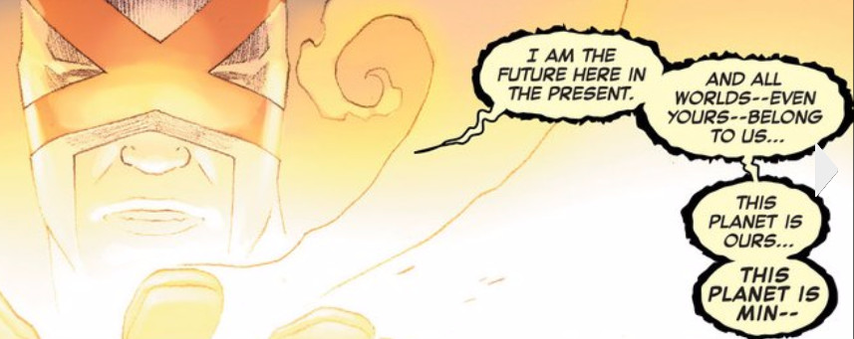

and Amadeus Cho’s hilarious indictment of ‘the certainty in ignorance’ so common in everyday thought.

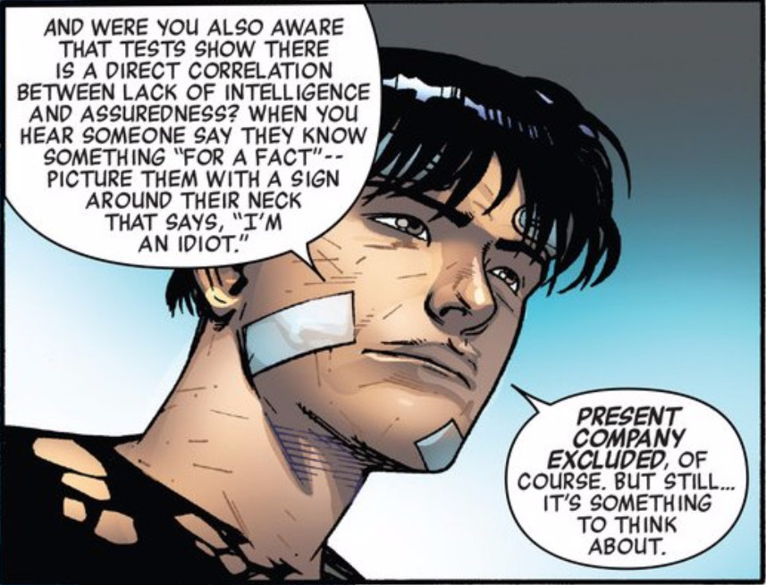

## Parting Words

The *Everything Dies* storyline is a remarkable set of comics and fine addition to the world of literature. It is the first real example of the epic being brought to fruition in the comic book medium and despite numerous flaws it is well worth reading. I only hope that Marvel will make an Omnibus publication in which the story is told in is proper publication order (*Avengers*, *New Avengers*, *Infinity* correctly interleaved). My congratulations to Jonathan Hickman for pulling it off.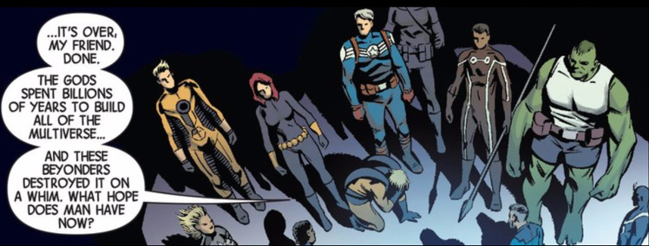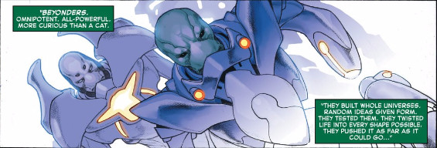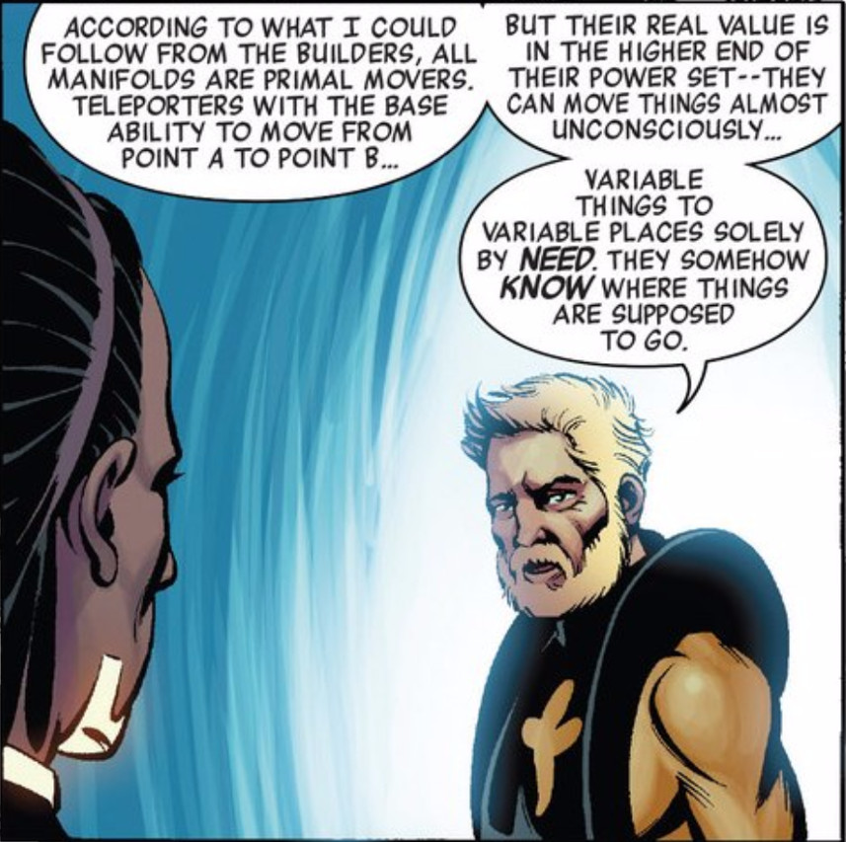

# Pretty Deadly Storytelling

I can’t say for sure whether I like the Image series Pretty Deadly by author/scripter Kelly Sue Deconnick and artist Emma Rios. One some level I like it a lot but in other areas I find its low points so distracting that it is hard to remember the good parts.

Set in the Old West of the late 1800s, the series is as much fairy tale as it is a Wild, Weird West tale (a la [East of West](http://aboutcomics.blogwyrm.com/?p=109), [The Sixth Gun](http://aboutcomics.blogwyrm.com/?p=580), or the [Deadlands](http://aboutcomics.blogwyrm.com/?p=77)). It’s also constructed as a frame tale, in which the main story is about the telling of the real story by one character for the benefit of the other.

Our western version of Homer is, in fact, a dead rabbit who goes by the name of Bunny Bones. The audience is filled with only one listener – Butterfly – who often asks questions and urges Bunny Bones to include something or skip some other thing. There is very much a quality of a parent reading to a child in their dialog.

The outer tale opens with Butterfly asking about the day they both met; the day in which Bunny Bones escaped his earthly life and become something simultaneously more and less. Butterfly is curious about his death and whether Bunny was afraid.

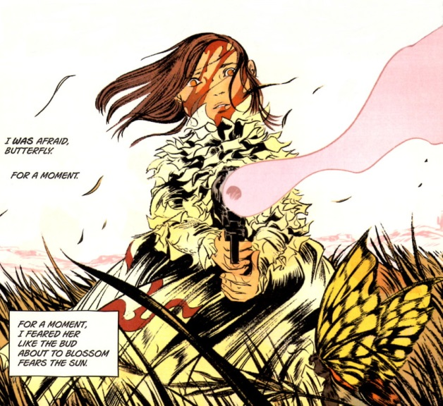

The gun-wielding little girl, as we come to know later, is Ginny, a daughter of death, and much of Bunny’s story centers around her, although she plays only a secondary role.

The bulk of Bunny’s story deals with the events that led to Ginny’s birth and the ongoing aftermath as their consequences play out. However, the thread of the tale is tugged in the middle as Butterfly, after asking Bunny to tell him her story, urges the skeletal rabbit to skip to the other girl.

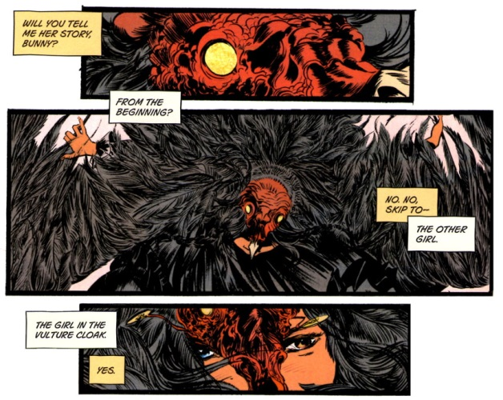

The other girl is small and dark and wears a vulture costume and has mismatched eyes. Her name is Sissy and she’s just arrived in a western town with her hulking, ‘blind’ guardian by the name of Fox. The pair has a strange side show that they perform for whatever change the townsfolk are willing to throw their way. In it Fox, who seems to be able to see despite his hidden eyes, stands at the rear of the stage, holding a large banner bearing the likeness of many people and events; a storyboard of sorts; with all the characters born out in Tarot Card fashion. At the front Sissy weaves a tale, in doggerel, of the gain and loss of the wonderful woman Beauty by her jealous husband Mason.

In her yarn, Sissy tells how Mason, fearful and envious, locks Beauty up in a tower to keep her from other men. Despite her numerous prayers and entreaties, Mason refuses to free her. Her desperation grows until she decides death is better. Using her own blood, Beauty begs for death; but instead being claimed by one of Death’s minions, the head man comes himself. He is immediately taken with her and falls in love and weds her. Together they have a child, whom Death calls Ginny. After her birth, Death allows Beauty to depart from life, but the child, as Sissy’s ragged rhyme says,

<He raised her a reaper of vengeance,

A hunter of men who have sinned—

If you done been wronged,

Say her name,

Sing this song,

Sound the bell’s knell

That calls her from hell…

Ginny rides for you on the wind my child..

Death rides on the wind!>

After she’s done with the show, Sissy mingles amongst the crowd for and is soon accosted by a crafty redhead by the name of Johnny Coyote. While outwardly he is pressing some coins into her palm, secretly he is manipulating her into stealing the Binder, a parchment or document of some importance to Death.

Fox and Sissy take a break from their journey to the next town and settle in for a night on prairie. Sitting by the fire, Sissy idly burns the Binder and waves the flaming sheet under Foxes blind eyes. He immediately realizes what the thing is and flees with her to the closest safe house run by a woman named Sarah.

In the meantime, Johnny, who is spending some time indulging his carnal side in the town, receives a visit from one of Death’s little helpers, a reaper who goes by the name of Big Alice. She’s tracking down the Binder and, after forcing the information out of Johnny with a bullet placed ever so lovingly in his left thigh, she begins her pursuit.

Fox and Sissy, having rested at Sarah’s, decide to press on into the night. But before they go, Sissy teaches the summoning song for Ginny to one of Sarah’s kids. A good thing too, since Big Alice soon arrives with her crew and begin to take Sarah and her farm and family apart. This ruckus stops when the rhyme is said and Ginny arrives. Ginny soon kills the crew and destroys Big Alice, who returns to Death disembodied but otherwise, apparently no worse for wear.

Back in the town, a talking raven, by the name of Molly rouses Johnny to take action. He soon starts his own pursuit. Meanwhile, the pair Fox and Missy continue their flight. Missy tells Fox of a woman she barely remembers, who gave her something – a key. It isn’t clear at this point what significance this interlude has and, unfortunately, it doesn’t become much clear later.

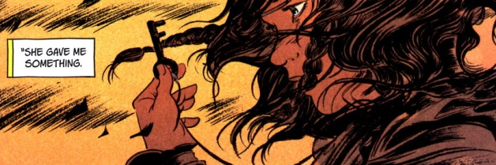

Eventually Missy refuses to go any further until Fox explains what it’s all about, why they are fleeing and who is pursuing and why. Fox reveals that he is the Mason of her story and then he tells the rest of his tale with Beauty and Death, the part she’s never heard. He tells how, when he learned she had died that he wanted to follow her to death. He tells of how he dug and dug and dug until he found his way into Death’s realm. Death refused to grant Fox/Mason release and is ready to send him away when Mason becomes aware of Ginny. He invokes his right to the child since Beauty was his wife. Death rebuffs the claim but offers a deal: Mason must go to a river of blood where

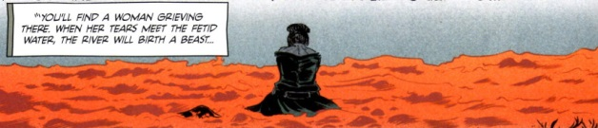

Once there, if he kills the beast, Death will bind Ginny to the spirit realm and Mason will live out his normal lifespan and once he has dies, Death will allow Mason to meet his wife and ask for her forgiveness. Should Mason refuse the deal, Death will unlease Ginny on him to exact revenge for Mason’s ill treatment of her mother.

When Mason arrives at the river, he sees that the beast that is birthed is a small girl with mismatched eyes

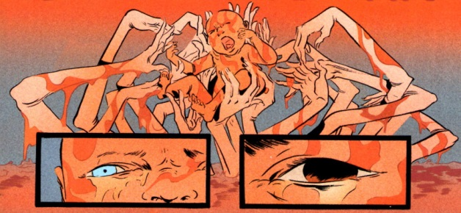

and he refuse to slay her. Instead he cares for her as his own.

During this revelation, rain waters swell the river next to where they are standing and a flood soon separates Fox (Mason) and Sissy. Johnny finds her and somewhat explains the Binder. He admits that her tricked her into stealing it but he thought she would read it and not burn it. That is the unspoken reason why the song sung by Sarah’s boy brings Ginny out when all the times the song was sung by Sissy nothing happened.

Johnny vows to give Sissy straight answers but as he starts to explain things about her the scene changes to Death’s domain. Like Mason before him, Death too can’t let Beauty go but her words and company are no comfort. She tells him that she knows that each Death must live and must die and that his time as death draws to a close as his cycle is ending. She offers him the comfort that when he dies he can join her. But Death has other plans

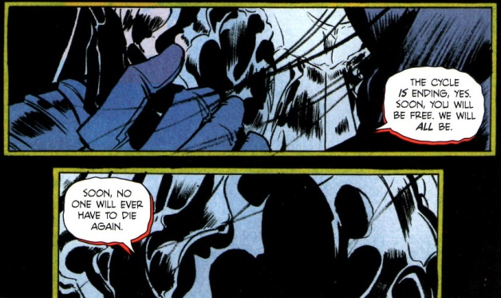

At this point, it seems likely but remains categorically stated, that Sissy is the replacement and that Death’s hope in sending Mason to kill her was to prevent anyone ever becoming Death, thereby stopping the natural order of things.

The one flaw in his plans is his wayward child Ginny. Now released, she soon tracks down Fox. Together, they enjoy a gentle father-daughter moment wherein they try to bash each other’s brains out. During the course of their ‘debate’, Fox is able to gain her sympathy by having her understand Sissy’s fate.

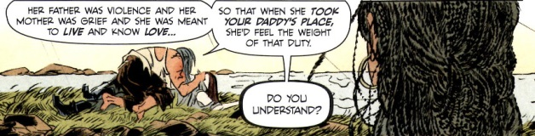

Eventually, everyone reunites and heads to Death’s realm. His guardians, the Day Maid and Night Maid, allow entrance to his realm since they recognize Sissy as the new Death ascendant

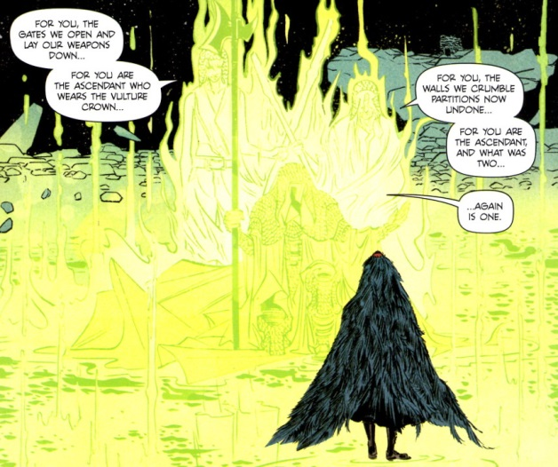

the being who reunites them again as a single entity. Apparently the world has been torn by the machinations that Death is employing so that he may be with Beauty forever.

The rest of the tale is actually easier to summarize. Ginny stops Death by running him through with a sword; Death dies; Sissy takes over as the new Death in a Vulture guise and the Soul of the World (whatever that really means) is healed.

If you understand that last bit you are quite a bit better than I am. This whole arc has a mythic, fable-like quality that has a great deal of charm. But much of this charm is marred by poor storytelling. The reader must interpolate between scenes or read additional information provided on the back cover just to understand character information. Most grievous is the fact that new information is place into the previous-issue summary. Why should a reader, who has already read the previous issue, be required to read the previous-issue summaries in order to get critical exposition? This lack of craftsmanship severely detracts from what could have been a good slice of myth.

Nonetheless there are some good bones here and perhaps *Pretty Deadly* will mature into a fine vehicle for storytelling. I haven’t given up on it yet but if Volume 2 is like this one, then the cycle will end for it as well.

Important piece on the back cover.

Johnny offers Sissy some money

Johnny lets Sissy steal the Binder

Fox realizes what Sissy got after she’s burned most of it

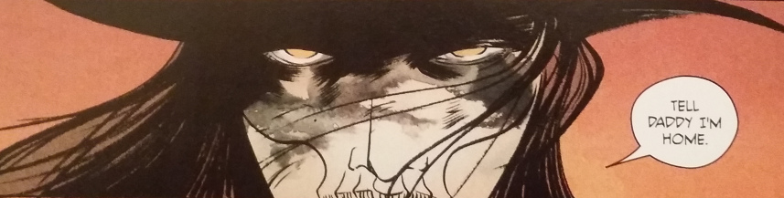

# Badger Don’t Care

***Yo! Larry.*** If that rallying cry doesn’t mean anything to you then you were not exposed to one of the most fun and quirky comic book runs of the 1980s – *The Badger*.

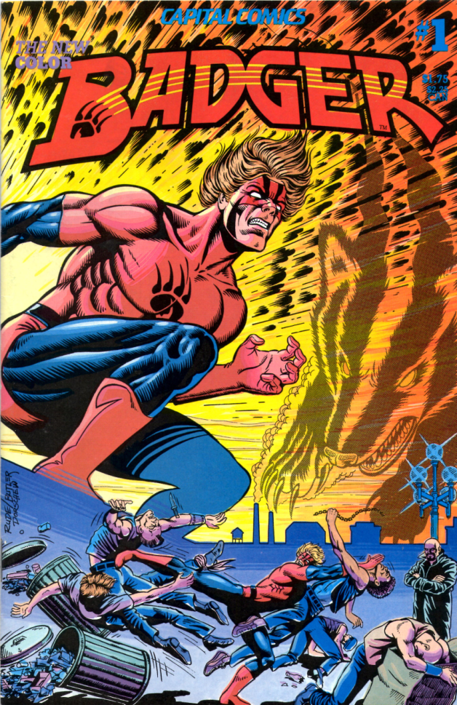

The central character, one Norbert Sykes, just happens to a Vietnam vet who exhibits multiple-personalities, a curious devotion to and the ability to speak with animals, a penchant for mastering various abstruse martial arts, and a total disregard for both social convention and for his own safety. In his role as Badger, Sykes is, more or less, the familiar with a 4th century Druid wizard who goes by the name Ham since his original Welsh name is a touch too long to pronounce.

Whether Ham is a force for good or evil or just in it for a little material comfort and wealth (well a lot of wealth – more on that in a moment) is difficult to pin down, but his magic certainly gets him and the Badger into some curious and amusing spots.

The final member of our little group is a clinical psychologist named Daisy Fields. On paper, Daisy is Ham’s private secretary, but closer to the truth, she seems to be both a moderator and enabler of the hijinks and insanity that ensue.

If my description seems murky, weird, confusing, and aimless then I shall have been true to the nature of the book. And what a wonderful nature it is. Rather than being a ponderously heavy and serious examination of modern life, *The Badger* has its tongue fairly planted in its cheek even when displaying biting social commentary on everything from annoying people in the checkout line in front of you or those who start their yard work a wee bit too early in the morning to the sometimes self-involved behavior of the rich and corporate malfeasance. *The Badger* shows that a good sense of humor is a powerful tool for both entertaining and making a point. 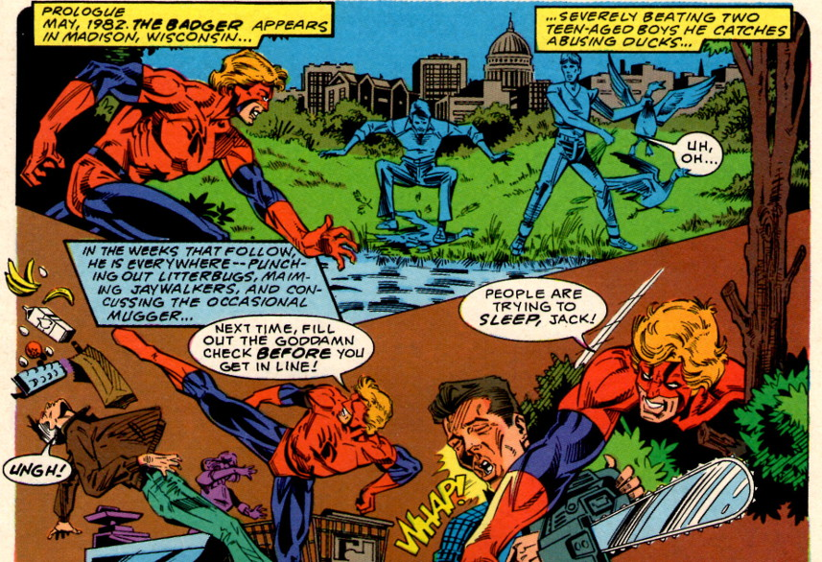

The trio is first brought together in a state sanitarium somewhere in Wisconsin, where the central figures of these tales, Norbert and Ham, are enjoying room and board and relaxing padded rooms courtesy of that fine state. It seems that Norbert has been committed for committing a variety of civil disobediences of the sort mentioned above.

On the other hand, the state has consigned Ham to a rubber room of catatonia and vagrancy. The former condition is a consequence of some early handling of the Druid by the angry townsfolk of the 4th century British Isles. It seems that Ham had a nasty habit of sacrificing whatever he needed to get the magic he wanted

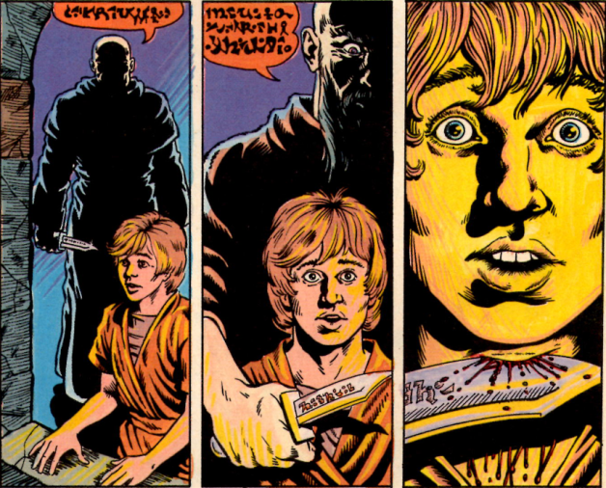

Having had enough, the various peoples subdue him and, failing to be able to harm or kill him, they place him under spells of deep sleep and then hiring explorers to drop his body off the face of the Earth. Mistaking North America as the end of the world, the explorers deposit ham in what would later be one of the Midwest’s most interesting commonwealths.

Sharing adjacent rooms, Ham and Badger forge a psychic connection that soon blossoms into a full-fledged working relationship

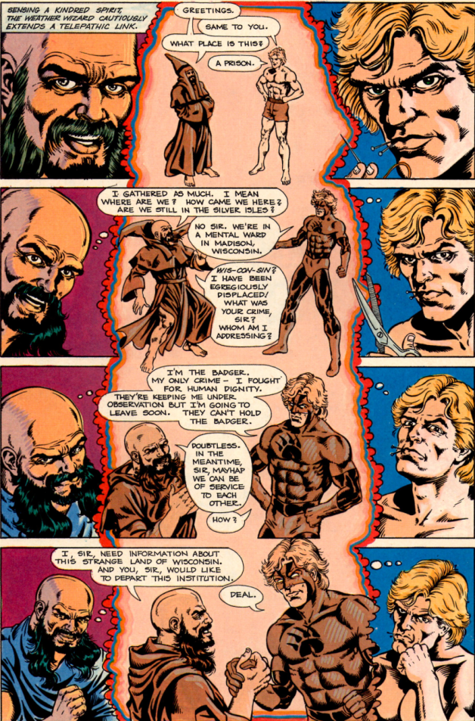

Affecting their joint release, Ham soon discovers that the magic of money may be as powerful as the magic of sacrifice. Using his wizarding skill, he soon amasses a small fortune which he uses to set to build a castle in which he and Badger will use as a base of operations. He also entices Daisy from the Sanitarium with both a promise of more money and a chance to examine Norbert and his various splintered personalities at her leisure. He wants her part of the team so that she can help manage his growing wealth and to help manage the Badger, who is an integral part of his scheme.

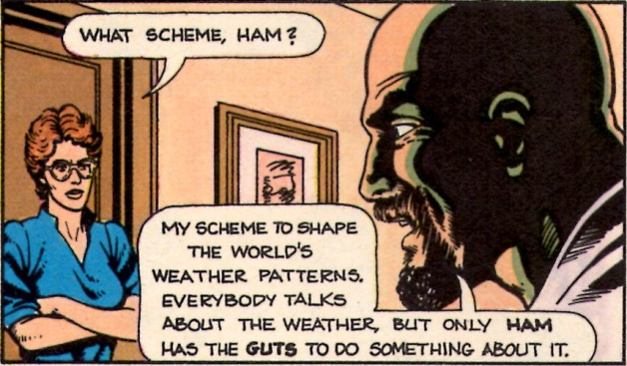

As Ham later explains to a supernatural entity called the Hodag, the Badger is his familiar

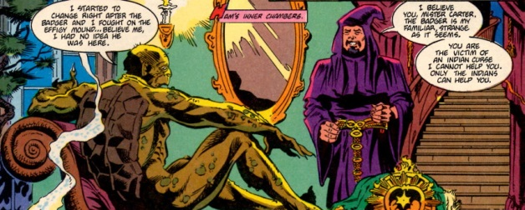

and that connection – sometimes strained, oftentimes cordial, and always strange – catapults them into bizarre territory and unimagined adventure that allows the series creator, Mike Baron, the material he needs to explore spirituality, individualism, society, lunacy, and fun.

For example, one the earliest adventures involves a California-based energy company being a poor corporate citizen. Wanting to build a Midwest power plant, the company has procured a parcel of land that contains an extremely old oak tree. They plan to level the parcel in order to make way for their new power plant, thus ending the oak’s long life span. Being a Druid, Ham desperately wants the land since the ancient oak is a powerful source of magic. Being rich, Ham tries to purchase the land in the usual fashion – directing one of his minion’s to dig up information while he is chauffeured in his Bently by another

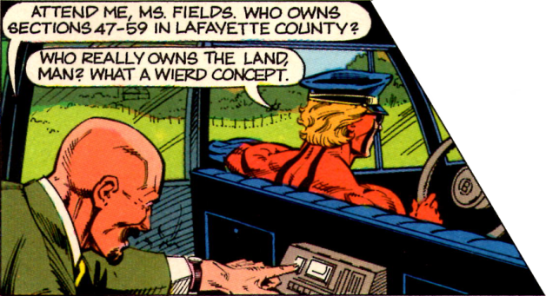

When he discovers that he has been too late to save the oak, Ham vows revenge. He asks the Badger to

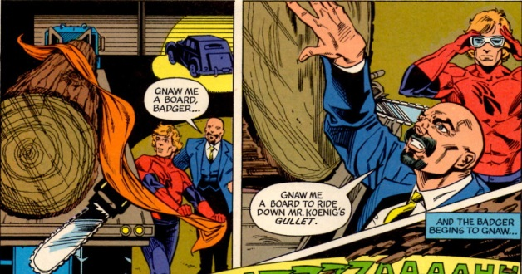

Using the resulting, mystic surf-board, Ham mounts a huge tidal wave which he has aimed at the power company’s California headquarters.

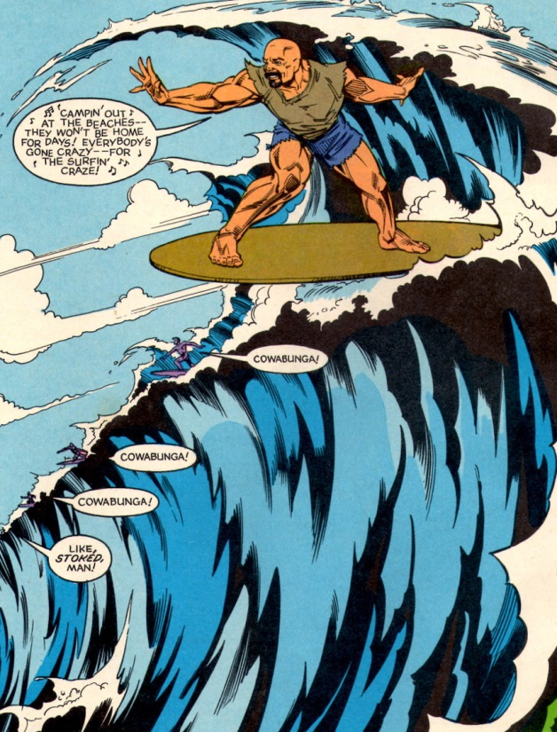

At the last minute, disaster is averted, but not before the corporate-types are sufficiently chastised by the whole experience.

Other zany vignettes include an exchange between a flight attendant and a westward-bound Badger that reflects a point many of air travelers have pondered

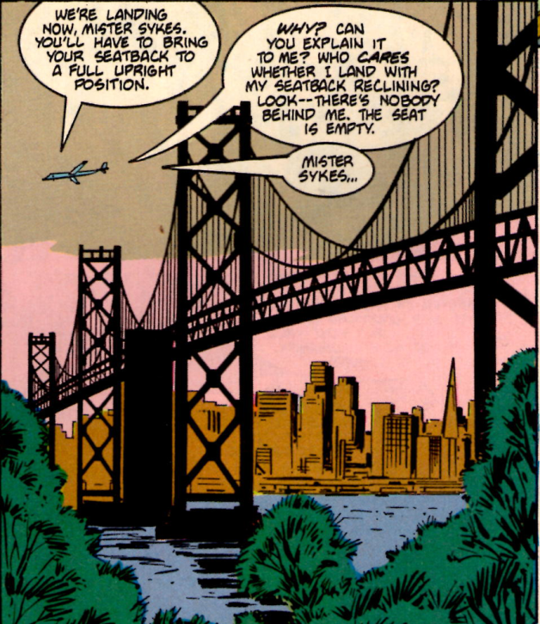

and a self-absorbed, wealthy woman, who disregards the need to evacuate an upscale Madison mall when two jaguars are free themselves from a mall-attraction and decide to do a little shopping

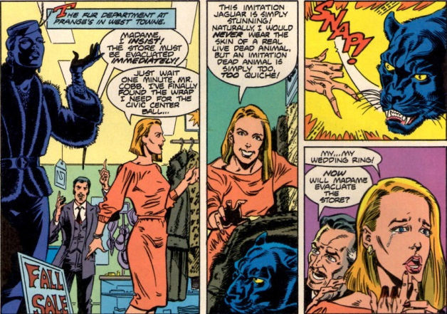

Along the way, the reader gets to meet some of the various personalities that make up Norbert’s psyche

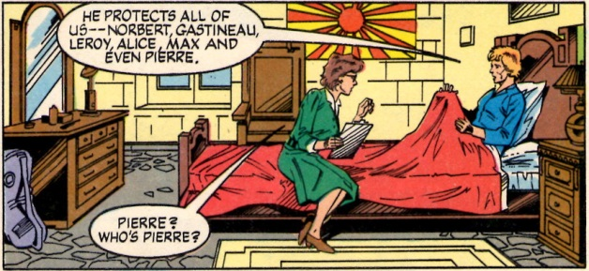

Of particular interest, is Max, who is charming, refined, and gentlemanly in ways that neither Norbert nor Badger can be

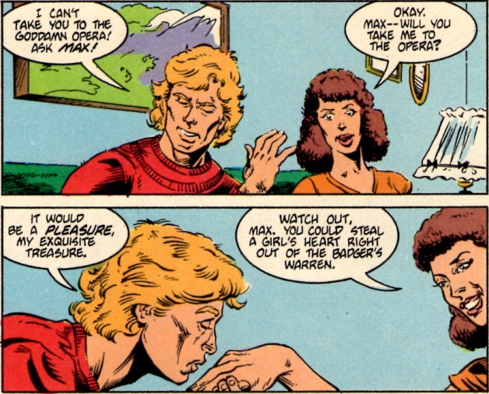

Along the way, Mike Baron throws in a lot of esoteric modern lore, including a whole issue (#23) homage to the [Church of the SubGenius](https://en.wikipedia.org/wiki/Church_of_the_SubGenius), in which the International Brotherhood of Brujos (IBOB) has sent a powerful demon, who just happens to bear a striking resemblance to [J.R. ‘Bob’ Dobbs](https://en.wikipedia.org/wiki/J._R._%22Bob%22_Dobbs), to take on the Badger (a sampling of their verbal sparring shown below)

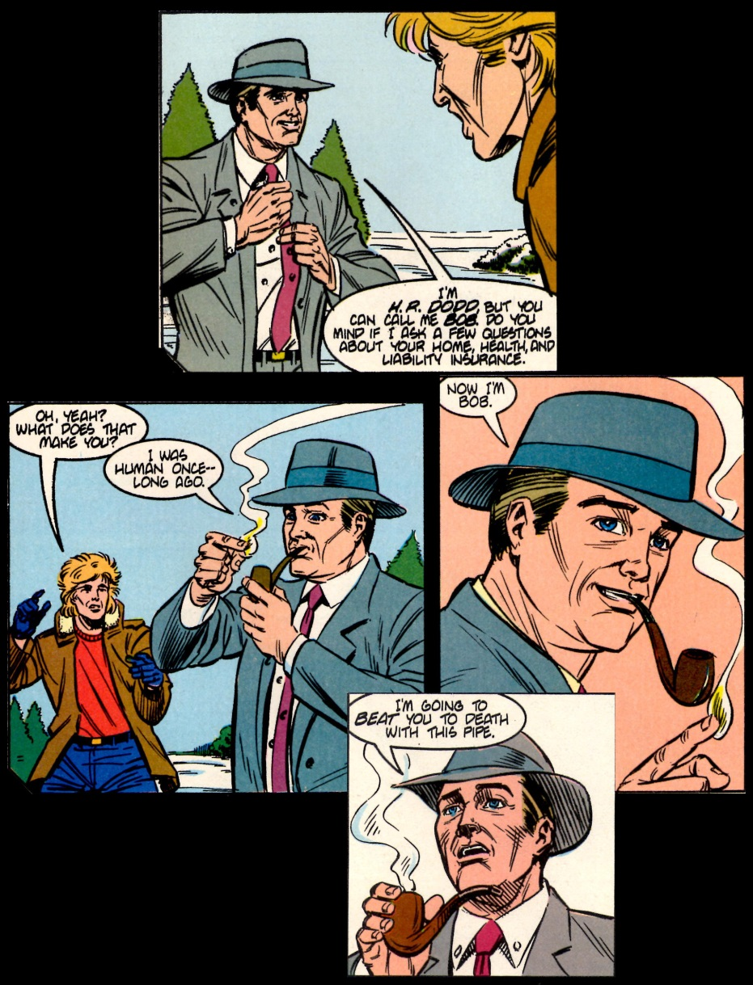

All told, I wish there were trade paperback versions of *The Badger* readily available because it was a fun read and remains quite fresh. It would do the new generation of comics readers some good to see some of the crazy but charming ways in which a series can be both enjoyable and meaningful. A new version of *The Badger*, stylistically updated to reflect the 30-years that have elapsed, is being published. Whether it can conjure the old fun remains to be seen but if not we always have ***Yo! Larry*** to fall back on.

# Badger Redux

The last column was devoted to *The Badger* comic book run of the 1980s. This column is devoted to the 5-issue mini-series (at least at the time of this writing) that revamps the Badger character to be in line with the current day.

Mike Baron is again the writer and creative force behind the book and much of bones of the original story are present in this incarnation. The central three characters of Ham, Norbert (aka the Badger), and Daisy Fields again grace the pages of the book. And their origins and backstories closely parallel the original material but with variations designed to coincide with today’s zeitgeist. Let’s start with Norbert.

Unlike the original Viet Nam motif, where, no doubt, Sykes was drafted, this time around he volunteers for military service. From the get-go, Norbert is a bit strange, as evidenced by his behavior when he enlists with the army.

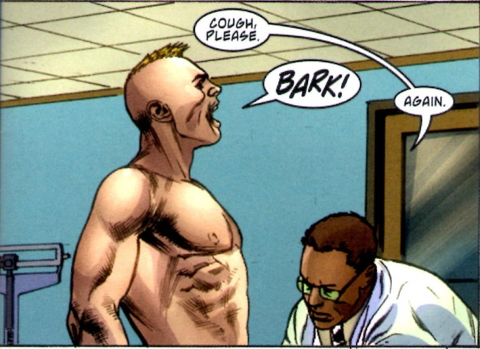

He is soon teamed with a bomb-sniffing dog and both of them pull a tour in Iraq. Sykes shows an aptitude working with Otis (as he so named the dog) and a positive aptitude for combat. However, he is a bit standoffish with his fellow non-comms.

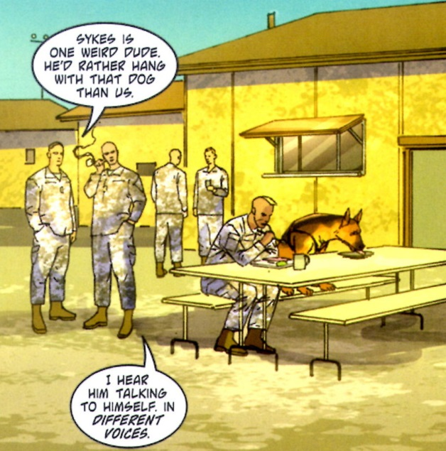

Their time together is short-lived and, as most of the stories from Iraq go, jihadis have soon killed Otis and captured Norbert. They torture him with a combination of physical and psychological techniques, but the one that sends him over the edge is when they place a puppy in a bucket to drown on top of the cage in which they keep him. Driven mad by his impotence in helping an animal, Sykes soon has a vision in which he is visited by a badger (get it – a badger)

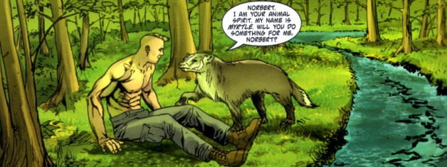

In return for his assent to be a human champion for animal, Myrtle grants him an even greater ferocity in combat – a skill he soon employs to great effect when he breaks free and slaughters his captors. Thus the Badger is born and, perhaps, his personality is splintered.

After he has made his way back to the US held side, he is honorably discharged and sent home. But being a restless sort, Norbert doesn’t stay in Walter Reed to receive the attention he needs. Slipping out, he heads for the open road, hitchhiking back to Wisconsin. Along the way, when asked how many jihidis he killed, Norbert remarks that he didn’t kill any, Pierre did.

Shortly after his arrival in Wisconsin (Racine perhaps, maybe Madison), Norbert comes on a bunch of punks hassling a wheelchair-bound man who had just left the bank. When Sykes comes to his aid and roundly beats the spit out of the thugs he is rewarded with arrest, trial, and subsequent commitment to the sanitarium.

There he meets Dr. Daisy Fields – yes she’s become her own woman and has moved from assistant to full-fledged doctor. She soon recognizes that Norbert suffers with multiple personalities but her reaction is one filled far more with concern than with fascination.

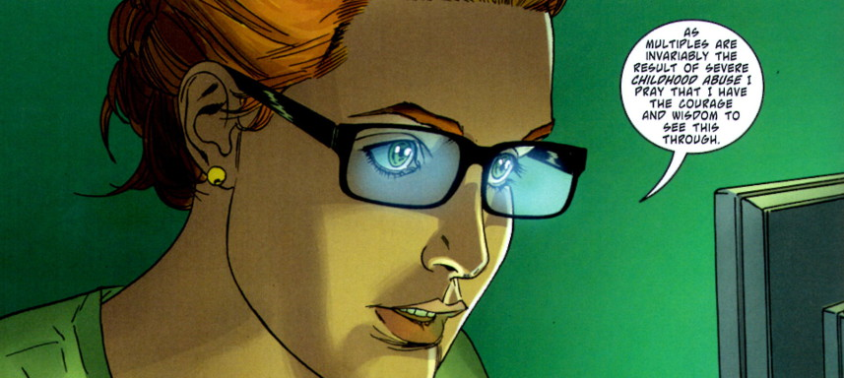

For a while, the santarium permits him to roam the grounds freely, but when he intervenes to stop some orderlies from abusing some geese he again is rewarded; this time with a nice straight jacket and a stay in the padded room. It is while Norbert is looked up in that dark, confined space that the final ingredient in our little drama shows up – Hammaglystwyth (Ham for short).

To prove his power, Ham first unleases Max, the gay-architect splinter of Norbert’s psyche, and, second, arranges for him to have a fine suit, tailored to his needs. Max is getting along splendidly with Doctor Bor, the head of the Sanitarium,

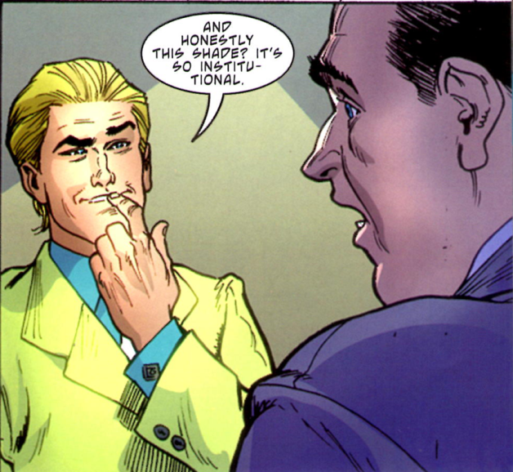

handing out decorating advice, when one of the orderlies bursts in to inform the Doctor that they can’t find Sykes. Back goes the Badger into the general population but not before he is so impresessed with Ham’s magic that he agrees to be Ham’s familiar.

Ham soon affect’s his release from the Sanitarium using magic far more powerful than that of the Druids – today’s legalistic, wired, politically correct sensibilities.

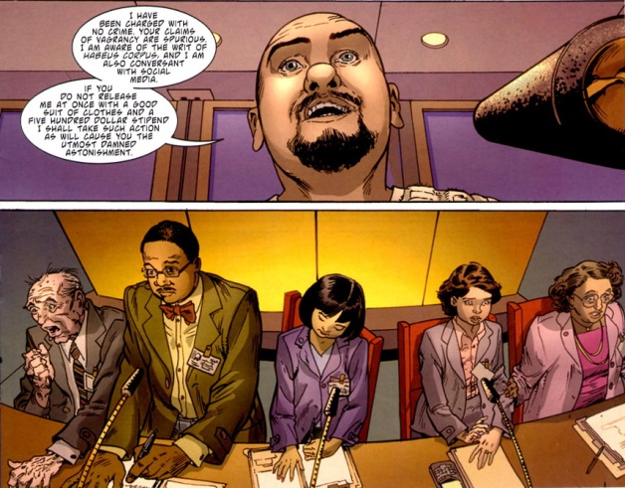

Using the stipend provided on his release, Ham soon turns $500 in mega millions.

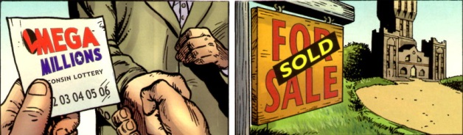

Meanwhile, Daisy has arranged for Norbert to be an outpatient, and hoping to get him a new set of clothes as the first step to trying to help him reintegrate into society, she pulls up to a store with Sykes in tow. But her rehabilitation plans soon go awry, when the Badger comes out to physically punish a rich, arrogant, punk who parks in the handicapped spot since he’ll “only be a sec”. Before the cops can come by, Ham shows up (as if he knew) and whisks them both away in his limo.

Ham soon fills in his Druidic origin; how he was placed under spells in the 4th century that caused him to sleep until modern times; how his inert body was carried to the new world and left buried by Vikings; and how he subsequently woke up and educated himself using that handy modern magic of the internet. Ham further reveals that his plight was the result of the machinations of Rathkrogen, his eternal enemy, and that Rathkrogen is none other that Vladimir Putin. Ham claims that it is only a matter of time before Putin sends an assassin to kill him. No sooner are those words uttered, than a behemoth of a man bursts in (how does he know where and how to penetrate the castle) and the farce is underway. Despite the size differential, the Badger makes short work of the villian.

Ham interogates the now-defeated ‘bully boy’ and finds some startling changes have occurred while he slept

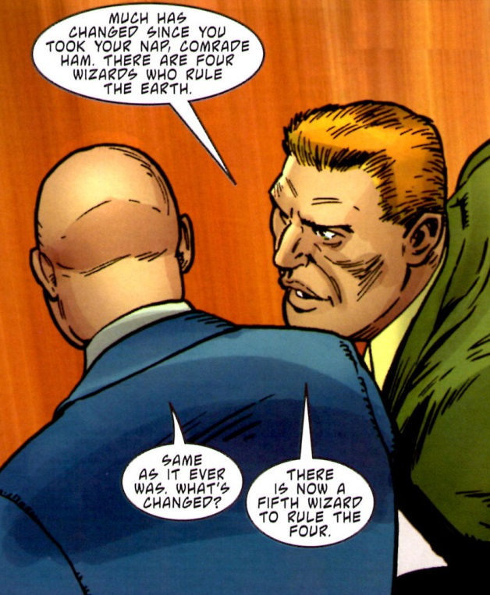

Putin, it seems is vying to be the Fifth Wizard. So end Issues #1-2.

Well there’s more – a lot more. But very little else is important. The key groundwork has been laid and I, frankly, am a bit dissappointed. Not by the story itself, which is reasonably well constructed and paced. Nor by the art, which, while not as vibrant as the original, is pretty good. No, what is disappointing is the tone of the story, which is a queer mix of too much and too little.

Too much time is spent on Norbert’s origin. His enlistment in the army and tour of duty in Iraq is very serious and dramatic and depressing. It pulls back the curtain too much on what made Norbert the man (or men/women/little girl/dog) that he is. The mystery of the Badger was one of the most enjoyable components of the original run. You never knew just what was going to be revealed. Too much pathos is generated around Norbert’s plight – being punished for being a good guy, being misunderstood, and so on.

Too little time and space is spent on the crazy hijinks that made the first series so much fun. Gone are the random acts of pummelling jay walkers and snacking people who don’t fill in their checks before getting in the cashier’s line. Gone are the wacky social observations and zany one-liners. Gone is the banter between the main three characters.

In short, this mini-series has too much drama, too many explanations, too few jokes, and too little of the original style that made the Badger of the 1980s a hit. It is true, that the tone does lighten as the series progresses but in all cases it is more accurate to say that broods along rather than capers. As I mentioned above, the Badger has been recast to fit in with modern times. Perhaps reflecting the zeitgeist is not the way to go – a sad commentary on our current day.